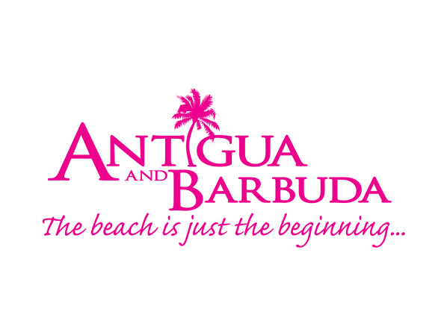
WEDDINGS AND HONEYMOONS IN ANTIGUA AND BARBUDA
Antigua and Barbuda is a tropical paradise perfectly suited for the ultimate romantic wedding or honeymoon getaway with a tropical climate, 365 white sandy beaches to choose from, luxurious hotels and an array of activities to be enjoyed.
Voted the Caribbean’s Most Romantic Destination by the World Travel Awards in 2015, 2016 and 2017, Antigua and Barbuda is considered one of the easiest Caribbean islands to get married in. With no residency requirement, the destination hosts a record number of marriages annually and has gained recognition as a leader in the wedding, honeymoon and romance market. The destination boasts award-winning properties, romance-inducing landscapes, exciting excursions and has a luxurious beach for every day of the year.
The destination has numerous hotels which provide the ultimate romantic setting for couples combining their wedding with a honeymoon in paradise. Professional staff and event planners offer every possible service needed to ensure couples can tie the knot and celebrate their honeymoon in style.
Fees are nominal, which makes it affordable to host a destination wedding:
- Special Marriage Licence – US$150
- Registration Fee – US$40 paid at the Court House
- Civil Marriage Officer Fee – US$100
- Copies of Marriage Certificate – US$10

On February 14 2017, the destination launched the world’s first tourism social media channel dedicated entirely to romance on Facebook. The ‘Antigua Barbuda Romance’ channel is an interactive platform that provides visitors with the best information and tools for those planning their perfect romantic trip. To find out more, visit the ‘Antigua Barbuda Romance’ platform at www.facebook.com/AntiguaBarbudaRomance

Activities planned from February to the destination’s romance month of June include the launch of specially crafted romance packages, and offerings for visitors.

###

MEDIA CONTACT:

Maria Blackman

Marketing Communications|
Antigua & Barbuda Tourism Authority – HEAD OFFICE |
3rd Floor | ACB Building | Corner of High and Temple Sts.| St. John’s Antigua
Office +1 268 562 7600 (Direct Line): +1 268 464 7601
visitantiguabarbuda or join us on www.facebook.com/antiguabarbuda

