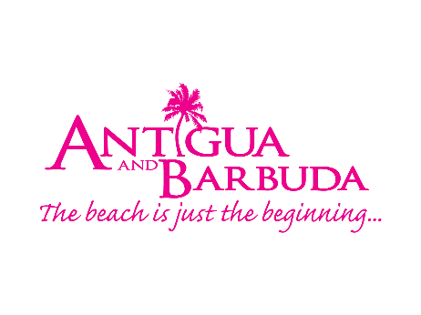
FOR IMMEDIATE RELEASE:

ANTIGUA AND BARBUDA TOURISM AUTHORITY RELEASES NEW DESTINATION VIDEO FOR TRAVELLERS SEEKING A SAFE HARBOUR AND ESCAPE ON THE WATER

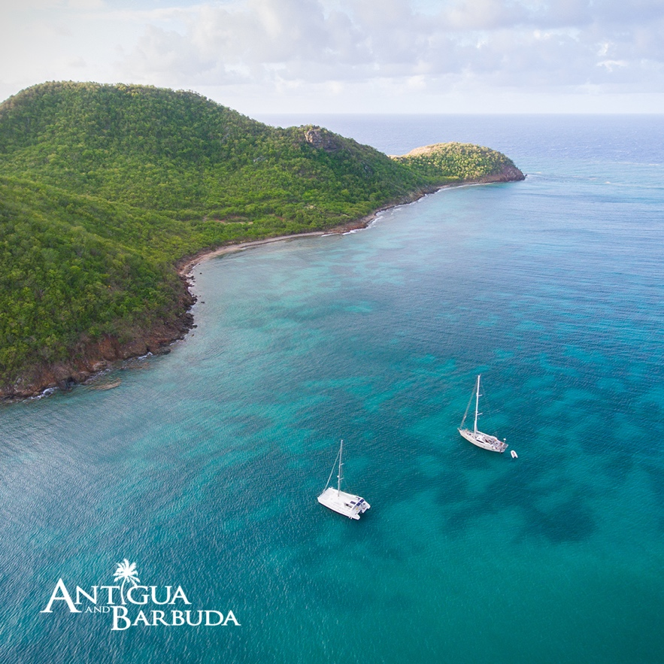

ST. JOHN’S, ANTIGUA AND BARBUDA (January 20, 2021) – Antigua and Barbuda’s magnificent harbours, charming marinas, and iconic landmarks are on full display in the Antigua and Barbuda Tourism Authority’s latest destination video created for travellers in need of an escape on the water.

The sailing capital of the Caribbean, Antigua and Barbuda boldly establishes itself as a safe haven and premier yachting destination for those seeking seclusion and space.

The four-minute video which can be viewed on the Antigua and Barbuda Tourism Authority’s YouTube www.youtube.com/goantiguabarbuda and social media pages, features remarks from Antigua and Barbuda Minister of Tourism, the Honourable Charles H. Fernandez.

Standing on board a beautiful yacht within the Catamaran Marina, Falmouth
Harbour, the Tourism Minister comments that, the Government of Antigua and Barbuda remains committed to the development of the yachting sector.

“We can assure you that working together with our partners in the yachting sector, we have put guidelines and measure in place throughout our marinas to allow for the safe resumption of the yachting industry, and the safe return of visitors in the best way possible.”

After months of preparation, the UNESCO World Heritage Site, Nelson’s Dockyard has re-opened with major upgrades visible and signage that allows for self-guided tours around the national park. New tours are also on offer at the National Parks alongside popular events such as the Copper and Lumber Seafood Friday and Rum in the Ruins.

The destination is also now safely welcoming rowers in the 3000 mile, Talisker Whisky Atlantic Challenge to Nelson’s Dockyard. The Tourism Minister tells viewers that the Government of Antigua and Barbuda and stakeholders continue to work, to make nautical events on the 2021 destination events calendar more socially responsible.

For Antigua and Barbuda’s full health and safety protocols designed to safely welcome visitors on yachts travelling to Antigua and Barbuda, including the requirement that all travellers show a negative RT-PCR Test result on arrival go to: www.visitantiguabarbuda.com

###

ABOUT THE ANTIGUA AND BARBUDA TOURISM AUTHORITY
The Antigua & Barbuda Tourism Authority is a statutory body dedicated to realizing the tourism potential of Antigua & Barbuda by promoting the twin island state as a unique, quality tourist destination with the overall objective of increasing visitor arrivals thereby providing sustainable economic growth. The Antigua and Barbuda Tourism Authority is headquartered in St. John’s Antigua, where regional marketing is directed. The Authority has three offices overseas in the United Kingdom, United States and Canada.
ABOUT ANTIGUA AND BARBUDA
Antigua (pronounced An-tee'ga) and Barbuda (Bar-byew’da) is located in the heart of the Caribbean Sea. Voted the World Travel Awards 2015, 2016, 2017 and 2018 Caribbean’s Most Romantic Destination, the twin-island paradise offers visitors two uniquely distinct experiences, ideal temperatures year-round, a rich history, vibrant culture, exhilarating excursions, award-winning resorts, mouth-watering cuisine and 365 stunning pink and white-sand beaches - one for every day of the year. The largest of the Leeward Islands, Antigua comprises 108-square miles with rich history and spectacular topography that provides a variety of popular sightseeing opportunities. Nelson’s Dockyard, the only remaining example of a Georgian fort a listed UNESCO World Heritage site, is perhaps the most renowned landmark. Antigua’s tourism events calendar includes the prestigious Antigua Sailing Week, Antigua Classic Yacht Regatta, and the annual Antigua Carnival; known as the Caribbean’s Greatest Summer Festival. Barbuda, Antigua’s smaller sister island, is the ultimate celebrity hideaway. The island lies 27 miles north-east of Antigua and is just a 15-minute plane ride away. Barbuda is known for its untouched 17 mile stretch of pink sand beach and as the home of the largest Frigate Bird Sanctuary in the Western Hemisphere. Find information on Antigua & Barbuda at: www.visitantiguabarbuda.com or follow us on Twitter. http://twitter.com/antiguabarbuda Facebook www.facebook.com/antiguabarbuda; Instagram: www.instagram.com/AntiguaandBarbuda

For Antigua and Barbuda media enquiries, please contact:
Maria Blackman
Antigua and Barbuda Tourism Authority
T: 1 (268) 562 7600/464-7601
E: maria.blackman@visitaandb.com

