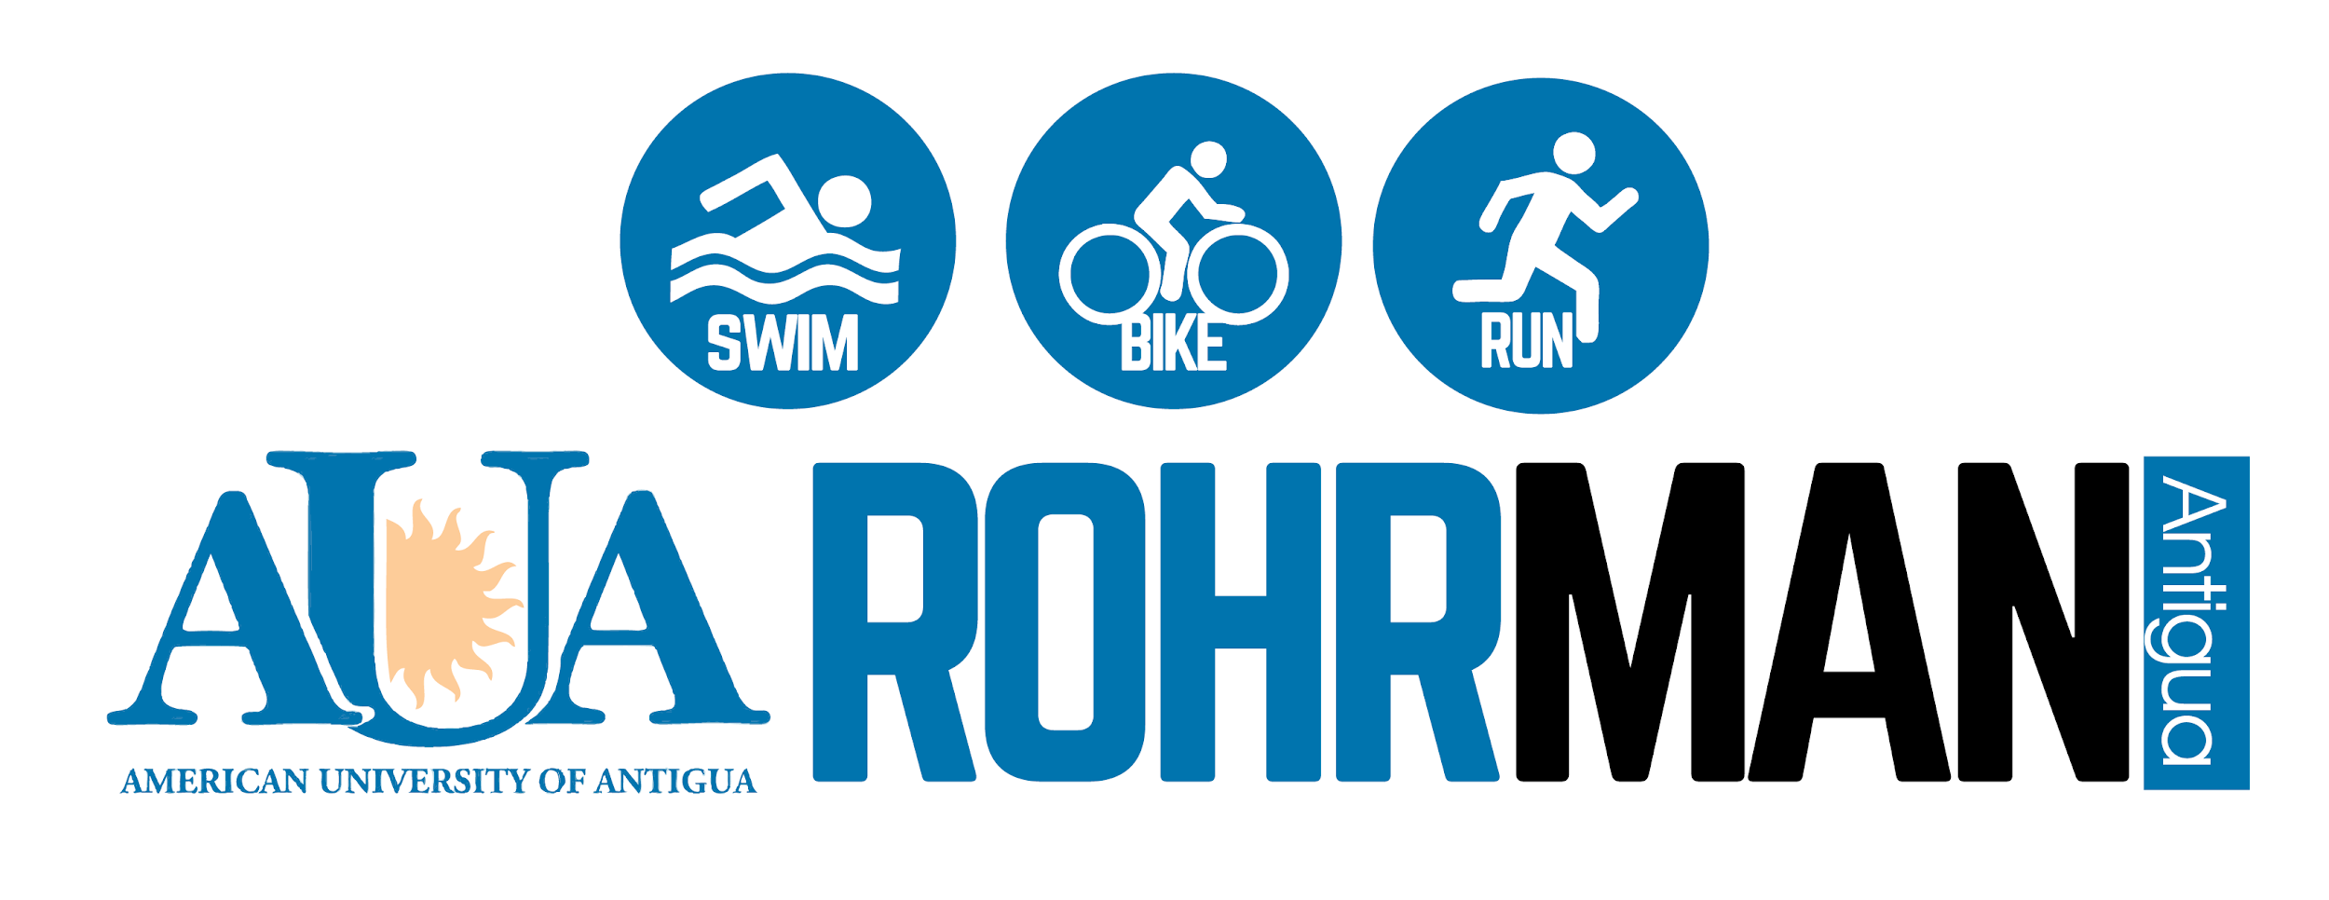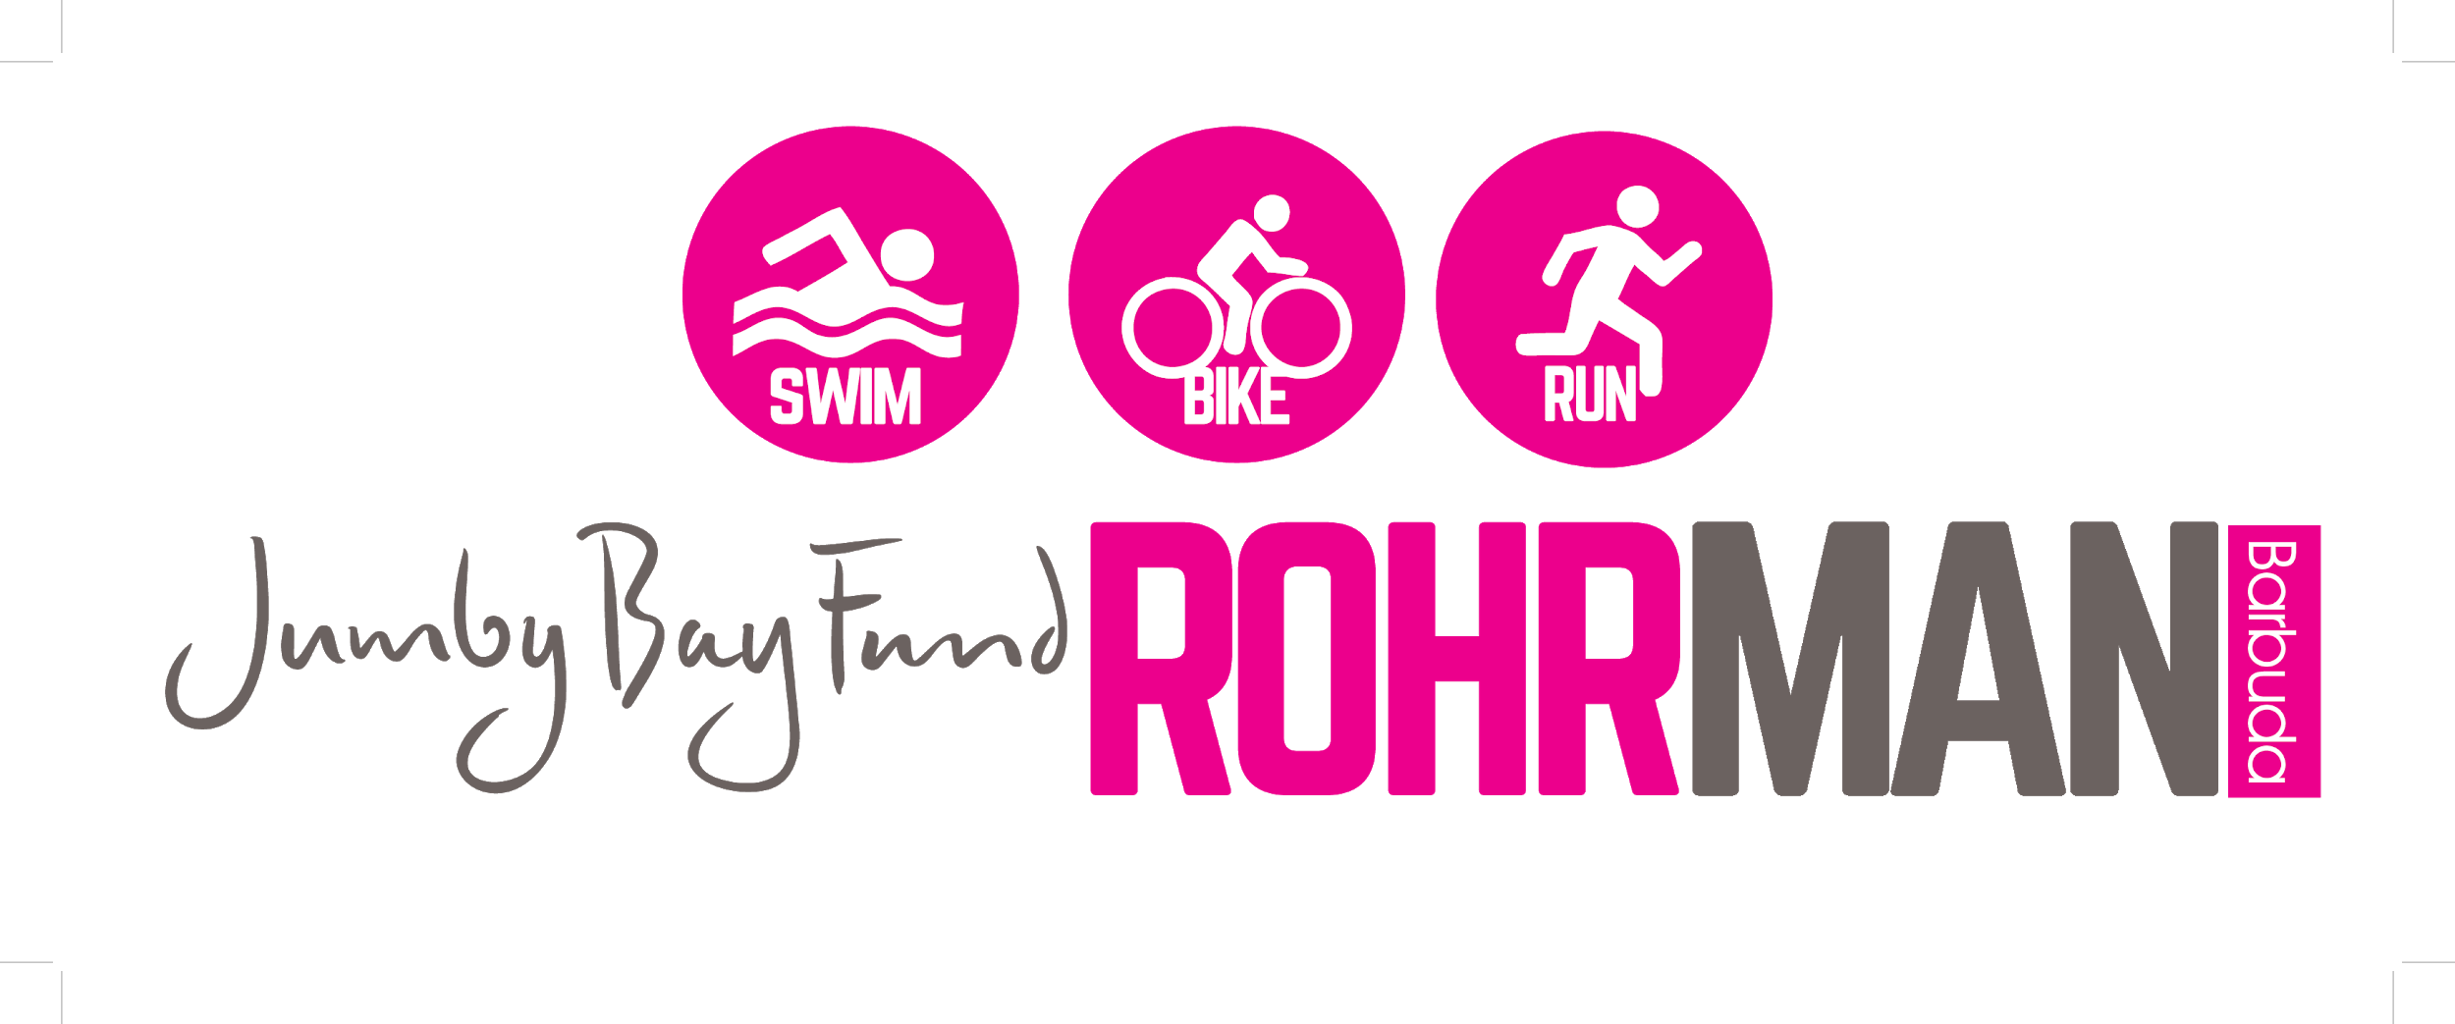
Rohrman Sports Association

MEDIA CONTACT:
Rory Butler
Tel: (268) 771 3825
Email: rorybutleranu@gmail.com

FRENCH NATIONAL TRIATHLON CHAMPION RETURNS TO DEFEND AUA ROHRMAN ANTIGUA TITLE

The reigning French Sprint Triathlon Champion Aurélien Raphaël has confirmed his return to Antigua to defend his title in the AUA Rohrman Triathlon on Saturday March 7th, 2020.

Raphaël, a former European Junior Champion and former Junior World Champion will also take part in the Jumby Bay Fund Rohrman Barbuda on Sunday March 8th, 2020.

Raphaël won the Antigua title in 2019 in stunning fashion, breaking the two hour barrier and setting a course record of 1 hour 57 minutes and 21 seconds, for the 1,500 meter swim, 40km bike, and 10k run.

The French triathlete, after starting his season in Antigua, then went onto claim his first ever French national title in June.

Raphaël’s confirmed presence has already attracted a contingent of over 20 French amateur athletes who will test themselves against him, in one of the only triathlons in the world which allows amateur triathletes to race side by side with pro-athletes.

The AUA Rohrman Antigua features 10 triathlons including junior age groups of 6 & under, 7-8, 9-10, 11-12and 13-15. The adult events include Olympic, Sprint and Mini distances, with the Sprint & Mini distances both available in individual or team formats.

The event continues with a second day for the Jumby Bay Fund Rohrman Barbuda which involves a number of swimming and running events along with fun activities such as tug o war.

The non-profit event is sponsored by the Government of Antigua & Barbuda, Antigua & Barbuda Tourism Authority, the Ministry of Sports, the National Olympic Committee, the American University of Antigua, the Jumby Bay Fund, Sugar Ridge, Tamarind Hills, Cool & Smooth, Cedars Pottery, Island Provision, Pellegrino water, Barbuda Council, Barbuda Ocean Club, Road Runners, Stonewall Sounds, Island Sanitation, Pure Sports & Events, Special Security Services, Antigua VIP Tours, and SO Ltd.

The event is also supported by the Royal Police Force of Antigua & Barbuda, ABSAR, the Ministry of Environment, the Coast Guard, the EMS and many volunteers.

About the Rohrman:

The Rohrman is a triathlon festival named in honour of the late Jonathan Rohr, a former triathlete and AUA student. The event is a non-profit endeavour aimed at boosting sports development and sports tourism in Antigua & Barbuda.

About AUA Rohrman Antigua:
https://raceroster.com/events/2020/26909/aua-rohrman-triathlon

About Jumby Bay Fund Rohrman Barbuda:
https://raceroster.com/events/2020/27661/jumby-bay-fund-rohrman-barbuda

Visit us on Facebook:
www.facebook.com/pg/AntiguaBarbudaTriathlon/

