AIR CANADA RETURNS, BOOSTING FLIGHTS TO
ANTIGUA AND BARBUDA STARTING OCTOBER 3RD, 2021

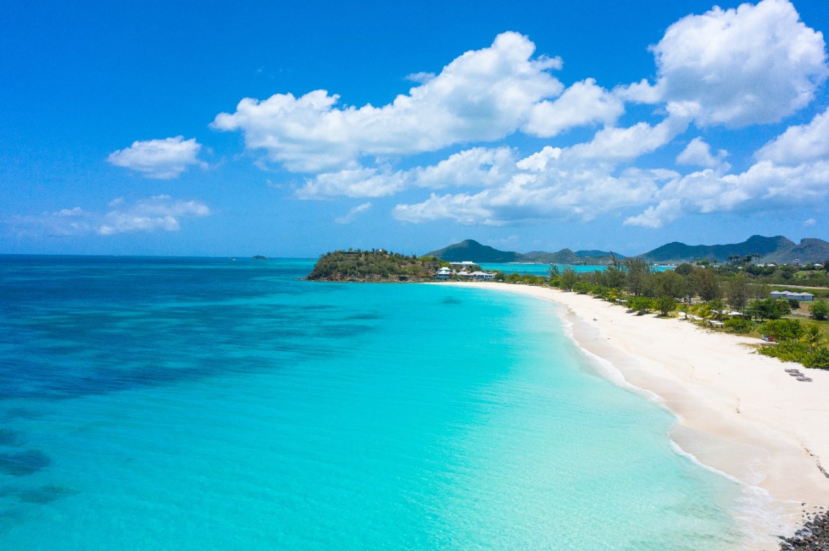
Ffryes Beach, photo courtesy of the Antigua & Barbuda Tourism Authority

ST. JOHN’S, ANTIGUA (SEPTEMBER 30, 2021) – Antigua and Barbuda will see a boost in airlift for the winter season, as demand for the destination increases amongst travellers seeking to escape the cold weather. Air Canada announced the resumption of its flights on Sunday, October 3, to and from Toronto to St. John’s, Antigua & Barbuda.

Antigua and Barbuda Minister of Tourism, the Hon. Charles Fernandez said: “We welcome Canadians back to our shores and are very pleased that Air Canada has decided to resume services from Toronto to St. John’s, Antigua. This upcoming winter season, visitors will continue to safely enjoy Antigua and Barbuda.”

Nino Montagnese, Vice President, Air Canada Vacations further added, “Canadians are anxious to travel to the beautiful locations they’ve been dreaming of, and we’re ready to respond to their needs. Our packaged holidays from Toronto to Antigua, available as of October 3rd, give them the opportunity to experience a stunning corner of the Caribbean and create new memories under the sun.”

The destination has put forward a number of COVID-19 protocols to ensure the safety of its residents, airline essential workers and visitors. As of October 1st, 2021, the following protocols will be in effect to protect their health and safety:

• All arriving passengers will require a negative COVID-19 RT-PCR (real-time polymerase chain reaction) test for SARS-CoV-2 using a nasopharyngeal or oropharyngeal swab taken within four days of their flight or fewer.

- Children below the age of 5 years, entering Antigua, DO NOT REQUIRE a COVID -19 RT-PCR test.

• As of October 1, 2021, all arriving passengers including returning nationals and residents (excluding children 18 years and younger) are required to have received at least one dose of a World Health Organization (WHO) or Ministry of Health Wellness and the Environment (MOHWE) approved 2-dose COVID 19 vaccine.

• The wearing of face mask in public spaces is mandatory throughout Antigua and Barbuda and social/physical distancing protocols must be adhered to.

To know more about the protocols in detail you can click here.

ABOUT ANTIGUA AND BARBUDA
Antigua (pronounced An-tee'ga) and Barbuda (Bar-byew’da) is located in the heart of the Caribbean Sea. Voted the World Travel Awards 2015, 2016, 2017 and 2018 Caribbean’s Most Romantic Destination, the twin-island paradise offers visitors two uniquely distinct experiences, ideal temperatures year-round, a rich history, vibrant culture, exhilarating excursions, award-winning resorts, mouth-watering cuisine and 365 stunning pink and white-sand beaches - one for every day of the year. The largest of the Leeward Islands, Antigua comprises 108-square miles with rich history and spectacular topography that provides a variety of popular sightseeing opportunities. Nelson’s Dockyard, the only remaining example of a Georgian fort a listed UNESCO World Heritage site, is perhaps the most renowned landmark. Antigua’s tourism events calendar includes the prestigious Antigua Sailing Week, Antigua Classic Yacht Regatta, and the annual Antigua Carnival; known as the Caribbean’s Greatest Summer Festival. Barbuda, Antigua’s smaller sister island, is the ultimate celebrity hideaway. The island lies 27 miles north-east of Antigua and is just a 15-minute plane ride away. Barbuda is known for its untouched 17 mile stretch of pink sand beach and as the home of the largest Frigate Bird Sanctuary in the Western Hemisphere. Find information on Antigua & Barbuda at: www.visitantiguabarbuda.com or follow us on:
Twitter: http://twitter.com/antiguabarbuda
Facebook: www.facebook.com/antiguabarbuda
Instagram: www.instagram.com/AntiguaandBarbuda

ABOUT AIR CANADA VACATIONS
Air Canada Vacations is a leading vacation expert that has been delivering unparalleled travel moments to Canadians for over 35 years. A repeat recipient of the Consumer’s Choice Award, the tour operator offers tailored vacation packages and cruises that fit each traveller’s individual needs. With convenient connectors from several Canadian cities and a wide array of destinations across Mexico and the Caribbean, Central and South America, Europe, Canada and the USA, Air Canada Vacations makes travelling easy, so that Canadians can focus on creating lasting memories. Air Canada Vacations packages include flights on board Air Canada and Air Canada Rouge, and the ability to earn and redeem Aeroplan® Points. To learn more about making your dreams travel, visit aircanadavacations.com.

For media enquiries, please contact:
Maria Blackman
Antigua and Barbuda Tourism Authority
T: 1 (268) 562 7600/464-7601
E: maria.blackman@visitaandb.com

