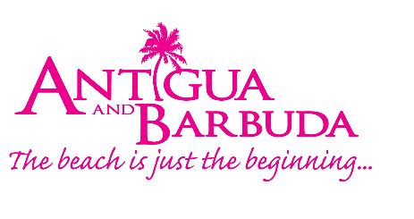
FOR IMMEDIATE RELEASE:

THE TAKEOVER TRAVEL CLUB MAKES CHILDREN’S BOOK PRESENTATION TO THE NATIONAL PUBLIC LIBRARY DURING VACATION

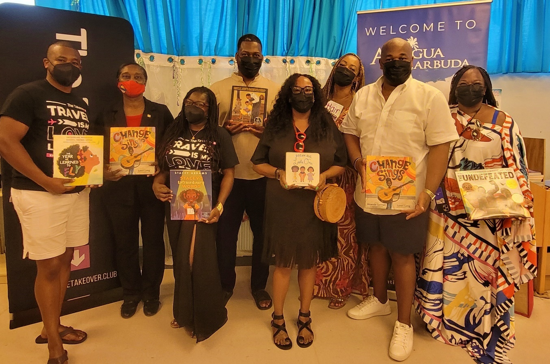

Photo Caption: The Takeover Travel Club from the USA presented a selection of children’s books to the National Public Library today, during their visit to Antigua.

ST. JOHN’S, ANTIGUA (MAY 30, 2022) – United States visitors to Antigua and Barbuda today made a presentation of around one hundred children’s books to the National Public Library.

The special presentation by The Takeover Travel Club, an international travel club, was facilitated by the Antigua and Barbuda Tourism Authority. The Takeover Travel Club known for buying-out resorts, are guided by their mission “Live life fully and abundantly through inspired, extraordinary travel experiences”. The group of over one hundred and fifty travellers were welcomed to Antigua on May 28 by the Antigua and Barbuda Tourism Authority’s Special Projects and Events Team. Since their arrival they have been engaged in culturally immersive experiences.

Marketing Communications Manager within the Antigua and Barbuda Tourism Authority, Maria Blackman said, “We are very fortunate to have visitors, such as ‘The Takeover’ group who are interested in getting involved with the local community, and who seek out ways to make direct contributions that will be beneficial to our youth. We know that just like travel gives you a whole new perspective of the world, so to does reading. Reading allows you to travel, explore new places and get a broader sense of the world we live in, and so we welcome today’s presentation.”

The fictional books were specially selected for toddlers to children ages fourteen.

Ryllis Mannix, Director of the National Public Library expressed appreciation to the travel club, for donating the books, which will be added to the existing collection at the National Public Library. “Thank you for this magnificent donation. Thank you for being generous friends, especially for this act of love that will enhance education and bring more joy to the children of Antigua and Barbuda. We are forever appreciative of your thoughtfulness. A great initiative indeed!”

Participating in the presentation ceremony at the library was La Chanda Ricks, Founder and Chief Experience Officer of the Takeover Travel Club, alongside members of the club.

“Thank you so much for allowing us this opportunity to connect with and show love to the local community. Our travel club is made up of wonderful people - people who love to read, people who love to travel, and people who are service-oriented. At home, we are very much active in our local communities, and so it is always an extension of what we do at home, when we travel. Not only to come and enjoy your beautiful island, but also if and when there is an opportunity, to give back and to just interact with local residents as much as we possibly can, as a way of fully experiencing the island”, said Ricks, The Takeover Travel Club Founder.

Special Project and Events Marketing Manager, Shermain Jeremy, who also attended today’s presentation, expressed her pleasure at the group’s visit which had previously been delayed in 2021 due to the covid-19 pandemic.

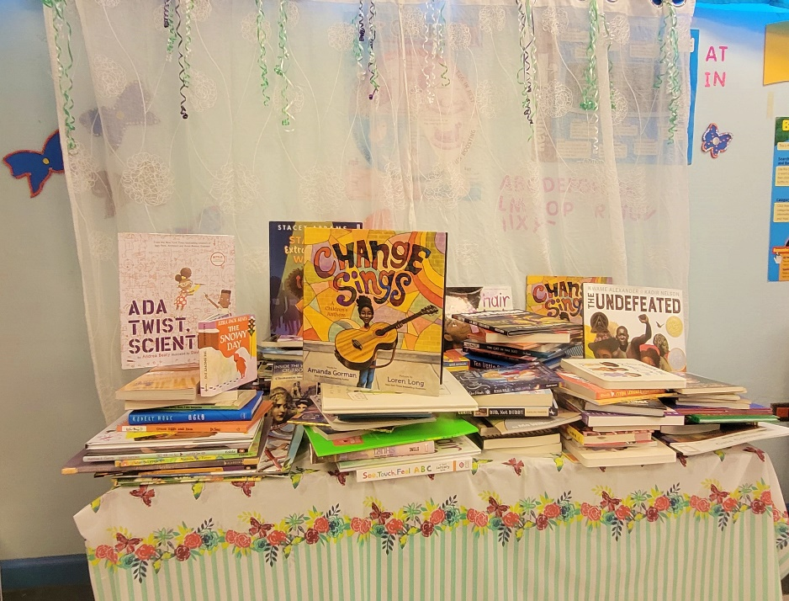

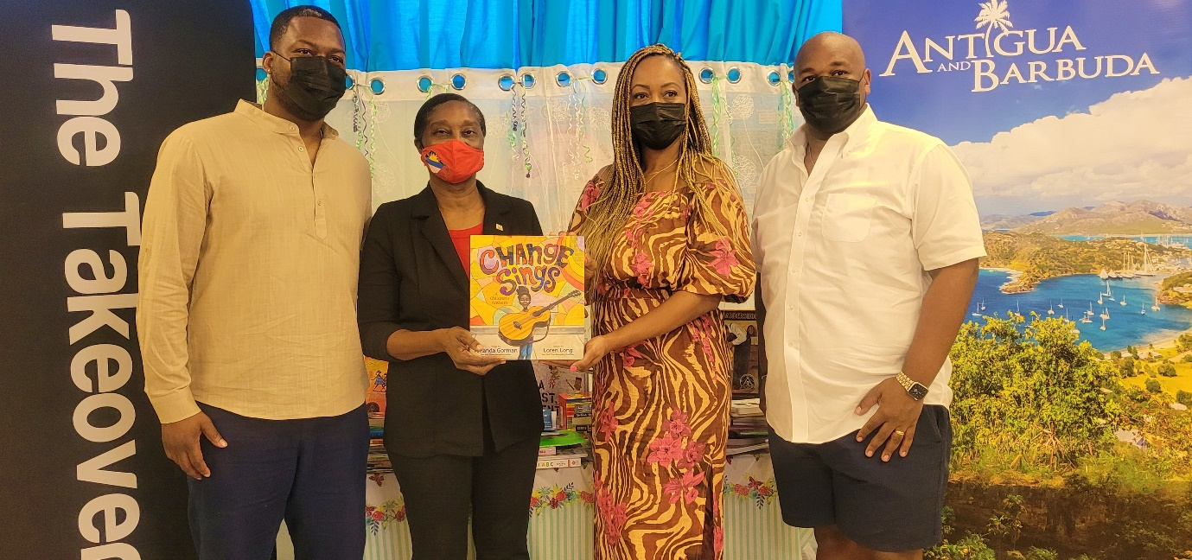
Photo Caption: Ryllis Mannix, Director of the National Public Library was pleased to accept the books on behalf of the National Library from La Chanda Ricks, Founder of The Takeover Travel Club

###
ABOUT THE ANTIGUA AND BARBUDA TOURISM AUTHORITY
The Antigua & Barbuda Tourism Authority is a statutory body dedicated to realizing the tourism potential of Antigua & Barbuda by promoting the twin island state as a unique, quality tourist destination with the overall objective of increasing visitor arrivals thereby providing sustainable economic growth. The Antigua and Barbuda Tourism Authority is headquartered in St. John’s Antigua, where regional marketing is directed. The Authority has three offices overseas in the United Kingdom, United States and Canada.

ABOUT ANTIGUA AND BARBUDA
Antigua (pronounced An-tee'ga) and Barbuda (Bar-byew’da) is located in the heart of the Caribbean Sea. The twin-island paradise offers visitors two uniquely distinct experiences, ideal temperatures year-round, a rich history, vibrant culture, exhilarating excursions, award-winning resorts, mouth-watering cuisine and 365 stunning pink and white-sand beaches - one for every day of the year. The largest of the English-speaking Leeward Islands, Antigua comprises 108-square miles with rich history and spectacular topography that provides a variety of popular sightseeing opportunities. Nelson’s Dockyard, the only remaining example of a Georgian fort a listed UNESCO World Heritage site, is perhaps the most renowned landmark. Antigua’s tourism events calendar includes the prestigious Antigua Sailing Week, Antigua Classic Yacht Regatta, and the annual Antigua Carnival; known as the Caribbean’s Greatest Summer Festival. Barbuda, Antigua’s smaller sister island, is the ultimate celebrity hideaway. The island lies 27 miles north-east of Antigua and is just a 15-minute plane ride away. Barbuda is known for its untouched 11-mile stretch of pink sand beach and as the home of the largest Frigate Bird Sanctuary in the Western Hemisphere. Find information on Antigua & Barbuda at: www.visitantiguabarbuda.com or follow us on Twitter: http://twitter.com/antiguabarbuda Facebook: www.facebook.com/antiguabarbuda; Instagram: www.instagram.com/AntiguaandBarbuda

For Antigua and Barbuda media enquiries, please contact:
Maria Blackman
Marketing Communications Manager
Antigua and Barbuda Tourism Authority
T: 1 (268) 562 7600/464-7601
E: maria.blackman@visitaandb.com
Antigua and Barbuda Images: aandbtourism.fotoseeker.com

