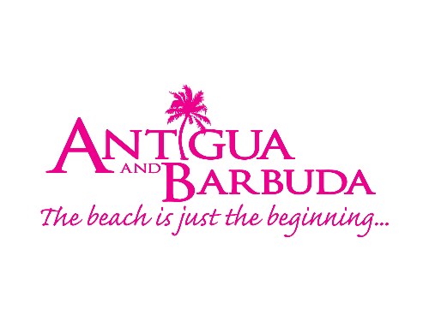
FOR IMMEDIATE RELEASE:

ANTIGUA AND BARBUDA TARGETS REGIONAL TRAVELLERS FOR CARIBBEAN’S GREATEST SUMMER FESTIVAL
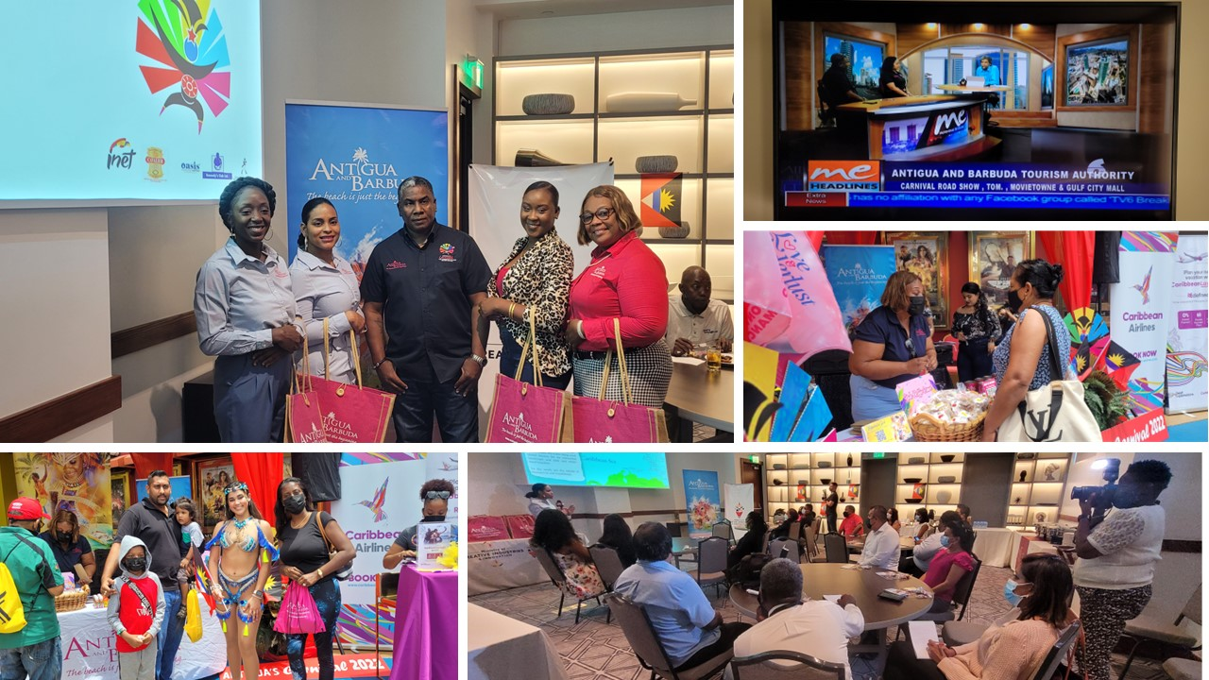
Photo Caption: The Antigua and Barbuda Tourism Authority has partnered with the Ministry of Creative Industries and Innovation to promote travel to the destination for the Caribbean’s Greatest Summer Festival, Antigua Carnival taking place from July 27 – August 2, 2022. (Photo Courtesy: The Antigua and Barbuda Tourism Authority)

ST. JOHN’S, ANTIGUA (June 8, 2022) - As Antigua and Barbuda gears up for Antigua’s Carnival, ‘The Caribbean’s Greatest Summer Festival’, taking place from July 27 – August 2, 2022, regional neighbours will get a teaser of the carnival celebrations with The Antigua and Barbuda Tourism Authority, and The Ministry of Creative Industries and Innovation ‘Taste of Antigua Carnival’ Roadshow, being held throughout a number of the Caribbean islands, ahead of the summer festival.

Trinidad and Tobago, home to millions of Carnival aficionados, was the first stop on the roadshow. “The purpose of ‘Taste of Antigua Carnival’ is to build momentum for the festivities. Carnival is a major draw for regional travellers and a huge economic driver for us. Following a break of two years, and under the theme: ‘Reigniting the Spirit’, we felt it critical to make our presence felt within the region, with a strong comeback. We are building back bridges with our regional trade partners, connecting with the media, and speaking directly to the consumer. There was no better place to start the show, than one of our key regional markets and a mecca for Carnival, Trinidad and Tobago”, said Antigua and Barbuda Tourism Authority’s Marketing Consultant for the Caribbean and Latin America, Charmaine Spencer.

Joining Spencer to bring the Antigua Carnival excitement to Trinidad on June 3 and June 4 was Antigua and Barbuda Tourism Authority’s Marketing Communications Manager, Maria Blackman as well as Tours Executive, Francine Joseph and, from the Ministry of Creative Industries and Innovation Marketing and Public Relations Manager, Roger Perry and Marketing & Communications Executive, Leanda Ann Norville.

The delegation hosted an ‘Antigua Carnival Brunch’ exclusively for the Trinidadian travel trade and media partners. Twenty travel agencies alongside three media houses attended the oversubscribed event, to learn about Antigua’s latest tourism developments, easy travel protocols, and hear more about the 2022 Carnival festivities. Five down-the-line radio interviews as a part of the media blitz, took place targeting various regions and carnival audiences in Trinidad. Spencer and Perry also made an early morning appearance on CCN TV 6 to promote the roadshow.

“Leading up to Carnival, we have one of the longest fete seasons with eight-four fetes”, Perry, noted during his presentations. “Our 2022 Carnival will feature new routes, new events, and more mechanisms in place for crowd control, to ensure a safe and responsible enjoying of our festivities. Visitors who have been deprived of Carnival for the last two years, will find a rich, cultural experience when they attend Antigua’s Carnival.

“This weekend has been extremely successful. There has been lots of interest in the 2022 Carnival and we are also beginning the outreach and planning for 2023,” noted Perry.
Spencer held on-the-spot meetings with tour operators to discuss Carnival packages for the 2022 Carnival, to provide travellers with the option of having their flights, hotels, carnival costumes and event tickets coordinated through an agency. The Ministry of Creative Industries and Innovations will continue dialoguing with the agencies on the packages.

Meetings were also held with Caribbean Airlines to discuss possible additional airlift to the destination to meet the increased demand expected.

“Demand for the destination has been high. Antigua is one of the few Caribbean countries that will host a Carnival in 2022, and with protocols that allow for both the vaccinated and unvaccinated to travel, we are preparing for a boost to the 2022 summer season that will rival our 2019 figures”, remarked Spencer, tourism marketing consultant.

On Saturday, the team along with partner Caribbean Airlines, created a Carnival atmosphere at the popular MovieTowne in Port of Spain. Here, they greeted and engaged with an audience of persons eager to learn about the destination and the Carnival celebrations. Visitors to the Antigua and Barbuda display were able to sample local sweet treats to include, massa harris, coconut tarts, and coconut slice-up, while enjoying the Antigua Cavalier rum punch. Revelers dressed in costumes from Insane Carnival and Xklusive Carnival, danced with visitors while Antiguan soca music filled the air. There were lots of prizes to be won, with Caribbean Airlines promoting Antigua flights, and the Antigua and Barbuda Tourism Authority offering regional travellers the chance to, ‘Win a Trip for Two to Antigua Carnival’.

The Antigua and Barbuda team was warmly received by the Trinidadian public and look forward to announcing the dates and other Caribbean island stops for the ‘Taste of Antigua Carnival’ roadshow.

Regional Travellers have up until July 3 to enter to win a trip for two to Antigua’s Carnival on https://visitantiguabarbuda.com/destinations/win-a-trip-to-antigua-carnival/

Antigua’s Carnival 2022 Carnival Schedule includes:

Wednesday 27 July
Opening of Carnival
Jaycees Caribbean Queen Show

Thursday 28 July
Caribbean Melting Pot

Friday 29 July
Calypso Monarch Competition

Saturday 30 July
Party Monarch Competition

Sunday 31 July
Pan De Mix
Emancipation Watch Night Celebrations

Monday 1 August
Emancipation Day
J’ouvert
Culture and Cuisine
Carnival Monday

Tuesday 2 August
Parade of the Bands
Last Lap

For more information on Antigua’s Carnival go to: www.mcii.gov.ag

###

ABOUT THE ANTIGUA AND BARBUDA TOURISM AUTHORITY
The Antigua & Barbuda Tourism Authority is a statutory body dedicated to realizing the tourism potential of Antigua & Barbuda by promoting the twin island state as a unique, quality tourist destination with the overall objective of increasing visitor arrivals thereby providing sustainable economic growth. The Antigua and Barbuda Tourism Authority is headquartered in St. John’s Antigua, where regional marketing is directed. The Authority has three offices overseas in the United Kingdom, United States and Canada.

ABOUT ANTIGUA AND BARBUDA
Antigua (pronounced An-tee'ga) and Barbuda (Bar-byew’da) is located in the heart of the Caribbean Sea. The twin-island paradise offers visitors two uniquely distinct experiences, ideal temperatures year-round, a rich history, vibrant culture, exhilarating excursions, award-winning resorts, mouth-watering cuisine and 365 stunning pink and white-sand beaches - one for every day of the year. The largest of the English-speaking Leeward Islands, Antigua comprises 108-square miles with rich history and spectacular topography that provides a variety of popular sightseeing opportunities. Nelson’s Dockyard, the only remaining example of a Georgian fort a listed UNESCO World Heritage site, is perhaps the most renowned landmark. Antigua’s tourism events calendar includes the prestigious Antigua Sailing Week, Antigua Classic Yacht Regatta, and the annual Antigua Carnival; known as the Caribbean’s Greatest Summer Festival. Barbuda, Antigua’s smaller sister island, is the ultimate celebrity hideaway. The island lies 27 miles north-east of Antigua and is just a 15-minute plane ride away. Barbuda is known for its untouched 11-mile stretch of pink sand beach and as the home of the largest Frigate Bird Sanctuary in the Western Hemisphere. Find information on Antigua & Barbuda at: www.visitantiguabarbuda.com or follow us on Twitter: http://twitter.com/antiguabarbuda Facebook: www.facebook.com/antiguabarbuda; Instagram: www.instagram.com/AntiguaandBarbuda

For Antigua and Barbuda media enquiries, please contact:
Maria Blackman
Marketing Communications Manager
Antigua and Barbuda Tourism Authority
T: 1 (268) 562 7600/464-7601
E: maria.blackman@visitaandb.com

Antigua and Barbuda Images: aandbtourism.fotoseeker.com

