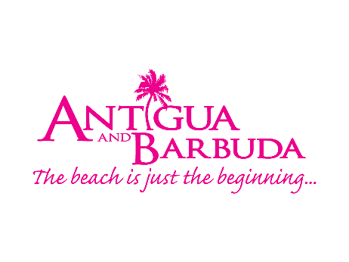

ANTIGUA AND BARBUDA FEATURES ON NEW SERIES ‘THE
BIG BODY HOTEL’

March 12, 2021 (St. John’s, Antigua) - One of Antigua and Barbuda’s hotels, the Catamaran Hotel is now appearing on a major new primetime series ‘The Big Body Hotel’ which started airing today on Discovery+ in the United Kingdom.

‘The Big Body Hotel’ is an eight-part series that chronicles plus sized tourists on their Caribbean holiday in the beautiful twin-island paradise of Antigua and Barbuda. As the Discovery+ website describes “The tourists check into the hotel designed with larger guests in mind and learn to embrace their bodies in a place where size is no obstacle to enjoying a care-free holiday.”

Throughout the non-judgmental and uplifting show, the tourists participate in experiences at the ‘Resort’ hotel, which is Antigua’s Catamaran hotel. The Catamaran Hotel, with plus-size facilities such as reinforced, enlarged furniture, is one of the only hotels in the world that can cater to the plus-size holidaymaker.
The tourists also explore Antigua with activities chosen to help them overcome their body confidence issues. There is an emotional unpacking of issues and the steps to help remedy them, are at the heart of the series.

In media coverage of the show, contestant Chris Conway tells the Blackpool Gazette "My experience on the show was fantastic and positive. We did water-sports and kayaking, which I would never have usually done. I would panic that the kayak would sink with me in it and I'd be embarrassed. We did a mountain hike and kickboxing, and it was stuff I enjoyed but never would have considered doing on holiday.
All eight episodes of the show are available on Discovery+ UK: https://www.discoveryplus.co.uk/show/the-big-body-hotel

Find more information on the plus-sized friendly, Catamaran Hotel - https://catamaranantigua.com/the-big-body-hotel/

###

ABOUT ANTIGUA AND BARBUDA
Antigua (pronounced An-tee'ga) and Barbuda (Bar-byew’da) is located in the heart of the Caribbean Sea. Voted the World Travel Awards 2015, 2016, 2017and 2018Caribbean’s Most Romantic Destination, the twin-island paradise offers visitors two uniquely distinct experiences, ideal temperatures year-round, a rich history, vibrant culture, exhilarating excursions, award-winning resorts, mouth-watering cuisine and 365 stunning pink and white-sand beaches - one for every day of the year. The largest of the Leeward Islands, Antigua comprises 108-square miles with rich history and spectacular topography that provides a variety of popular sightseeing opportunities. Nelson’s Dockyard, the only remaining example of a Georgian fort a listed UNESCO World Heritage site, is perhaps the most renowned landmark. Antigua’s tourism events calendar includes the prestigious Antigua Sailing Week, Antigua Classic Yacht Regatta, and the annual Antigua Carnival; known as the Caribbean’s Greatest Summer Festival. Barbuda, Antigua’s smaller sister island, is the ultimate celebrity hideaway. The island lies 27 miles north-east of Antigua and is just a 15-minute plane ride away. Barbuda is known for its untouched 17 mile stretch of pink sand beach and as the home of the largest Frigate Bird Sanctuary in the Western Hemisphere. Find information on Antigua & Barbuda at: www.visitantiguabarbuda.com or follow us on Twitter.http://twitter.com/antiguabarbuda Facebookwww.facebook.com/antiguabarbuda; Instagram:www.instagram.com/AntiguaandBarbuda

For Antigua and Barbuda media enquiries, please contact:
Maria Blackman
Antigua and Barbuda Tourism Authority
T: 1 (268) 562 7600/464-7601
E:maria.blackman@visitaandb.com

