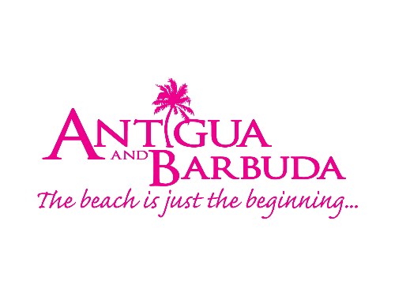

FOR IMMEDIATE RELEASE:

ANTIGUA & BARBUDA CELEBRATE LEGENDARY SAILING TRADITIONS AT THE HAMPTONS FESTIVAL & REGATTA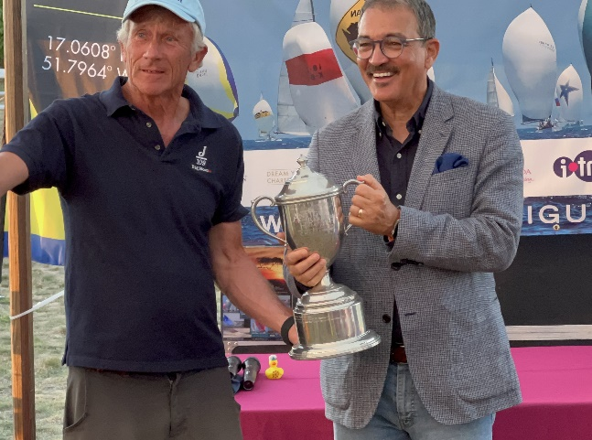 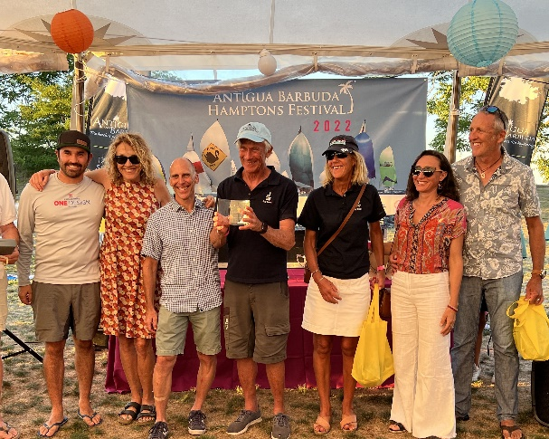
Photo Caption: Antigua and Barbuda’s Tourism Minister presents the grand prize of a trip to sail in Antigua Sailing Week 2023 to “Big Boat” Bud Rogers and Crew (Photos Courtesy Antigua and Barbuda Hamptons Challenge Regatta)

ST. JOHN’S, ANTIGUA (August 17, 2022) - The Antigua and Barbuda Tourism Authority (ABTA) showcased the beautiful twin-island destination in a series of events in The Hamptons, New York’s ritzy summer playground for the rich and famous.

Now in its twelfth year, the popular Antigua & Barbuda Hamptons Challenge Regatta was expanded this year to a four-day family festival. Hundreds of visitors were treated to steel pan music, a host of family-friendly activities such as face painting and costumed dancers, and delectable Antigua and Barbuda cuisine. 30 exhibitors attended the festival last week at the John Steinbeck Waterfront Park, Sag Harbor, including travel advisors who were promoting and selling the twin-islands to an affluent and receptive audience.

Antigua and Barbuda’s Minister of Tourism, the Hon. Charles “Max” Fernandez”, led the delegation from Antigua & Barbuda who travelled to The Hamptons to oversee and attend the series of events
Commenting on the festivities, Minister Fernandez said, “The Antigua & Barbuda Hamptons Challenge is one of the most eagerly anticipated events on our marketing calendar, which highlights our dominance as a premier sailing destination and promote the most important event on our calendar, Antigua Sailing Week. We are delighted to expand our outreach this year by extending the promotion to a four-day event, bringing greater awareness of our multi-faceted, twin-island destination to this key source market of affluent travellers.”

The highlight of the Festival was the Antigua & Barbuda Hamptons Challenge Regatta on Saturday, August 13th. Nineteen yachts competed in and around Noyack Bay in this handicapped race organized by the Peconic Bay Sailing Association. The winning team receives the biggest sailing prize in the Northeast, an all-expenses paid trip for the Captain and Crew to Antigua to race in the spectacular 2023 Antigua Sailing Week (www.sailingweek.com . The race was followed by a special Awards Cocktail Party at John Steinbeck Waterfront Park in Sag Harbor.

This year’s winner was “Big Boat” skippered by Bud Rogers with a time of 1:11:10. Rogers and his crew will travel to Antigua to participate in Antigua Sailing Week to be held from April 29 - May 5, 2023. Antigua and Barbuda’s Tourism Minister presented the Antigua and Barbuda top prize at the Awards Cocktail Party to Rogers and his crew.

Antigua and Barbuda prize partners included: Dream Yacht Charter, Falmouth Harbour Marina, Axxess Marine and Locman Italy

During his visit, Minister Fernandez paid a courtesy call on the Mayor of Sag Harbor, His Worship Mr. James Larocca, who presented him with a City Proclamation on behalf of the people of Sag Harbor, to honour and recognize the bonds of friendship that exist between their communities.

Minister Fernandez was also interviewed by the leading local newspaper, the Sag Harbor Express, and appeared on WLNG RADIO with celebrity host Bonnie Grice.

CEO of the Antigua and Barbuda Tourism Authority said, “We appreciate the tremendous support we receive each year from the Mayor, our Regatta founder and manager Theresa Roden, and the wider Sag Harbor community. This year we were delighted to partner with two of our own, the tremendously talented team of Tanya Willock and Temidra Willock-Morsch, owners of Hidden Gem boutique, alongside their mother Genevieve who is originally from Freetown. Thank you for contributing your invaluable time and sharing your well-heeled clientele with us to promote our wonderful country.”

Additional members of the Antigua & Barbuda delegation were Dean Fenton, Director of Tourism, ABTA USA; Marilyn Pires, ABTA USA, Noel Mignott, Founder & CEO of the PM Group, ABTA’s in-market agency.

For more information on Antigua and Barbuda visit here.

###

ABOUT THE ANTIGUA AND BARBUDA TOURISM AUTHORITY
The Antigua & Barbuda Tourism Authority is a statutory body dedicated to realizing the tourism potential of Antigua & Barbuda by promoting the twin island state as a unique, quality tourist destination with the overall objective of increasing visitor arrivals thereby providing sustainable economic growth. The Antigua and Barbuda Tourism Authority is headquartered in St. John’s Antigua, where regional marketing is directed. The Authority has three offices overseas in the United Kingdom, United States and Canada.

ABOUT ANTIGUA AND BARBUDA
Antigua (pronounced An-tee'ga) and Barbuda (Bar-byew’da) is located in the heart of the Caribbean Sea. The twin-island paradise offers visitors two uniquely distinct experiences, ideal temperatures year-round, a rich history, vibrant culture, exhilarating excursions, award-winning resorts, mouth-watering cuisine and 365 stunning pink and white-sand beaches - one for every day of the year. The largest of the English-speaking Leeward Islands, Antigua comprises 108-square miles with rich history and spectacular topography that provides a variety of popular sightseeing opportunities. Nelson’s Dockyard, the only remaining example of a Georgian fort a listed UNESCO World Heritage site, is perhaps the most renowned landmark. Antigua’s tourism events calendar includes the prestigious Antigua Sailing Week, Antigua Classic Yacht Regatta, and the annual Antigua Carnival; known as the Caribbean’s Greatest Summer Festival. Barbuda, Antigua’s smaller sister island, is the ultimate celebrity hideaway. The island lies 27 miles north-east of Antigua and is just a 15-minute plane ride away. Barbuda is known for its untouched 11-mile stretch of pink sand beach and as the home of the largest Frigate Bird Sanctuary in the Western Hemisphere. Find information on Antigua & Barbuda at: www.visitantiguabarbuda.com or follow us on Twitter: http://twitter.com/antiguabarbuda Facebook: www.facebook.com/antiguabarbuda; Instagram: www.instagram.com/AntiguaandBarbuda

For Antigua and Barbuda media enquiries, please contact:
Maria Blackman
Marketing Communications Manager
Antigua and Barbuda Tourism Authority
T: 1 (268) 562 7600/464-7601
E: maria.blackman@visitaandb.com
Antigua and Barbuda Images: aandbtourism.fotoseeker.com

ADDITIONAL IMAGES:

Antigua & Barbuda Hamptons Festival & Regatta Opening Reception (Photos provided by James Lane)

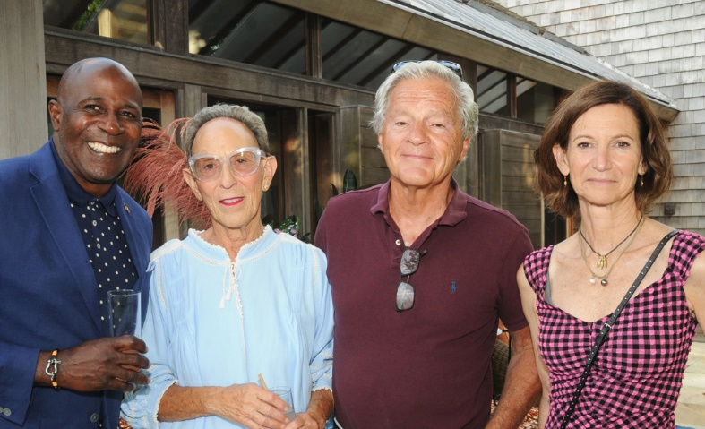
Dean Fenton, Dale Larocca, Mayor James Larocca, Toni Ross. Photo by Richard Lewin

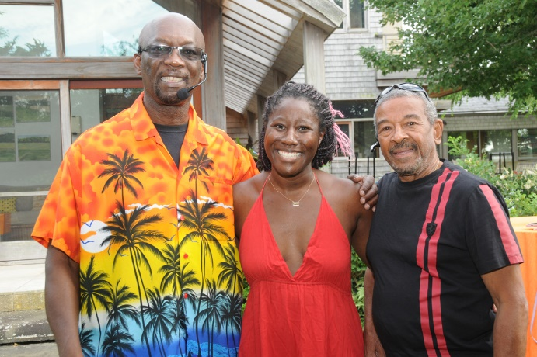
Conroy Warren, Temidra Willock, Patrick Gomes. Photo by Richard Lewin
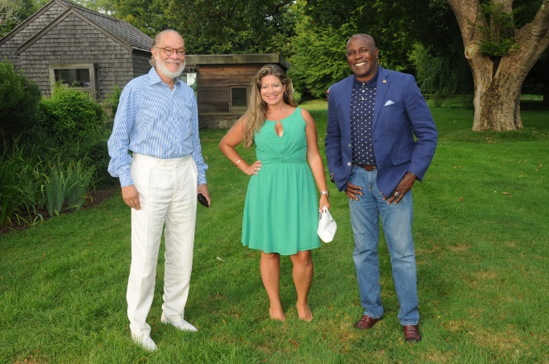

The Antigua and Barbuda Tourism Authority’s US Team at the reception included: Noel Mignott, Marilyn Pires, Dean Fenton. Photo by Richard Lewin

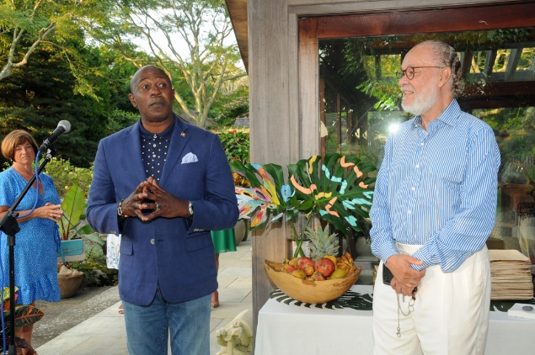
Photo by Richard Lewin
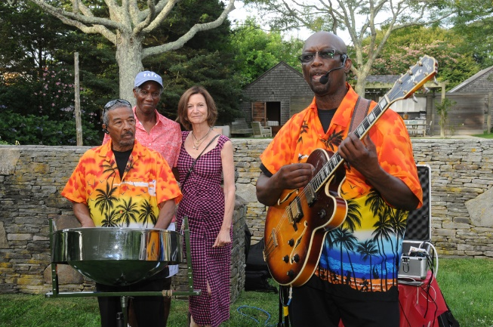
Photo by Richard Lewin

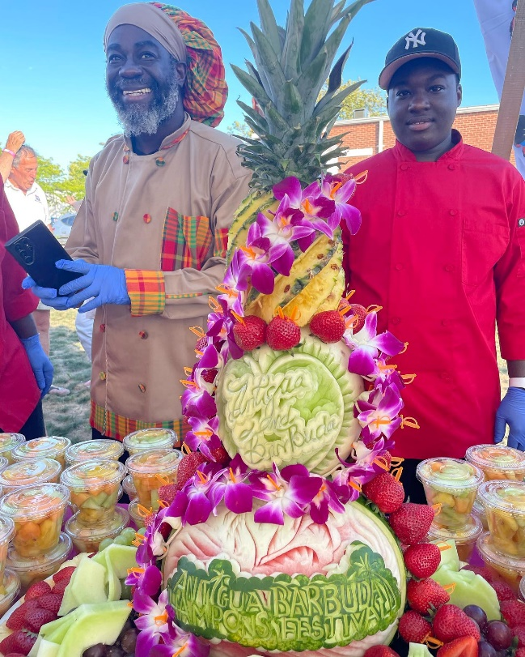
Lauded Executive Chef Melvin Myers of Antigua and Barbuda displayed his culinary carvings in The Hamptons

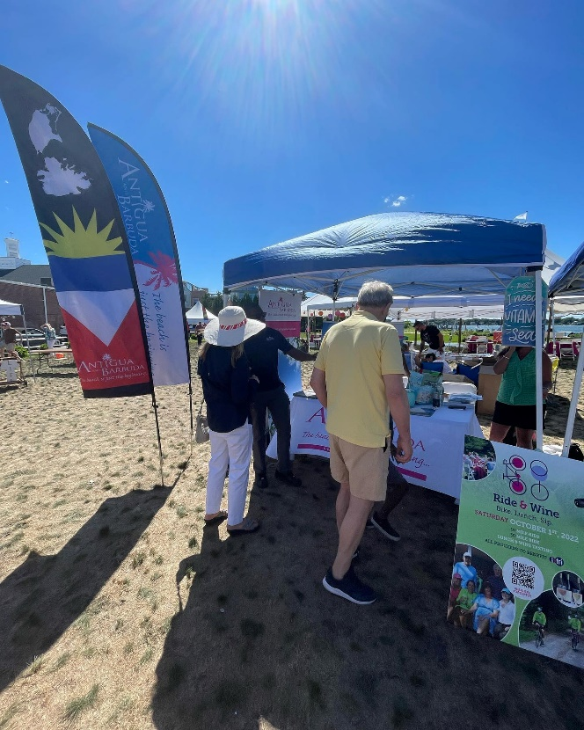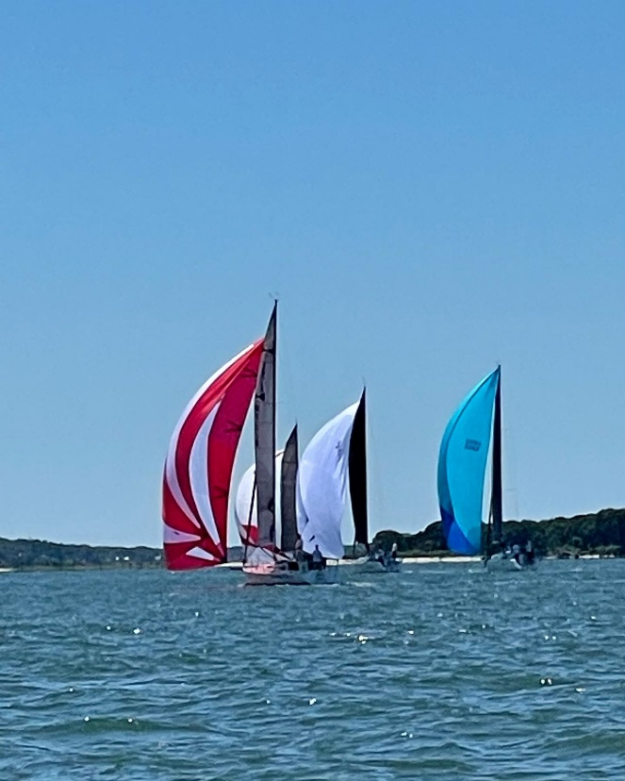
Scenes from the Antigua and Barbuda Hamptons Festival and Regatta

