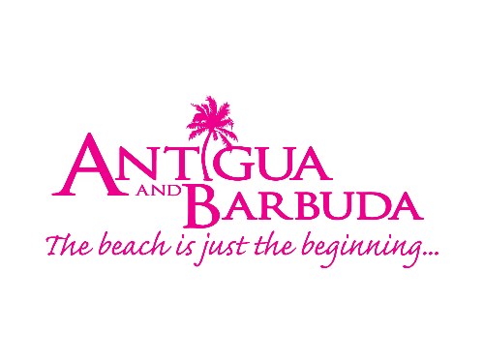
FOR IMMEDIATE RELEASE:

Antigua and Barbuda Tourism Authority Launches Global Summer Campaign

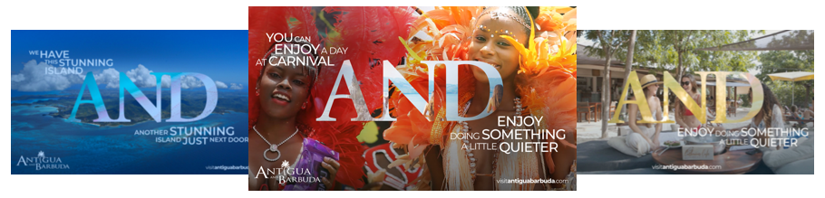

Photo Caption: The Antigua and Barbuda Tourism Authority yesterday launched its global summer advertising campaign. The ‘AND’ theme highlights the luxury and authenticity of this twin island nation (Photo Courtesy: The Antigua and Barbuda Tourism Authority)

ST. JOHN’S, ANTIGUA (June 28, 2022) - The Antigua and Barbuda Tourism Authority yesterday launched its global summer advertising campaign which highlights the luxury and authenticity of the destination. The twin island nation is looking to capture consumer hearts and minds in what is predicted to be a competitive market as consumer become more discerning and value conscious with their vacation spending.

Each facet of the campaign images focuses on the word ‘AND’ to highlight the breadth and depth of the authentic travel experiences available on Antigua and Barbuda, as well as reinforce and reflect the strength of the product offering as a two-island nation.

Commenting on the campaign, Charles Fernandez, Minister of Tourism for Antigua and Barbuda says, “It was vital for us to launch a campaign for the summer which communicates our unique offering as a holiday experience and so we are delighted that this is reflected in the look and feel of our new digital and social advertising imagery.

It has all been carefully curated so that the consumer can be in no doubt that Antigua and Barbuda offers the perfect combination of luxury and value - experiences which create priceless memories within a relaxing and authentic environment.”

Every digital and social media asset of the campaign is set around four main image themes designed to illustrate the range of experiences available on Antigua and Barbuda. They are: ‘Enjoy Carnival’, ‘Stunning Islands’, ‘Gorgeous Beaches’ and ‘Gourmet Seafood’.
CEO of the Antigua and Barbuda Tourism Authority added “The campaign shows how much Antigua and Barbuda has to offer as a destination in a totally ownable and memorable way. The answer was in the name - and the logo. The ‘AND’ provides us with a vehicle to showcase the islands' many sides - and say 'why compromise when you can have everything?"
The campaign will be delivering millions of digital impressions, across the various source markets and is designed to reflect all that Antigua and Barbuda has to offer in a distinctive and memorable way. The modern traveler is looking for luxury as well as authenticity and luckily on Antigua and Barbuda, they don’t have to make a choice as they can have it all!

For imagery, click here and view the video assets here.

For more information on Antigua and Barbuda visit here.

###

ABOUT THE ANTIGUA AND BARBUDA TOURISM AUTHORITY
The Antigua & Barbuda Tourism Authority is a statutory body dedicated to realizing the tourism potential of Antigua & Barbuda by promoting the twin island state as a unique, quality tourist destination with the overall objective of increasing visitor arrivals thereby providing sustainable economic growth. The Antigua and Barbuda Tourism Authority is headquartered in St. John’s Antigua, where regional marketing is directed. The Authority has three offices overseas in the United Kingdom, United States and Canada.

ABOUT ANTIGUA AND BARBUDA
Antigua (pronounced An-tee'ga) and Barbuda (Bar-byew’da) is located in the heart of the Caribbean Sea. The twin-island paradise offers visitors two uniquely distinct experiences, ideal temperatures year-round, a rich history, vibrant culture, exhilarating excursions, award-winning resorts, mouth-watering cuisine and 365 stunning pink and white-sand beaches - one for every day of the year. The largest of the English-speaking Leeward Islands, Antigua comprises 108-square miles with rich history and spectacular topography that provides a variety of popular sightseeing opportunities. Nelson’s Dockyard, the only remaining example of a Georgian fort a listed UNESCO World Heritage site, is perhaps the most renowned landmark. Antigua’s tourism events calendar includes the prestigious Antigua Sailing Week, Antigua Classic Yacht Regatta, and the annual Antigua Carnival; known as the Caribbean’s Greatest Summer Festival. Barbuda, Antigua’s smaller sister island, is the ultimate celebrity hideaway. The island lies 27 miles north-east of Antigua and is just a 15-minute plane ride away. Barbuda is known for its untouched 11-mile stretch of pink sand beach and as the home of the largest Frigate Bird Sanctuary in the Western Hemisphere. Find information on Antigua & Barbuda at: www.visitantiguabarbuda.com or follow us on Twitter: http://twitter.com/antiguabarbuda Facebook: www.facebook.com/antiguabarbuda; Instagram: www.instagram.com/AntiguaandBarbuda

For Antigua and Barbuda media enquiries, please contact:
Maria Blackman
Marketing Communications Manager
Antigua and Barbuda Tourism Authority
T: 1 (268) 562 7600/464-7601
E: maria.blackman@visitaandb.com

Antigua and Barbuda Images: aandbtourism.fotoseeker.com

