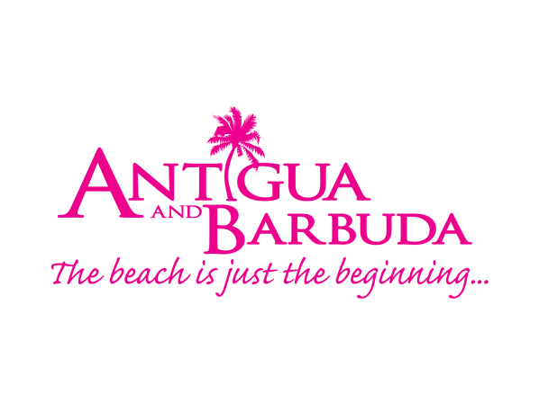
FOR IMMEDIATE RELEASE:
ANTIGUA AND BARBUDA TOURISM AUTHORITY PLANS NEW MARKETING STRATEGY
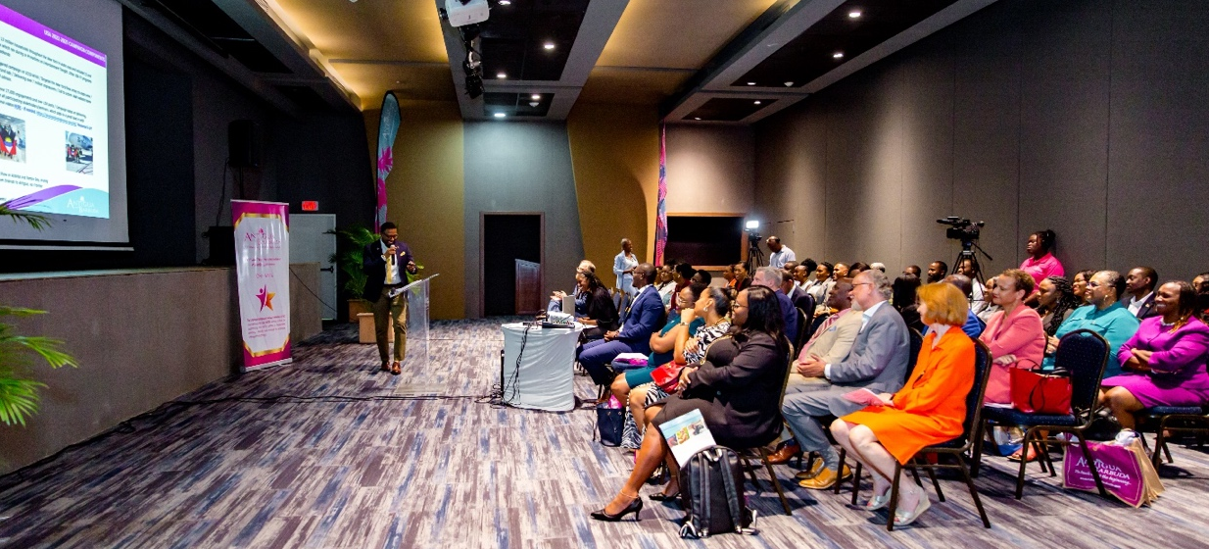
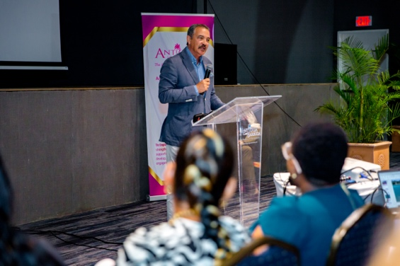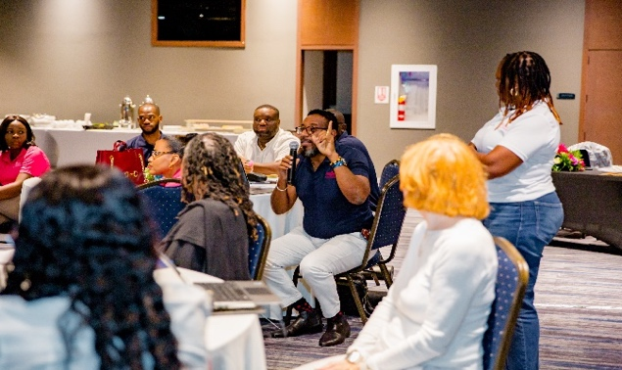
Photo Caption: Antigua and Barbuda Tourism Authority to deliver a marketing plan that will further growth and revenues in tourism following marketing strategy meetings (Photos credit: The Antigua and Barbuda Tourism Authority)
ST. JOHN’S, ANTIGUA – (October 7, 2022) The Antigua and Barbuda Tourism Authority (ABTA) has now wrapped up a series of strategy meetings as marketing teams all gathered in Antigua for face-to-face meetings - the first since covid-19 - to discuss the future of marketing for the destination.
The ABTA Board, CEO, and Directors with responsibility for the United States, United Kingdom & Europe, Canada, Latin America & The Caribbean, alongside their teams, were locked into sessions where they reviewed key elements of the Antigua and Barbuda Tourism Authority brand and marketing strategy.
Antigua and Barbuda’s Minister of Tourism and Investment, The Honourable Charles Fernandez told the teams ahead of the meetings to bear in mind that the “Vision 2032 plan published by the Ministry of Tourism will only be achieved if we succeed in creating economic value for locals and residents through maximum linkages”.
The meetings take place at a time when Antigua and Barbuda’s tourism stay-over arrival numbers have surpassed pre-pandemic levels. July, August, and September 2022 tourism arrivals have outperformed those of 2019, previously considered the best summer ever for the destination. In August 2022, the destination welcomed 20,125 at the V.C. Bird International Airport. This is 2472 more persons than in benchmark year, 2019 when arrivals stood at 17,653. The August 2022 stayover tourism arrivals have also exceeded those of August 2021 when Antigua and Barbuda received 18,792 visitors.
Antigua and Barbuda Tourism Authority’s Chairman, Dr. Lorraine Raeburn, declared to teams at the start of the meeting that, “Now is the time to review, re-evaluate and make sure we are aligned to the new traveller and the rapidly changing industry.
In an appeal for collaborative partnerships across the industry, the ABTA Chairman is “also galvanizing the support and energy of all stakeholders, anticipating that our revitalized vision inspires you to join us on this journey.”
Antigua and Barbuda Tourism Authority’s CEO, Colin C. James summarized the approach of this year’s strategy meeting saying, “At this stage of our growth, as we look towards elevating our product, marketing and economic impact, collaboration is key. We engaged stakeholders prior to our team sessions, and for the first time brought the entire ABTA team, those working internationally and locally together, for a bottom-up approach to planning.
We are pooling all creative talents and skills to ensure Antigua and Barbuda has the best possible strategy in place to build on the momentum that we have and finish this year strong, but most importantly continue our growth into 2023”, said James.
A two-year marketing plan will rollout following the marketing meetings. Top of mind for the tourism market teams will be growing visitor arrivals by cruise, yachting, and air to maintain the current growth being experienced. The Antigua and Barbuda Tourism Authority also intends to leverage the destination’s strengths, to position and market Antigua and Barbuda, as a year-round destination. Emphasis is being placed on the further development of the destination’s marketing pillars Romance, Yachting and Sailing, Heritage and Culture, and Wellness to achieve this.
The ABTA CEO said, “Our vision aligns with the Vision 2032 presented by the Ministry of Tourism. It is to grow our numbers, grow the revenues that this country receives from tourism, ensure that more revenue is left in Antigua and Barbuda, for services that our visitors will enjoy while they are here and ultimately ensure Antiguans and Barbudans have a better standard of living, a better lifestyle, and we do so in a sustainable manner.”
The Antigua and Barbuda Tourism Authority also used the strategy meeting to celebrate the hard work of the teams with a Peer Appreciation Awards and Luncheon.
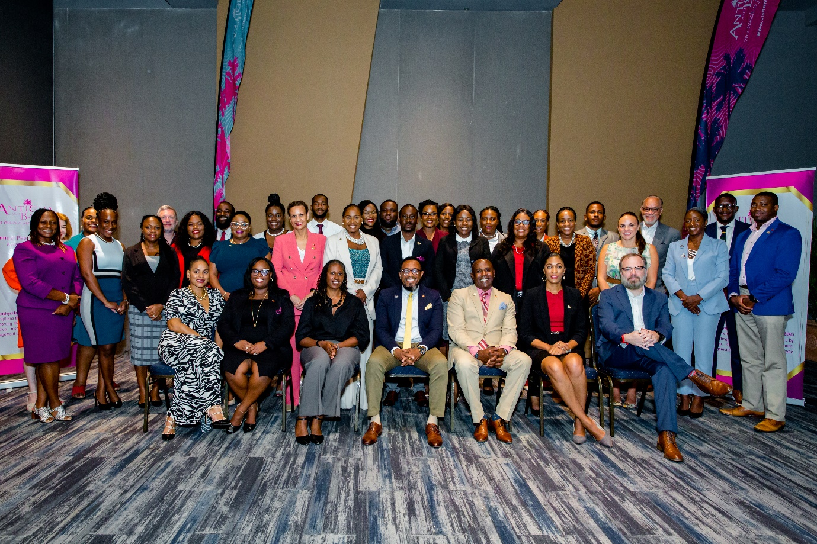
Photo Caption: The Antigua and Barbuda Tourism Authority marketing strategy meeting gathered teams from all source markets for peer appreciation awards and strategy meeting sessions led by facilitator Mr. Patrick King CEO of Imagine, a brand strategy and destination marketing agency. (Photo courtesy, The Antigua and Barbuda Tourism Authority)
###

ABOUT THE ANTIGUA AND BARBUDA TOURISM AUTHORITY
The Antigua & Barbuda Tourism Authority is a statutory body dedicated to realizing the tourism potential of Antigua & Barbuda by promoting the twin island state as a unique, quality tourist destination with the overall objective of increasing visitor arrivals thereby providing sustainable economic growth. The Antigua and Barbuda Tourism Authority is headquartered in St. John’s Antigua, where regional marketing is directed. The Authority has three offices overseas in the United Kingdom, United States and Canada.

ABOUT ANTIGUA AND BARBUDA
Antigua (pronounced An-tee'ga) and Barbuda (Bar-byew’da) is located in the heart of the Caribbean Sea. The twin-island paradise offers visitors two uniquely distinct experiences, ideal temperatures year-round, a rich history, vibrant culture, exhilarating excursions, award-winning resorts, mouth-watering cuisine and 365 stunning pink and white-sand beaches - one for every day of the year. The largest of the English-speaking Leeward Islands, Antigua comprises 108-square miles with rich history and spectacular topography that provides a variety of popular sightseeing opportunities. Nelson’s Dockyard, the only remaining example of a Georgian fort a listed UNESCO World Heritage site, is perhaps the most renowned landmark. Antigua’s tourism events calendar includes the prestigious Antigua Sailing Week, Antigua Classic Yacht Regatta, and the annual Antigua Carnival; known as the Caribbean’s Greatest Summer Festival. Barbuda, Antigua’s smaller sister island, is the ultimate celebrity hideaway. The island lies 27 miles north-east of Antigua and is just a 15-minute plane ride away. Barbuda is known for its untouched 11-mile stretch of pink sand beach and as the home of the largest Frigate Bird Sanctuary in the Western Hemisphere.

Find information on Antigua & Barbuda at: www.visitantiguabarbuda.com or follow us on Twitter: http://twitter.com/antiguabarbuda Facebook: www.facebook.com/antiguabarbuda; Instagram: www.instagram.com/AntiguaandBarbuda

For Antigua and Barbuda media enquiries, please contact:
Maria Blackman
Marketing Communications Manager
Antigua and Barbuda Tourism Authority
T: 1 (268) 562 7600/464-7601
E: maria.blackman@visitaandb.com

Kayla Christian
Tourism Marketing Officer
Antigua and Barbuda Tourism Authority
T: 1 (268) 562 7600
E: kayla.christian@visitaandb.com

Antigua and Barbuda Images: aandbtourism.fotoseeker.com

