FOR IMMEDIATE RELEASE:

Antigua and Barbuda Hosts Successful Tourism Stakeholder Engagement Meeting
With the relaxation of entry requirements hoteliers are readying for a spectacular summer season

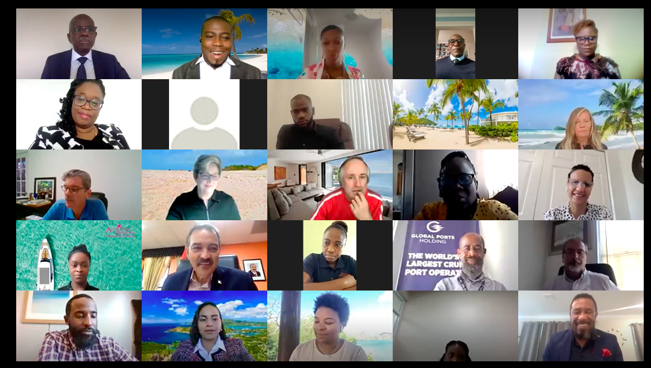
St. Johns, Antigua (April 14, 2022) - Over 80 local and global tourism industry partners participated via the Zoom platform as the Antigua and Barbuda Tourism Authority (ABTA) convened their quarterly state of the industry update. Led by the ABTA CEO Colin James with the Chairman of the Board of Directors, Dr. Lorraine Raeburn and Minister of Tourism and Investment, The Honourable Charles ‘Max’ Fernandez in attendance, it was welcomed news as hoteliers shared that at this time, most are fully booked.
CEO James gave opening welcome remarks and told the participants of the success of the ABTA’s recent activation in Dubai and spoke of the first ever stand-alone advertising campaign for Barbuda.
The Country’s Tourism Minister, The Hon. Charles ‘Max’ Fernandez thanked the tourism partners for their ongoing partnership and congratulated the entire ABTA team for their sterling service throughout the pandemic. The Minister shared the good news that fully vaccinated passengers are not required to test prior to arrival and very soon unvaccinated passengers will shortly be able to visit with a PCR or Antigen test done 4 days prior to arrival. He also made mention of the many strides the destination is enjoying with increased airlift from all markets and a bigger interest in investment opportunities for the hotel, yachting, and cruise sectors.
The meeting’s overall objective was to reinforce the importance of public/private sector collaboration and to ensure vital details were shared on the destination’s sales and marketing, human resource development, product enhancement, air service plans and upcoming activities. The meeting drew participants from a range of tourism-related industries, including the Executive Director of the Antigua Barbuda Hotels and Tourism Association (ABHTA), Patrice Simon. She highlighted the successes the destination is experiencing in higher occupancy levels. In March 2022, when compared to the same period pre-pandemic in 2019, Antigua and Barbuda recorded a 74.6% occupancy across the sector. Simon remarked that the increase in visitor arrivals augurs well and is further proof of the industry’s recovery. She shared that there were important aspects of employee and customer service training carried out by the ABHTA in 2021 and 2022 and these programs will be ongoing.
The ABTA’s Regional Directors made presentations on their respective regions, updating the audience on in-market activations, and sharing initiatives that will be unrolled throughout the year. Regional Directors Dean Fenton in the United States of America, Tameka Wharton in Canada, Cherrie Osborne in the UK & Europe, and Charmain Spencer for the Caribbean/Latin America spoke on their respective markets.
Among the highlights the Directors shared were the Antigua and Barbuda Hamptons Challenge Regatta that will be staged in Sag Harbour, New York and the Holidaying with Jane McDonald a television broadcast on Antigua and Barbuda that will air in the UK. With Antigua Sailing Week and Showcase Antigua and Barbuda being staged in Antigua in the weeks ahead, the consensus among the gathering was that tourism to the destination is on a steady rebound and the destination is well poised to take advantage of the surge in demand for travel in the ensuing months of 2022.
###
For Antigua and Barbuda media enquiries, please contact:
Maria Blackman
Antigua and Barbuda Tourism Authority
T: 1 (268) 562 7600/464-7601
E: maria.blackman@visitaandb.com

ABOUT ANTIGUA AND BARBUDA:
Antigua (pronounced An-tee'ga) and Barbuda (Bar-byew’da) is located in the heart of the Caribbean Sea. The twin-island paradise offers visitors two uniquely distinct experiences, ideal temperatures year-round, a rich history, vibrant culture, exhilarating excursions, award-winning resorts, mouth-watering cuisine and 365 stunning pink and white-sand beaches - one for every day of the year. The largest of the English-speaking Leeward Islands, Antigua comprises 108-square miles with rich history and spectacular topography that provides a variety of popular sightseeing opportunities. Nelson’s Dockyard, the only remaining example of a Georgian fort, a listed UNESCO World Heritage site, is perhaps the most renowned landmark. Antigua’s tourism events calendar includes the prestigious Antigua Sailing Week, Antigua Classic Yacht Regatta, and the annual Antigua Carnival; known as the Caribbean’s Greatest Summer Festival. Barbuda, Antigua’s smaller sister island, is the ultimate celebrity hideaway. The island lies 27 miles north-east of Antigua and is just a 15-minute plane ride away. Barbuda is known for its untouched 11-mile stretch of pink sand beach and as the home of the largest Frigate Bird Sanctuary in the Western Hemisphere. Find information on Antigua & Barbuda at: www.visitantiguabarbuda.com

