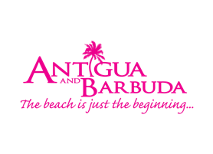

**ANTIGUA AND BARBUDA LAUNCHES**

**ULTIMATE ‘YOUR SPACE IN THE SUN’ SWEEPSTAKES**

***INVITES VISITORS TO ESCAPE TO THE SPACE THEY DESERVE***

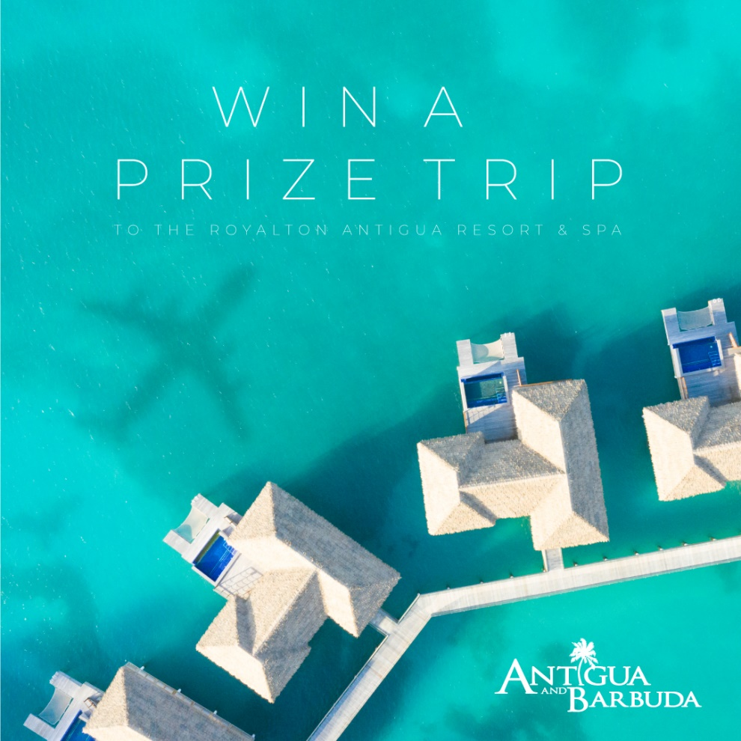

**(ST. JOHN’S ANTIGUA) NOVEMBER 29, 2020** – The Antigua and Barbuda Tourism Authority is delivering joy to wanderlust travellers during the holiday season, by providing them with the chance to win the escape they deserve in Antigua and Barbuda for 2021.

For travellers looking forward to a bit more space, and a change of scenery in the new year, Antigua and Barbuda is your space in the sun. With 365 beaches, airy beach side resorts that welcome the Caribbean breeze, and lots of wide-open spaces, the twin-island paradise is perfect for distancing.

The ‘Your Space in the Sun’ Sweepstakes offers a prize of free airfare for two and four nights stay in an amazing Diamond Club suite at the all-inclusive, luxurious [Royalton Resort](https://www.royaltonresorts.com/royalton-antigua) in beautiful Antigua. The sweepstakes officially launched at the resort on November 29. The exquisite resort reopened with a fanfare and Royalton safety-assured protocols in place the day of the sweepstakes launch, after closing in March when the coronavirus pandemic started.

The online holiday sweepstakes is open to persons over 18, residing in the United States of America, The United Kingdom, Canada and the Caribbean. To enter go to [visitantiguabarbuda.com](http://www.visitantiguabarbuda.com). Only one entry is allowed. The sweepstakes will run until 11:59 p.m. on December 31, 2020. The winner will be chosen randomly.

The Antigua and Barbuda Tourism Authority and Royalton Antigua Resort and Spa will take potential travellers on a virtual journey through the fascinating destination and Royalton’s All-In luxury vacation experience, as a series of activities continue during the sweepstake launch week. Activities include a twitter chat on December 1 focused on the destination experience and safety protocols. The following day on a virtual island tour, travellers explore the UNESCO World Heritage Site at Nelson’s Dockyard and make other notable stops before a check-in to the stunning Diamond Club suite at the Royalton Resort. And finally, the cocktail happy hour party on December 4 at Royalton, will showcase a masterful mixologist creating delicious speciality cocktails featuring the English Harbour Rum.

The twitter chat takes place with [@AntiguaBarbuda](https://twitter.com/Antiguabarbuda) on Twitter, while all other activities will air live on Facebook with [@AntiguaBarbudaTourism](https://www.facebook.com/AntiguaBarbuda) and on Zoom. Register to join the zoom events: [**Live & Direct from Antigua & Barbuda – The Virtual Tour**](https://zoom.us/webinar/register/WN_n8hgcPWJRZq0DO4f_LI1og) **and**[**The Virtual Cocktail Party**](https://zoom.us/webinar/register/WN_-e1d6MDmTC6-bzJdGMCbsA) by clicking the online link or emailing the Antigua and Barbuda Tourism Authority at: [info@visitaandb.com](mailto:info@visitaandb.com)

For details of Antigua and Barbuda’s covid-19 health and safety protocols for the tourism sector, go to: [visitantiguabarbuda.com](http://www.visitantiguabarbuda.com). Over four thousand tourism stakeholders have been trained and certified in the destination’s covid-19 protocols, close to 450 certified accommodations are now on offer, and there are a range of certified restaurants and excursions open for business.

Visitors are welcomed to participate in Antigua and Barbuda’s 2021 events, with lots of great experiences that allow for physical distancing. These include the Jolly Harbour Valentine’s Regatta in February, AUA Rohrman Triathlon in March, the Antigua and Barbuda International Kite Festival and Antigua Sailing Week in April, and the Sports-fishing Tournament and Run in Paradise in May. For details of events taking place from January – July in Antigua and Barbuda go to:[visitantiguabarbuda.com](http://www.visitantiguabarbuda.com/)

###

**ABOUT THE ANTIGUA AND BARBUDA TOURISM AUTHORITY**

The Antigua & Barbuda Tourism Authority is a statutory body dedicated to realizing the tourism potential of Antigua & Barbuda by promoting the twin island state as a unique, quality tourist destination with the overall objective of increasing visitor arrivals thereby providing sustainable economic growth. The Antigua and Barbuda Tourism Authority is headquartered in St. John’s Antigua, where regional marketing is directed. The Authority has three offices overseas in the United Kingdom, United States and Canada.

**ABOUT ANTIGUA AND BARBUDA**

Antigua (pronounced An-tee'ga) and Barbuda (Bar-byew’da) is located in the heart of the Caribbean Sea. Voted the World Travel Awards 2015, 2016, 2017 *and 2018* *Caribbean’s Most Romantic Destination*, the twin-island paradise offers visitors two uniquely distinct experiences, ideal temperatures year-round, a rich history, vibrant culture, exhilarating excursions, award-winning resorts, mouth-watering cuisine and 365 stunning pink and white-sand beaches - one for every day of the year. The largest of the Leeward Islands, Antigua comprises 108-square miles with rich history and spectacular topography that provides a variety of popular sightseeing opportunities. Nelson’s Dockyard, the only remaining example of a Georgian fort a listed UNESCO World Heritage site, is perhaps the most renowned landmark. Antigua’s tourism events calendar includes the prestigious Antigua Sailing Week, Antigua Classic Yacht Regatta, and the annual Antigua Carnival; known as the Caribbean’s Greatest Summer Festival. Barbuda, Antigua’s smaller sister island, is the ultimate celebrity hideaway. The island lies 27 miles north-east of Antigua and is just a 15-minute plane ride away. Barbuda is known for its untouched 17 mile stretch of pink sand beach and as the home of the largest Frigate Bird Sanctuary in the Western Hemisphere.  Find information on Antigua & Barbuda at: [www.visitantiguabarbuda.com](http://www.visitantiguabarbuda.com) or follow us on **Twitter**. <http://twitter.com/antiguabarbuda>  **Facebook** [www.facebook.com/antiguabarbuda](http://www.facebook.com/antiguabarbuda); **Instagram**: [www.instagram.com/AntiguaandBarbuda](http://www.instagram.com/AntiguaandBarbuda)

**For media enquiries, please contact:**Maria Blackman  
Antigua and Barbuda Tourism Authority

T: 1 (268) 562 7600/464-7601  
E: [maria.blackman@visitaandb.com](mailto:maria.blackman@visitaandb.com)