Antigua & Barbuda Tourism Authority partners with Traverse for Second Global Influencer Conference

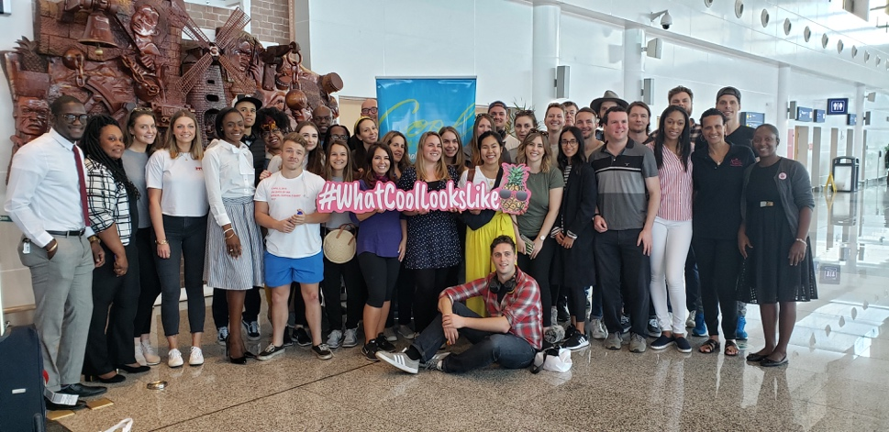

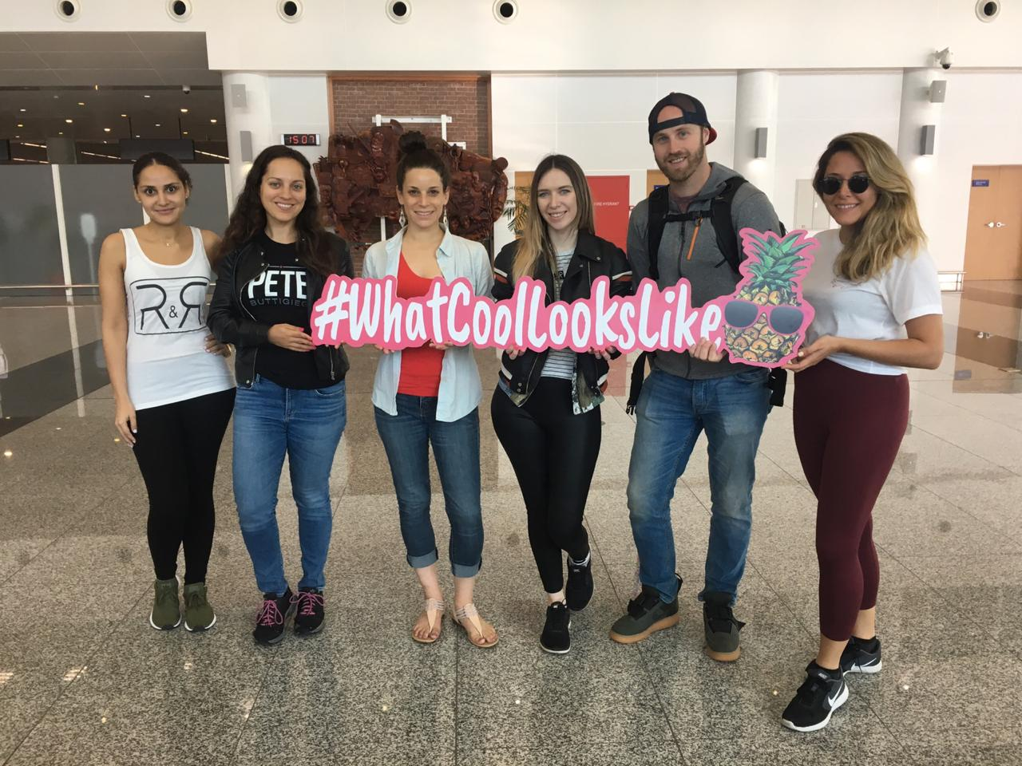

May 7 2019, (St. John's Antigua) - The Antigua & Barbuda Tourism Authority has partnered with influencer specialist Traverse for the second year running on the Caribbean’s largest influencer conference. Taking place from 7th – 14th May, this year’s conference will build upon the success of 2018. Antigua will welcome over 30 influencers from the UK, Europe, US, Canada and other areas of the Caribbean for a week of interactive workshops, events and island exploration. The conference will have an overarching theme of everyone’s a teacher with some influencers leading workshops sessions for other attendees.

For the conference, the term ‘influencer’ will encompass bloggers, YouTubers, Instagrammers and professional photographers, all with high engagement and interaction in their market. The goal is to create a social buzz around Antigua and what the island offers visitors and drive summer 2019 bookings to support the recently launched ‘What Cool Looks Like’ summer campaign.

The Tourism Authority has partnered with Elite Island Resorts once again, with influencers staying at Verandah Resort and Spa with the opportunity to experience both Pineapple Beach Club and St James’s Club throughout the week.

Over the week, there will be 14 workshop sessions with speakers from the UK and Europe. The speakers will host inspiring talks and interactive workshops on how the influencers can improve their writing, develop filming and photography skills and much more. There will also be plenty of time to explore the island including learning to sail with the National Sailing Academy, hike Wallings Nature Reserve, partying at Shirley Heights on Thursday night and watching the sunset during the closing party cruise.

For more information on Antigua visit www.visitantiguabarbuda.com. For more details on Traverse visit www.traverse-events.com.

###
For media enquiries, please contact:
Maria Blackman
Antigua and Barbuda Tourism Authority
T: 1 (268) 562 7600/464-7601
E: maria.blackman@aandbtourism.com

NOTE TO EDITORS:

STATS FROM 2018 Conference:
- 2,790 tweets
- 200 Instagram post
- 1,400 Instagram stories
- 43 Facebook posts
- 22 blog posts
- 15 YouTube videos
- Total follower count was an incredible 5,054,026.

For the 2019 CONFERENCE
- The conference is made up of bloggers and influencers from UK, Germany, Italy, USA, Canada and the Caribbean
- 33 content creators
- Between 23 YouTube accounts, there is a total of 471,110 YouTube subscribers and a Total Views of 52.1M.
- There is a total 1.3M of Instagram followers between all of the accounts
- We are welcoming back Deja Shu for her second influencer conference
- We have Tommy Clarke**** aerial photographer and influencer in attendance
- Over the week, there will be 14 workshop sessions with speakers from the UK and Europe.

