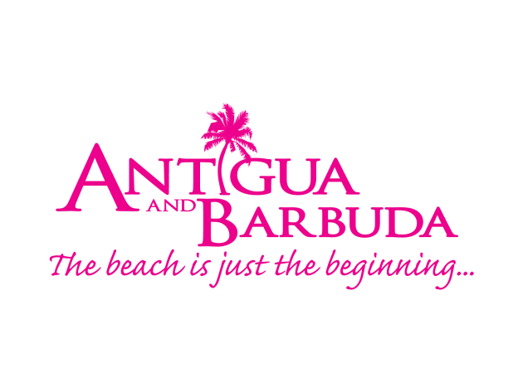

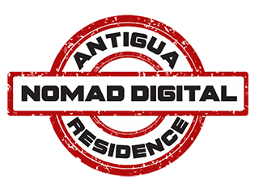

FOR IMMEDIATE RELEASE:

WORK EASILY FROM ANTIGUA AND BARBUDA WITH NEW ‘NOMAD DIGITAL RESIDENCE’ PROGRAMME

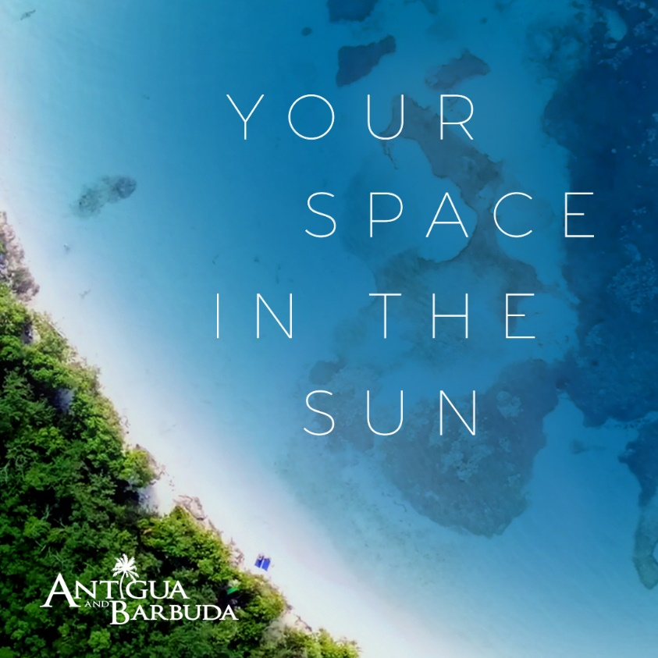

ST. JOHN’S, ANTIGUA (30 September, 2020) – The Caribbean country of Antigua and Barbuda is providing much needed space for workers throughout the world, with the launch of its Nomad Digital Residence (NDR) Programme, that allows persons to work safely and with ease from the twin-island paradise for as long as two years with the new NDR visa.

Announced by Antigua and Barbuda’s Prime Minister, The Honourable Gaston Browne, the Nomad Digital Residence programme is designed to attract persons who can meet the requirements of their employers or their clients, while working remotely.

Under the programme, eligible persons can live and move freely throughout Antigua and Barbuda for up to two years, and benefit from Antigua and Barbuda’s no personal income tax status.

“Antigua and Barbuda is in a unique position to offer the ‘Nomad Digital Residence’ programme. Our very small number of Covid-19 cases and our effective system of containing community spread, makes our country one of the safest environments in the world”, said Prime Minister Gaston Browne.

Antigua and Barbuda’s Minister of Tourism, The Honourable Charles Fernandez said, “Antigua and Barbuda represent the perfect place to escape, and enjoy all the space you need – space to move, space to think and space to work. The Nomad Digital Residence Programme encourages persons to broaden their horizons and consider Antigua & Barbuda when thinking of work from home options.”

The country’s telecommunication system, linked seamlessly to the rest of the world, places it in an advantageous position to attract persons seeking a safe environment in which to work and live their lives.

For more information on the Nomad Digital Residence Programme, go to www.antiguanomadresidence.com/

Persons entering Antigua and Barbuda on the NDR programme will be required to comply with all of Antigua and Barbuda’s protocols regarding COVID-19 which can be viewed on www.visitantiguabarbuda.com

###
ABOUT ANTIGUA AND BARBUDA
Antigua (pronounced An-tee'ga) and Barbuda (Bar-byew’da) is located in the heart of the Caribbean Sea. Voted the World Travel Awards 2015, 2016, 2017 and 2018 Caribbean’s Most Romantic Destination, the twin-island paradise offers visitors two uniquely distinct experiences, ideal temperatures year-round, a rich history, vibrant culture, exhilarating excursions, award-winning resorts, mouth-watering cuisine and 365 stunning pink and white-sand beaches - one for every day of the year. The largest of the Leeward Islands, Antigua comprises 108-square miles with rich history and spectacular topography that provides a variety of popular sightseeing opportunities. Nelson’s Dockyard, the only remaining example of a Georgian fort a listed UNESCO World Heritage site, is perhaps the most renowned landmark. Antigua’s tourism events calendar includes the prestigious Antigua Sailing Week, Antigua Classic Yacht Regatta, and the annual Antigua Carnival; known as the Caribbean’s Greatest Summer Festival. Barbuda, Antigua’s smaller sister island, is the ultimate celebrity hideaway. The island lies 27 miles north-east of Antigua and is just a 15-minute plane ride away. Barbuda is known for its untouched 17 mile stretch of pink sand beach and as the home of the largest Frigate Bird Sanctuary in the Western Hemisphere. Find information on Antigua & Barbuda at: www.visitantiguabarbuda.com or follow us on Twitter. http://twitter.com/antiguabarbuda Facebook www.facebook.com/antiguabarbuda; Instagram: www.instagram.com/AntiguaandBarbuda

