FOR IMMEDIATE RELEASE:
ANTIGUA AND BARBUDA TOURISM STAKEHOLDERS EXCITED AS
WEST JET RETURNS
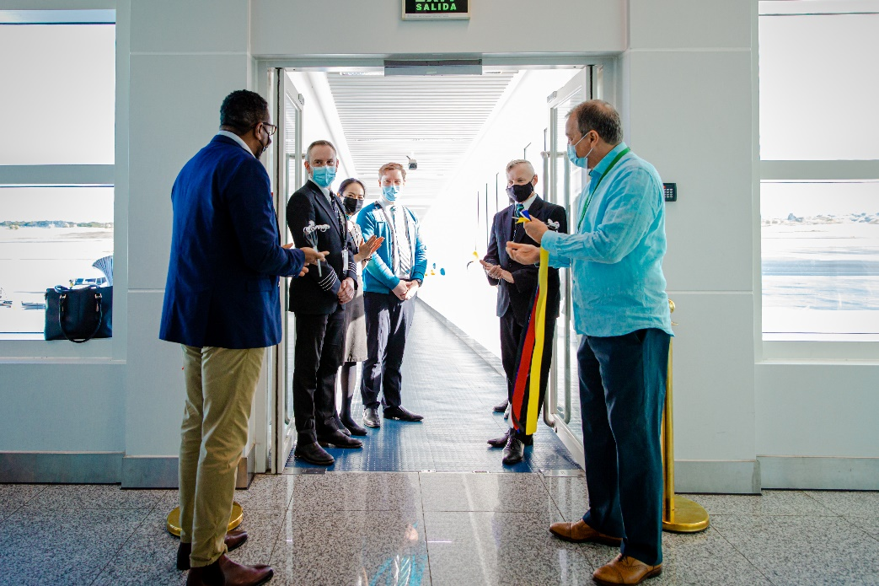
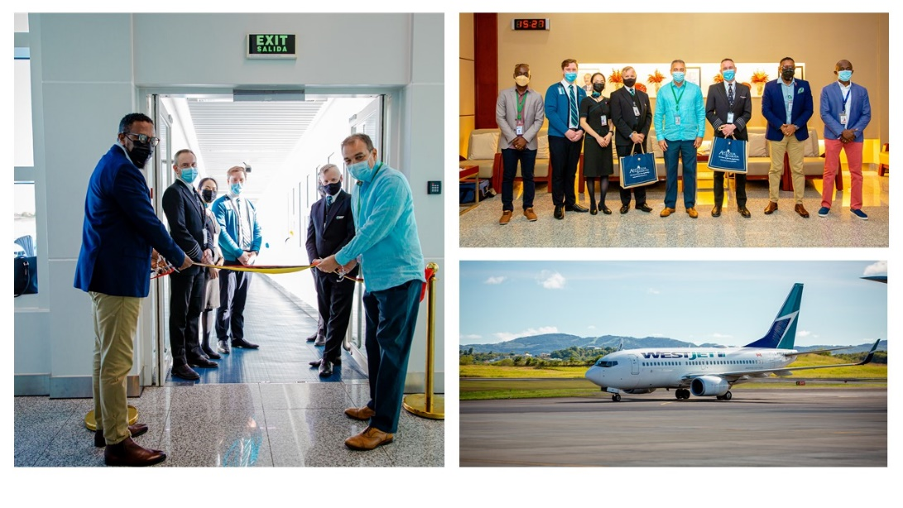
Photo Caption: WestJet is welcomed back to Antigua and Barbuda by Minister of Tourism and Investment The Honourable Charles Fernandez, CEO of the Antigua and Barbuda Tourism Authority Colin C. James, Director of Operations at the Antigua and Barbuda Airport Authority Joseph Samuel, alongside other tourism stakeholders (Photos courtesy: The Antigua and Barbuda Tourism Authority)
ST. JOHN’S, ANTIGUA (November 22, 2021) – WestJet is now back in Antigua and Barbuda, providing Canadian travellers with another means of escaping the cold winter and finding themselves in the sunny twin-island paradise.
On Sunday, the Canadian airline resumed service to Antigua and Barbuda, for the first time following over a year’s absence. A symbolic water canon salute showered the WestJet aircraft on touchdown at the V.C. Bird International Airport.
Minister of Tourism and Investment, The Honourable Charles Fernandez, CEO of the Antigua and Barbuda Tourism Authority, Colin C. James, Director of Operations at the Antigua and Barbuda Airport Authority, Joseph Samuel, General Manager of Caribbean Airport Services, Craig Richards, alongside other tourism stakeholders were present to officially welcome back the carrier and to greet arriving passengers.
The Tourism Minister called the airline’s arrival great news, as Canada is a key source market for the country. “Heading into the winter season, our tourism forecast is extremely positive as we see consumer travel confidence grow and demand for the destination increase. Having WestJet back, is a tremendous boost for us, and we are excited by the return.”
He continued, “Within the last twenty months we have put in place a number of measures to ensure all our visitors have a #sunseasafe vacation in Antigua and Barbuda.”
Antigua and Barbuda’s latest travel advisory issued on November 18, now allows fully vaccinated arriving passengers the option of presenting a RT PCR test negative result of four (4) days or fewer from date of testing, OR an approved Rapid Antigen test negative result of (3) or fewer days from date of testing to be permitted entry into Antigua and Barbuda. The list of approved Rapid Antigen tests is provided on the official tourism website: www.visitantiguabarbuda.com
WestJet will continue a weekly Sunday service to Antigua’s V.C. Bird International Airport until next month when the service will be increased to twice a week.
A total of 94 passengers arrived on Sunday’s flight.
###

About Antigua & Barbuda:
The 365 white and pink sand beaches of Antigua & Barbuda, one for every day of the year, are just the beginning of the treasures that await visitors. Antigua’s rich history and spectacular topography provide a variety of popular sightseeing opportunities. Nelson’s Dockyard, the only remaining example of a Georgian fort commissioned by the British in 1755, is perhaps the most renowned landmark. Betty’s Hope, built in 1674, is the site of one of the first full-scale sugar plantations on Antigua, and offers a chance to step back into time by visiting the restored mills. Another unique attraction is Devil’s Bridge, located at the eastern tip of the island in Indian Town National Park, where Atlantic breakers have carved out a natural limestone arch. Antigua boasts a varied tourism calendar including events such as the World Class Antigua Sailing Week, Classic Yacht Regatta, Antigua Sports Fishing and also the annual Carnival; known as the Caribbean’s Greatest Summer Festival. Island accommodation ranges from luxury resorts and all-inclusive hotels to smaller more intimate boutique guesthouses and cottages. For information about Antigua & Barbuda visit www.visitantiguabarbuda.com

For Antigua and Barbuda media enquiries, please contact:
Maria Blackman
Antigua and Barbuda Tourism Authority
T: 1 (268) 562 7600/464-7601
E: maria.blackman@visitaandb.com

