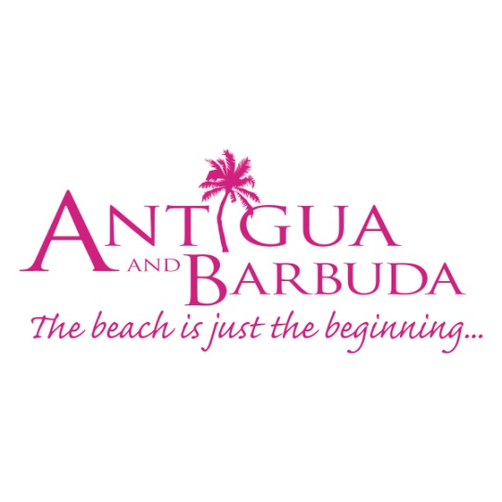

**FOR IMMEDIATE RELEASE:**

**ANTIGUA AND BARBUDA TOURISM ARRIVALS BEGIN GRADUAL RISE**

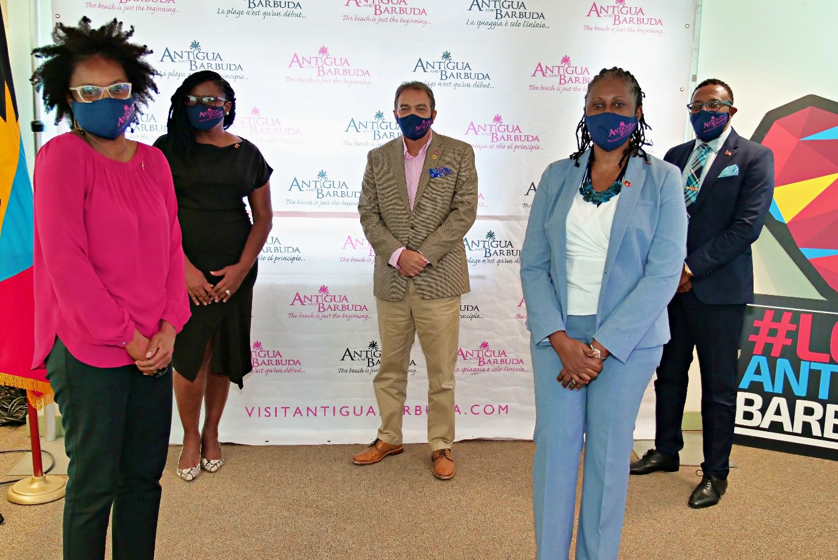

*Antigua and Barbuda Minister of Tourism The Honourable Charles Fernandez (centre) alongside (L-R) CEO of the Airport Authority, Euletta Francis, Executive Director of the Antigua and Barbuda Hotels and Tourism Association Patrice Simon, CEO of the Antigua and Barbuda Tourism Authority Colin C. James, and Chairman of the Antigua and Barbuda Tourism Authority Lorraine Raeburn in June, following a Destination re-opening press conference.*

*The pie chart shows Antigua and Barbuda Stayover Tourism Arrivals as reported by the Ministry of Tourism for the month of August, with locations visitors arrived from.*

**(ST. JOHN’S, ANTIGUA) September 23, 2020 –** As Antigua and Barbuda Tourism Industry stakeholders prepare for peak season, tourism officials are cautiously optimistic that with arrivals steadily increasing each month since the destination’s re-opening, that the moderate upward trend will continue into the traditionally busy tourism period.

For the year to August 2020, tourism stayover arrivals show that the destination received 94,810 visitors. Though arrivals dipped drastically in March due to reduced airlift brought on by the global pandemic, as the V.C Bird International Airport re-opened to international flights in June, monthly visitor arrivals have more than doubled from then until the end of August.

For the month of August, the destination received 4761 visitors. From the main source markets, 67% of Antigua and Barbuda’s visitors travelled from the United States, followed by 21% from the United Kingdom, 7% from the Caribbean and 3% from Canada.

Minister of Tourism, Charles Fernandez noted that: “The Ministry of Tourism and the Antigua and Barbuda Tourism Authority continue to carefully monitor the Covid-19 landscape within our main source markets. We remain committed to working with the Ministry of Health and the entire Antigua and Barbuda Tourism sector to ensure that as the destination opens up further, we keep those protective measures in place that have been designed to safeguard our residents and those who visit our shores.”

The Tourism Minister explained that it would not be busines as normal, as with the pandemic ongoing, Covid-19 protocols would still require visitors to travel with their negative PCR test, wear facial masks when social distancing was not possible and adhere to other protocols stipulated by the Ministry of Health. For tourism businesses, he noted that protocols would also affect operations, and in some instances would mean reduced occupancy levels.

Presently American Airlines, Delta, JetBlue, British Airways, Caribbean Airlines, interCaribbean Airlines and Winair are operating flights into the destination. In the next few months, Antigua and Barbuda will welcome, Virgin Atlantic, Air Canada, and Sunwing.

In October, additional hotel re-openings have also been planned. These include Antigua and Barbuda Hotels and Tourism Association member hotels: Blue Waters Resort, Tamarind Hills, Hermitage Bay, Antigua Village, Galley Bay, Carlisle Bay Resort, St. James’s Club, The Great House, Antigua Yacht Club Marina, Ocean Point Resort, Curtain Bluff Resort, and Hawksbill.

“Each hotel or accommodation offering that has opened has been inspected by the Ministry of Tourism and the Ministry of Health, to ensure that they are adhering to the covid-19 protocols set for tourism accommodation. Over two hundred properties have been inspected to date ranging from small bed & breakfast styled properties, to the larger all-inclusives,” said the Tourism Minister. The full listing of all tourism properties certified as of September 15 by the Ministry of Tourism’s Quality Assurance Unit, can be viewed [here](https://visitantiguabarbuda.com/antigua-and-barbuda-is-open/)

The Ministry of Tourism also recently released to the Antigua and Barbuda yachting sector, operational guidelines, and protocols for the sector. These protocols are also available on [www.visitantiguabarbuda.com](http://www.visitantiguabarbuda.com)

The Tourism Minister urged the tourism sector to remain mindful of the Covid-19 protocols in place that all key players should be guided by during the tourism recovery.

###

**ABOUT ANTIGUA AND BARBUDA**

Antigua (pronounced An-tee'ga) and Barbuda (Bar-byew’da) is located in the heart of the Caribbean Sea. Voted the World Travel Awards 2015, 2016 and 2017 *Caribbean’s Most Romantic Destination*, the twin-island paradise offers visitors two uniquely distinct experiences, ideal temperatures year-round, a rich history, vibrant culture, exhilarating excursions, award-winning resorts, mouth-watering cuisine and 365 stunning pink and white-sand beaches - one for every day of the year. The largest of the Leeward Islands, Antigua comprises 108-square miles with rich history and spectacular topography that provides a variety of popular sightseeing opportunities. Nelson’s Dockyard, the only remaining example of a Georgian fort a listed UNESCO World Heritage site, is perhaps the most renowned landmark. Antigua’s tourism events calendar includes the prestigious Antigua Sailing Week, Antigua Classic Yacht Regatta, and the annual Antigua Carnival; known as the Caribbean’s Greatest Summer Festival. Barbuda, Antigua’s smaller sister island, is the ultimate celebrity hideaway. The island lies 27 miles north-east of Antigua and is just a 15-minute plane ride away. Barbuda is known for its untouched 17 mile stretch of pink sand beach and as the home of the largest Frigate Bird Sanctuary in the Western Hemisphere.  Find information on Antigua & Barbuda at: [www.visitantiguabarbuda.com](http://www.visitantiguabarbuda.com) or follow us on **Twitter**. <http://twitter.com/antiguabarbuda>  **Facebook** [www.facebook.com/antiguabarbuda](http://www.facebook.com/antiguabarbuda); **Instagram**: [www.instagram.com/AntiguaandBarbuda](http://www.instagram.com/AntiguaandBarbuda)

**For media enquiries, please contact:**Maria Blackman  
Antigua and Barbuda Tourism Authority

T: 1 (268) 562 7600/464-7601  
E: [maria.blackman@visitaandb.com](mailto:maria.blackman@visitaandb.com)