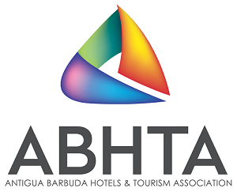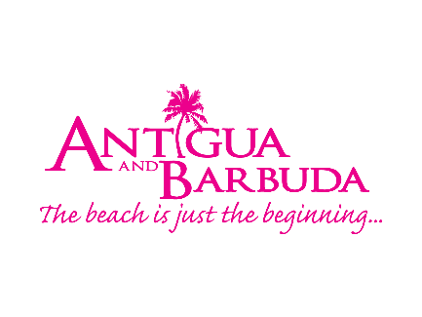
Save the date
Showcase Antigua and Barbuda is back

February 24, 2022, Antigua and Barbuda: On June 8 – 10, 2022 the Antigua & Barbuda Hotels and Tourism Association, in collaboration with the Antigua and Barbuda Tourism Authority will be presenting the 7th installment of the travel trade business to business destination event, Showcase Antigua Barbuda.
The event which has been absent from the destination’s calendar for the past two years due to the pandemic, has been re-designed with a focus not only on the business aspect of the one-on-one meetings with Tourism related businesses, but also presenting the destination’s offerings of Culture & Heritage, Wellness, Romance, as well as Yachting & Sailing.
Patrice Simon, Executive Director of the ABHTA remarked that “Giving our partners the opportunity to experience the destination firsthand is important now more than ever. We are looking forward to welcoming our partners from the US, UK & EU, Canada and the Caribbean for face-to-face meetings with our members. As travel continues to rebound, we cannot miss an opportunity to showcase Antigua and Barbuda to the key decision makers in the travel industry.”
Colin C. James, CEO of the Antigua and Barbuda Tourism Authority wants travel partners to continue to keep Antigua and Barbuda top of mind. James said, “Antigua and Barbuda has incredible new product offerings that have come on stream since 2020 and we are more than ready to wow our travel partners, some of who will be making their first visit back to Antigua and Barbuda since the pandemic.
“We will be highlighting our key pillars, and our partners can expect to be fully immersed in the destination, as we take them on a journey with vibrant presentations that focus on our heritage and culture, wellness attributes, romance-inducing scenes and our rich nautical elements – all experiences that visitors to the destination can enjoy on their vacation.”
Showcase Antigua and Barbuda will include a welcome event on June 8 and a full day of business meetings on the 9th and the opportunity to play and explore the destination on June 10. Travel partners and local stakeholders can also look forward to a new element being added to this year’s event which will include sessions of consultations on the destination and exploring avenues for growth and development of the industry.
Travel partners and Members of the ABHTA are asked to save the date June 8 – 10 2022. More details on registration will be shared in the coming weeks.

###

ABOUT THE ANTIGUA AND BARBUDA TOURISM AUTHORITY

The Antigua & Barbuda Tourism Authority is a statutory body dedicated to realizing the tourism potential of Antigua & Barbuda by promoting the twin island state as a unique, quality tourist destination with the overall objective of increasing visitor arrivals thereby providing sustainable economic growth. The Antigua and Barbuda Tourism Authority is headquartered in St. John’s Antigua, where regional marketing is directed. The Authority has three offices overseas in the United Kingdom, United States and Canada.

ABOUT THE ABHTA
The ABHTA collectively represents the hospitality industry by educating, advocating and promoting to increase visitation and the economic benefits for Antigua and Barbuda. The primary focus is on the needs and best interests of the members of the Association. The membership of the Antigua & Barbuda Hotels & Tourism Association is open to all hotels, restaurants, airlines, and companies directly or indirectly involved in the tourism sector of Antigua and Barbuda. Joining the Association is a way of showing your support of the island’s tourism product and helping us to further develop our tourism industry.

For Antigua and Barbuda media enquiries, please contact:
Maria Blackman
Antigua and Barbuda Tourism Authority
T: 1 (268) 562 7600/464-7601
E: maria.blackman@visitaandb.com

