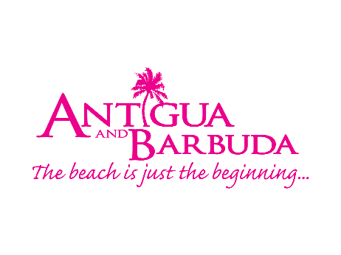
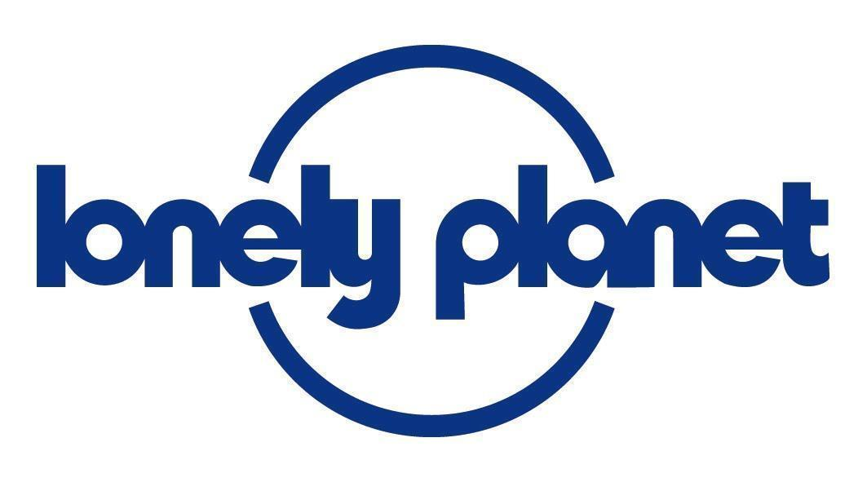

Antigua and Barbuda Named Lonely Planet’s
Emerging Sustainable Destination of the Year

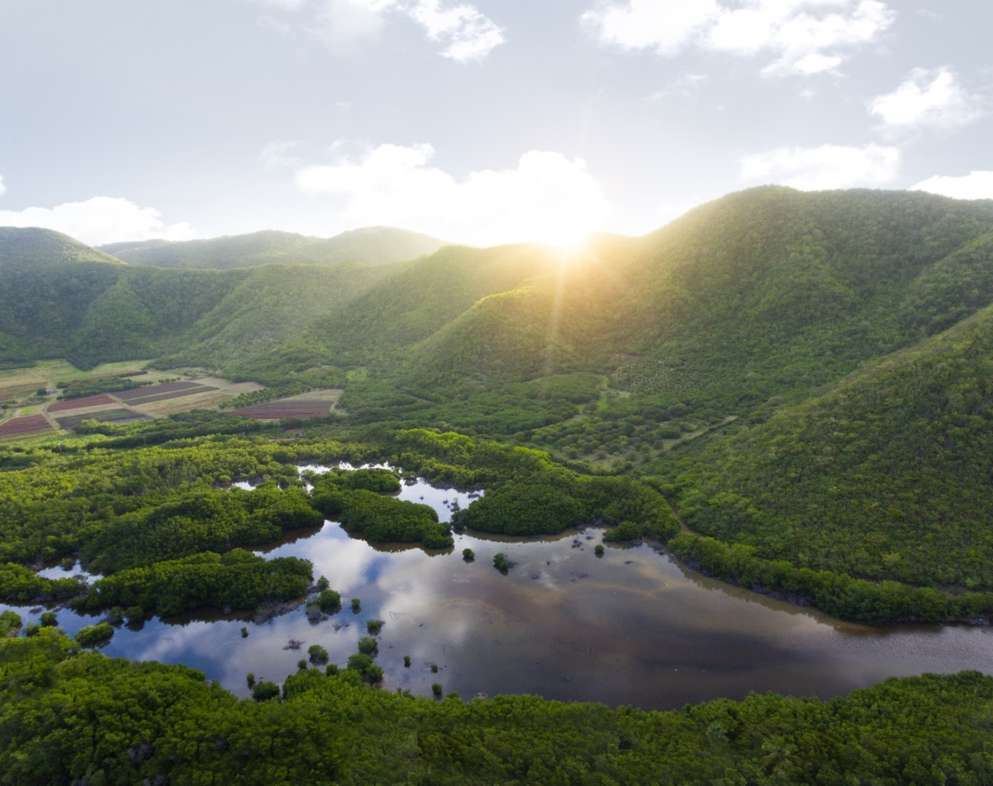
Photo caption: The sun sets on the Shekerley Mountains in Antigua.
(Photo courtesy, Tom Archer for the Antigua and Barbuda Tourism Authority)

(ST. JOHN’S, ANTIGUA) 17 NOVEMBER 2020 - Lonely Planet’s Best in Travel Awards has named the twin-island nation of Antigua and Barbuda 2021’s Emerging Sustainable Destination of the Year.

Unveiling a radical reimagining of its much-awaited Best in Travel picks for 2021, Lonely Planet is looking ahead to the important changes taking place globally, from sustainability to diversity, and shining a light on the future of travel. This year, Antigua and Barbuda has been heralded out as one of the destinations who are transforming the travel industry.

From banning single-use plastics to establishing a “Green Corridor” of environmentally friendly businesses, Antigua and Barbuda have made sustainability a priority.

Charles Fernandez, Minister of Tourism for Antigua and Barbuda, has said that the islands are incredibly proud to have been recognised by Lonely Planet’s Best in Travel Awards. “As a nation, we are constantly striving to ensure sustainability is at the forefront of everything we do. Although we are a small country, we are pioneering initiatives to ensure that the beauty of our islands is preserved and nurtured for generations to come. The Sustainable Tourism department has made this a priority in Antigua and Barbuda, and within a short five year period, we are very proud of the progress that has been made and the example we have set.”

CEO of the Antigua and Barbuda Tourism Authority, Colin C. James, said, “The Antigua and Barbuda Tourism Authority is excited to celebrate this win with the Ministry of Tourism. This is an amazing accolade to receive as we continue to promote Antigua and Barbuda as a safe and responsible tourism destination.”

The twin-island nation has introduced several sustainable initiatives over the years, which include the following:

- The Green Tourist Initiative, also known as the “Green Corridor”. This initiative aims to assist businesses in reducing the negative aspects of tourism on the environment by improving the efficiency of their operations. Under the “Green Corridor” initiative, Antigua has introduced the “Green Fins Programme”, a UNEP certification programme that provides support and guidance to snorkellers and divers – the only country in the Western hemisphere to have done so.

- Antigua has introduced the Mapping of Natural and Cultural Heritage Sites to create awareness of tourism assets and attractions sites, to assist with the management of cultural and natural heritage. So far, 64 sites have been mapped out with their true histories being shared with tour guides, locals, and visitors alike. Under the Management of Historical Sites Antigua continues to work with the Sustainable Tourism Unit to restore and develop Betty’s Hope as a sustainably managed historical site.

- Antigua seeks to maintain and enhance select communities under its Community Empowerment Project, to create a new tourism product that will create alternative livelihoods for members of those communities. Antigua has also introduced a Waste to Craft Management Project, to create further awareness among artisans and craftsmen on how waste can be reused in the accommodation sector.

- Under its Destination Sustainable Tourism Monitoring Programme, Antigua aims to works with its residents to ensure satisfaction with the development of Tourism products. This is to ensure that residents feel they are a part of the process and are benefitting from Tourism. Antigua has also introduced the Destination Stewardship Committee, to engage leaders from government, the private sector and NGO community through a collaborative process to embed wise policies and practices into all levels of tourism planning, development, and management.

For more information on Antigua and Barbuda, go to www.visitantiguabarbuda.com

For more information on the Lonely Planet Best in Travel 2021 list, go to www.lonelyplanet.com/best-in-travel. Award destinations can also be explored with Lonely Planet’s Guides app for free and on social media channels via #BestInTravel.

###

ABOUT THE ANTIGUA AND BARBUDA TOURISM AUTHORITY
The Antigua & Barbuda Tourism Authority is a statutory body dedicated to realizing the tourism potential of Antigua & Barbuda by promoting the twin island state as a unique, quality tourist destination with the overall objective of increasing visitor arrivals thereby providing sustainable economic growth. The Antigua and Barbuda Tourism Authority is headquartered in St. John’s Antigua, where regional marketing is directed. The Authority has three offices overseas in the United Kingdom, United States and Canada.
ABOUT ANTIGUA AND BARBUDA
Antigua (pronounced An-tee'ga) and Barbuda (Bar-byew’da) is located in the heart of the Caribbean Sea. Voted the World Travel Awards 2015, 2016, 2017 and 2018 Caribbean’s Most Romantic Destination, the twin-island paradise offers visitors two uniquely distinct experiences, ideal temperatures year-round, a rich history, vibrant culture, exhilarating excursions, award-winning resorts, mouth-watering cuisine and 365 stunning pink and white-sand beaches - one for every day of the year. The largest of the Leeward Islands, Antigua comprises 108-square miles with rich history and spectacular topography that provides a variety of popular sightseeing opportunities. Nelson’s Dockyard, the only remaining example of a Georgian fort a listed UNESCO World Heritage site, is perhaps the most renowned landmark. Antigua’s tourism events calendar includes the prestigious Antigua Sailing Week, Antigua Classic Yacht Regatta, and the annual Antigua Carnival; known as the Caribbean’s Greatest Summer Festival. Barbuda, Antigua’s smaller sister island, is the ultimate celebrity hideaway. The island lies 27 miles north-east of Antigua and is just a 15-minute plane ride away. Barbuda is known for its untouched 17 mile stretch of pink sand beach and as the home of the largest Frigate Bird Sanctuary in the Western Hemisphere. Find information on Antigua & Barbuda at: www.visitantiguabarbuda.com or follow us on Twitter. http://twitter.com/antiguabarbuda Facebook www.facebook.com/antiguabarbuda; Instagram: www.instagram.com/AntiguaandBarbuda

For Antigua and Barbuda media enquiries, please contact:
Maria Blackman
Antigua and Barbuda Tourism Authority
T: 1 (268) 562 7600/464-7601
E: maria.blackman@visitaandb.com

