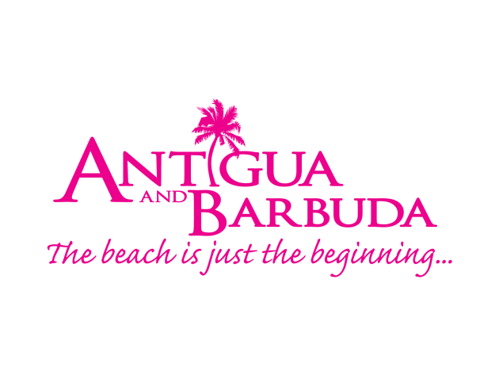

FOR IMMEDIATE RELEASE:

LATIN AMERICAN TRAVELLERS ENCOURAGED TO SPEND THEIR VACATION IN ANTIGUA AND BARBUDA

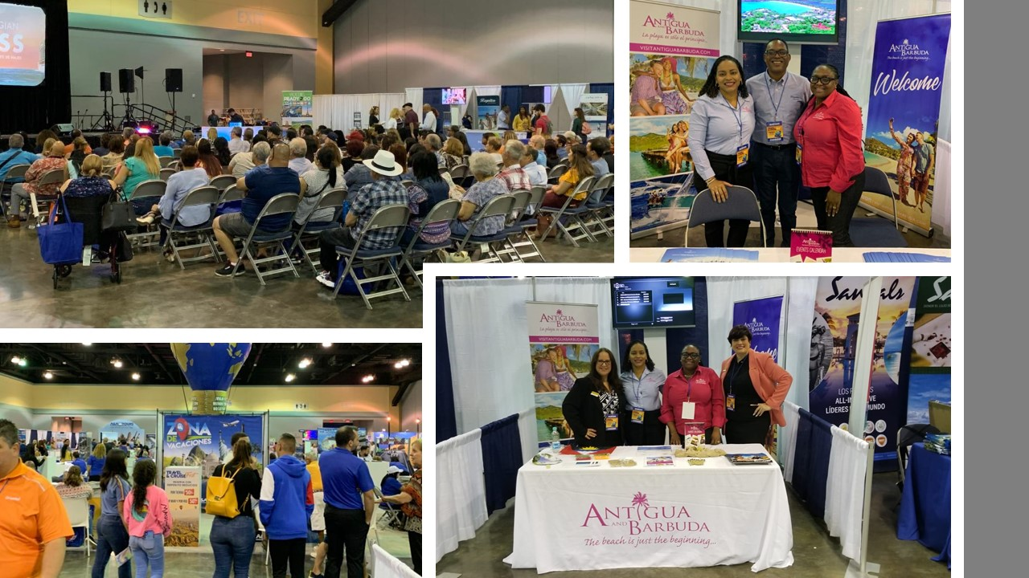
(Photo Caption: The Antigua and Barbuda Tourism Authority encouraged travel to Antigua and Barbuda when they participated in the A & A Tours ‘Travel and Cruise Fest’, recently held in Puerto Rico.)

ST. JOHN’S, ANTIGUA (February 13, 2020) – The Antigua and Barbuda Tourism Authority recently concluded participation at the A&A Tours ‘Travel & Cruise Fest’ in Puerto Rico on February 8 and 9, where tourism executives were busy encouraging Latin American travellers to spend their next vacation in Antigua and Barbuda.
Thousands of attendees were present at the annual travel and cruise fair, which is one of the most highly anticipated travel expos in Puerto Rico.

“The show provided an opportunity to reintroduce the Puerto Rican market to Antigua and Barbuda’s tourism offering, including its contemporary accommodations, tours, attractions, heritage sites, culture, yachting and sailing”, said Regional Marketing Consultant for the Antigua and Barbuda Tourism Authority, Charmaine Spencer who attended the show and was joined by ABTA’s Executive PA, Matara Thomas.

Spencer noted that, while many Puerto Ricans already visit Antigua and Barbuda, they mainly travel via cruise. She said it was therefore key for the Antigua and Barbuda Tourism Authority to deliver information on Antigua and Barbuda’s unique offerings, to encourage stayover visitation.

The fair which targets the travel trade as well as consumers, featured an exclusive business-2-business session geared specifically towards travel agents.

During one-on-one engagements with the agents, the Antigua and Barbuda Tourism Authority team shared the destination’s plans for 2020, which included the introduction of new events that would attract Puerto Rican visitors, whether families, couples or solo travellers.

Spencer also highlighted the destination’s upcoming #WhatCoolLooksLike Summer campaign which presents visitors with the opportunity to save on travel to Antigua and Barbuda during the periods the May – October.

Antigua and Barbuda partners at the show included, Blue Diamond Resorts and Sandals Resorts, as well as interCaribbean Airways and Silver Airways (formerly Seaborne Airline), who offer direct connectivity between Antigua and Puerto Rico, as well as to the Dominican Republic.

Some of the other neighbouring island destinations at the show included, British Virgin Islands, Anguilla and St. Martin.

###
ABOUT ANTIGUA AND BARBUDA
Antigua (pronounced An-tee'ga) and Barbuda (Bar-byew’da) is located in the heart of the Caribbean Sea. Voted the World Travel Awards 2015, 2016, 2017 and 2018 Caribbean’s Most Romantic Destination, the twin-island paradise offers visitors two uniquely distinct experiences, ideal temperatures year-round, a rich history, vibrant culture, exhilarating excursions, award-winning resorts, mouth-watering cuisine and 365 stunning pink and white-sand beaches - one for every day of the year. The largest of the Leeward Islands, Antigua comprises 108-square miles with rich history and spectacular topography that provides a variety of popular sightseeing opportunities. Nelson’s Dockyard, the only remaining example of a Georgian fort a listed UNESCO World Heritage site, is perhaps the most renowned landmark. Antigua’s tourism events calendar includes the prestigious Antigua Sailing Week, Antigua Classic Yacht Regatta, and the annual Antigua Carnival; known as the Caribbean’s Greatest Summer Festival. Barbuda, Antigua’s smaller sister island, is the ultimate celebrity hideaway. The island lies 27 miles north-east of Antigua and is just a 15-minute plane ride away. Barbuda is known for its untouched 17 mile stretch of pink sand beach and as the home of the largest Frigate Bird Sanctuary in the Western Hemisphere. Find information on Antigua & Barbuda at: www.visitantiguabarbuda.com or follow us on Twitter. http://twitter.com/antiguabarbuda Facebook www.facebook.com/antiguabarbuda; Instagram: www.instagram.com/AntiguaandBarbuda

For media enquiries, please contact:
Maria Blackman
Antigua and Barbuda Tourism Authority
T: 1 (268) 562 7600/464-7601
E: maria.blackman@visitaandb.com

