FOR IMMEDIATE RELEASE
FREEWINDS 31st ANNIVERSARY CELEBRATED BY ANTIGUA AND BARBUDA TOURISM OFFICIALS
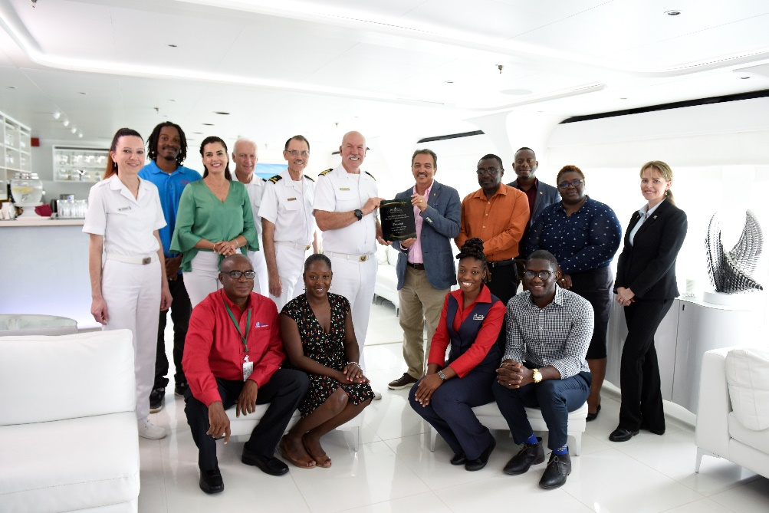
Antigua and Barbuda’s Minister of Tourism Charles Fernandez presents a plaque to Captain Napier of the Freewinds in celebration of their 31st Anniversary in the presence of officials from Freewinds, the Ministry of Tourism, The Antigua and Barbuda Tourism Authority, and Brysons Shipping
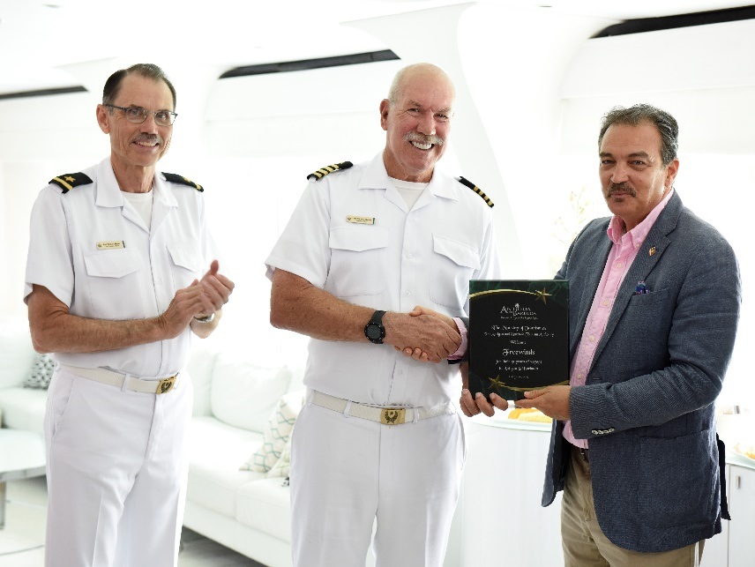
Minister Fernandez presents a plaque to Captain Mike Napier (c) and Port Captain Kenneth Weber commemorating the 31st anniversary of Freewinds

ST. JOHN’S, ANTIGUA (June 21, 2019) – Antigua and Barbuda’s Minister of Tourism, The Honourable Charles Fernandez today boarded the Freewinds cruise ship, the largest continuous running cruise ship in the Caribbean, meeting with ship officials to commemorate the 31st anniversary of the vessel’s maiden voyage and 30 years since the Freewinds first called to Antigua.
Joining the Tourism Minister for the special celebration were, Permanent Secretary in the Ministry of Tourism Walter Christopher, Principle Assistant Secretary Marvo Richards, Operations Manager within the Antigua and Barbuda Tourism Authority, Javier Jacobs, Brysons Shipping Chief Operations Officer Carl King, and other tourism representatives.
In a plaque presentation to Captain Mike Napier, and Freewinds Officials which included, Port Captain Kenneth Weber, Jes Anderson Public Affairs Officer and Ruddy Rodriguez, former Miss Universe representative from Venezuela and noted film actress in South America and Freewinds ‘The Way to Happiness’ Ambassador, the Minister recognized the commitment that Freewinds has to the country of Antigua and Barbuda and the indelible mark the ship has made on the Caribbean region, through its humanitarian mission to uplift the people of the Caribbean.
“Whether organizing and conducting cultural programs, to sponsoring drug education and human rights education programs for youth, or environmental programmes, the activities of the Freewinds are commendable and very much appreciated.
“For your support of this region, and of Antigua and Barbuda in particular, you are to be roundly applauded! We hold your kindness and generosity in high esteem, and we thank you for all you have done over the past 31 years for Antigua and Barbuda and the region at large and look forward to deepening our relationship with you, and working with you,” said Minister Fernandez.
The Tourism Minister also highlighted product development initiatives being made by the Government of Antigua and Barbuda to include the Global Ports and Royal Caribbean development to enhance the cruise port facilities, and the ban on plastic bags and Styrofoam containers in the destination.
Captain Napier of the Freewinds thanked Minister Fernandez, and noted that, “It has been a great pleasure and an honour to be a part of the community, and we will continue to do so and contribute to Antigua and Barbuda tourism. The Freewinds has enjoyed calling to Antigua over these years and has made many friends. The Freewinds always looks forward to her return to Antigua.”
The Freewinds first set sail in June 1988, from her home port of Curacao. The ship first called in Antigua in June 1989 and has visited the country many times over the years.
###
For media enquiries, please contact:
Maria Blackman
Antigua and Barbuda Tourism Authority
T: 1 (268) 562 7600/464-7601
E: maria.blackman@visitaandb.com

ABOUT ANTIGUA AND BARBUDA
Antigua (pronounced An-tee'ga) and Barbuda (Bar-byew’da) is located in the heart of the Caribbean Sea. Voted the World Travel Awards 2015, 2016, 2017 and 2018 Caribbean’s Most Romantic Destination, the twin-island paradise offers visitors two uniquely distinct experiences, ideal temperatures year-round, a rich history, vibrant culture, exhilarating excursions, award-winning resorts, mouth-watering cuisine and 365 stunning pink and white-sand beaches - one for every day of the year. The largest of the Leeward Islands, Antigua comprises 108-square miles with rich history and spectacular topography that provides a variety of popular sightseeing opportunities. Nelson’s Dockyard, the only remaining example of a Georgian fort a listed UNESCO World Heritage site, is perhaps the most renowned landmark. Antigua’s tourism events calendar includes the prestigious Antigua Sailing Week, Antigua Classic Yacht Regatta, and the annual Antigua Carnival; known as the Caribbean’s Greatest Summer Festival. Barbuda, Antigua’s smaller sister island, is the ultimate celebrity hideaway. The island lies 27 miles north-east of Antigua and is just a 15-minute plane ride away. Barbuda is known for its untouched 17 mile stretch of pink sand beach and as the home of the largest Frigate Bird Sanctuary in the Western Hemisphere. Find information on Antigua & Barbuda at: www.visitantiguabarbuda.com or follow us on Twitter. http://twitter.com/antiguabarbuda Facebook www.facebook.com/antiguabarbuda; Instagram: www.instagram.com/AntiguaandBarbuda

