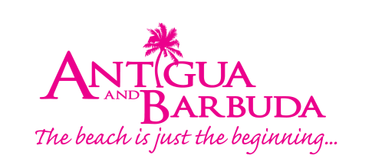

FOR IMMEDIATE RELEASE
A CELEBRATION OF ART, CULTURE AND CUISINE AS ANTIGUA AND BARBUDA HOLDS CULTURAL EVENT AT EXPO 2020 DUBAI

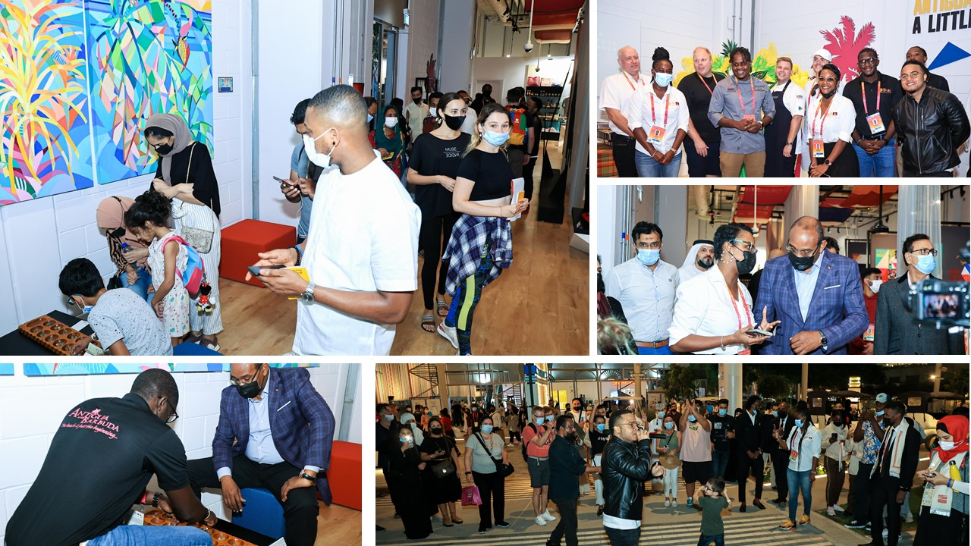
Photo Caption: The Antigua and Barbuda cultural event attended by Prime Minister of Antigua and Barbuda, The Hon. Gaston Browne, attracted scores of visitors to Antigua and Barbuda’s pavilion over the past weekend. (Photo Credits: The Antigua and Barbuda Tourism Authority)

ST. JOHN’S, ANTIGUA (December 8, 2021) - The Antigua and Barbuda delegation in Dubai, is continuing to bring attention to Antigua and Barbuda’s unique attributes and offerings while at Expo 2020 Dubai. Over the weekend the delegation hosted a cultural exchange event at the Antigua and Barbuda Pavilion.
Antigua and Barbuda Prime Minister, the Honorable Gaston Browne, who was in Dubai on an official visit by invitation of the U.A.E. Government was present at the event.
"Antigua and Barbuda's presence at Expo Dubai is a prime opportunity to increase awareness and to share ideas and cultures. I am particularly pleased that we have taken the initiative to host an event that is in keeping with the expo theme of connecting minds and creating a future. It is my hope that we leave this expo with a wealth of knowledge, experience and networks that will help position Antigua and Barbuda positively within the Middle East as well as bring tangible benefits to our tourism and business sectors", says Prime Minister Browne.
Pavilion Director and Special Projects and Events Manager for the Antigua and Barbuda Tourism Authority, Shermain Jeremy who was on-site coordinating the day's activities was pleased with the event stating, "The expo has brought the world to Dubai and Antigua and Barbuda's strategic approach is to maximize as much as possible on all the opportunities that this event brings from both a tourism and business perspective as well as social learning exercise. Our goal is to leave a mark on the minds of as many persons as possible who visit the expo and by extension the Antigua and Barbuda pavilion."
Additionally, Jeremy noted that, cultural event was designed to increase visitors to the pavilion during a high traffic period around the United Arab Emirates Independence holiday celebrations that were taking place over the weekend.
The event focused on highlighting Antigua and Barbuda's culinary, cultural, and musical traditions as a conduit for social exchange, while building brand awareness around the country as a tourism destination and safe haven for high-level business opportunities.
Visitors to the pavilion were greeted by the music of Antiguan and Barbudan musicians to include The Burning Flames, King Short Shirt, Tizzy, Claudette Peters, Drastic, Tian Winter and many others, with the music playing throughout the 2400 square foot pavilion. Two Warri game stations were also set up to allow for friendly gaming.
The wooden Warri board has been a highlight for many visitors to the pavilion as the strategic board game is played in numerous parts of the world to include Yemen, the Philippines, Oman, South India, in addition to Germany and many African and Caribbean countries. This activity allowed for the sharing and socializing of a variety of peoples and cultures who share a similar pastime.
Prime Minister Browne was seen participating a game of Warri with the Antigua and Barbuda Tourism Authority’s Operations Manager, Javier Jacobs leaving many onlookers intrigued.
Lejorn Hill, Executive Chef at the Paramount Hotel, owned by DAMAC which is one of the Middle East's largest real estate developers served-up local cuisine to include goat water as well as saltfish and dumplings with chop-up allowing visitors a taste of Antigua and Barbuda. To add to the culinary and cultural exchange experience, the pavilion teamed up with the Denmark pavilion for a friendly local hot sauce taste-off with Susie’s and Granny Annie condiments.
Ricardo Drue, Antigua and Barbuda's ‘Power Soca’ Winner who was in Dubai for special appearances over the Independence weekend gave bystanders and visitors a taste of Antigua and Barbuda's music and carnival experience which was a highlight for many in attendance.
Visitors also had a chance to win customized gift bags once they took a brief survey and opted into the destination's mailing list. A key deliverable at the expo is to create a robust mailing list of potential visitors that can be remarketed and retargeted in the future.
The Antigua and Barbuda Tourism Authority plans to engage the travel trade in 2022 as the next phase of its expo strategy. This will take form of a travel trade week where the Antigua and Barbuda delegation will introduce the destination to qualified travel professionals, and influencers from the UAE. Tourism officials also plan to ramp up discussions with key airlines from the Middle East.
###

ABOUT ANTIGUA AND BARBUDA
Antigua (pronounced An-tee'ga) and Barbuda (Bar-byew’da) is located in the heart of the Caribbean Sea. Voted the World Travel Awards 2015, 2016, 2017 and 2018 Caribbean’s Most Romantic Destination, the twin-island paradise offers visitors two uniquely distinct experiences, ideal temperatures year-round, a rich history, vibrant culture, exhilarating excursions, award-winning resorts, mouth-watering cuisine and 365 stunning pink and white-sand beaches - one for every day of the year. The largest of the Leeward Islands, Antigua comprises 108-square miles with rich history and spectacular topography that provides a variety of popular sightseeing opportunities. Nelson’s Dockyard, the only remaining example of a Georgian fort a listed UNESCO World Heritage site, is perhaps the most renowned landmark. Antigua’s tourism events calendar includes the prestigious Antigua Sailing Week, Antigua Classic Yacht Regatta, and the annual Antigua Carnival; known as the Caribbean’s Greatest Summer Festival. Barbuda, Antigua’s smaller sister island, is the ultimate celebrity hideaway. The island lies 27 miles north-east of Antigua and is just a 15-minute plane ride away. Barbuda is known for its untouched 17 mile stretch of pink sand beach and as the home of the largest Frigate Bird Sanctuary in the Western Hemisphere. Find information on Antigua & Barbuda at: www.visitantiguabarbuda.com or follow us on Twitter. http://twitter.com/antiguabarbuda Facebook: www.facebook.com/antiguabarbuda; Instagram: www.instagram.com/AntiguaandBarbuda

For media enquiries, please contact:
Maria Blackman
Antigua and Barbuda Tourism Authority
T: 1 (268) 562 7600/464-7601
E: maria.blackman@visitaandb.com

Notes to Editors:
Additional high-resolution images available on request.

