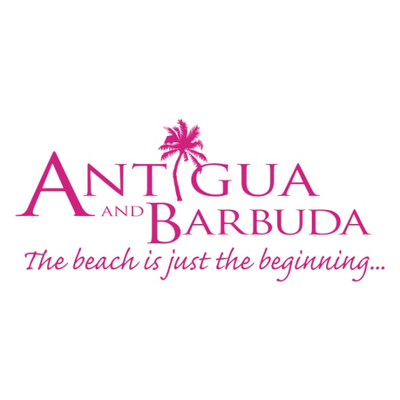

**FOR IMMEDIATE RELEASE**

**WINDSTAR CRUISES RETURN TO BARBUDA FOR 2018/2019 SEASON**

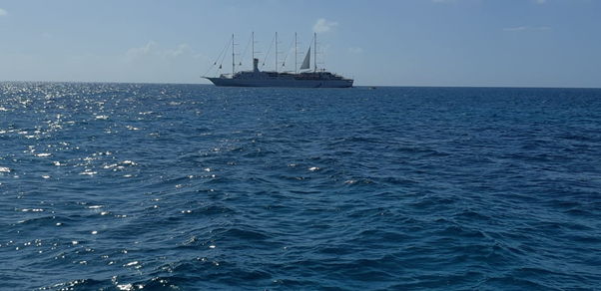

*(Photo Caption, A view of Windstar cruise line's Wind Surf, anchored off Barbuda)*

**ST.JOHN’S, ANTIGUA (November 26, 2018) –** In another first for Barbuda, Antigua’s sister island, has welcomed luxury cruise line Windstar back to Barbuda; the first cruise line to return to the island following Hurricane Irma.

Antigua and Barbuda Tourism Officials celebrated the anchoring of Windstar’s Wind Surf, which comes less than one month after the re-opening of the luxurious Barbuda Belle boutique hotel.

Minister of Tourism & Investment, The Honourable Charles Fernandez said:  This is an extremely important milestone for Barbuda tourism as the island returns to normalcy.

“Windstar’s return is the result of a lot of lobbying by the Ministry of Tourism, The Antigua and Barbuda Tourism Authority and our cruise partners who have been attending major cruise conferences since 2017, encouraging the smaller cruise lines to return to Barbuda. This is a vote of confidence in Barbuda, and the services and tours that will be available for guests of the ship to enjoy.”

The largest ship in the Windstar fleet, the Wind Surf is a five-masted motor-sail yacht that accommodates 310 guests. The Windstar website describes the ship “as being known for its casually elegant environment”.

Wind Surf will make nine calls to Barbuda this season, calling bi-weekly.

The Barbuda Council’s Chair of Tourism, Culture, Sports and Youth Affairs for the Barbuda Council Asha Frank was present at the Barbuda dock on Sunday November 25 to greet cruise executives from the vessel.

Frank said, “Small cruise lines such as the Windstar that offer a more personal and authentic experience are ideal for the picturesque shores of Barbuda. We welcome the Windstar and thank them for the huge support of our local businesses.”

Barbuda is being marketed as an eco-friendly, high-value, low volume destination, making it perfect for inclusion on the cruise itineraries of smaller luxury cruise lines.

Antigua and Barbuda Tourism Authority, CEO Colin C. James, noted that, “As a result of the work done reassuring cruise lines that Barbuda is open for business, Barbuda will also see additional calls from other scheduled cruise ships as the season goes into high gear. This will act as a significant economic stimulus for Barbuda as passengers not only enjoy Barbuda’s beautiful beaches but explore the destination on tours to Barbuda’s fascinating sites such as the caves, the largest Frigate Bird Sanctuary in the Western hemisphere and the historic and unique Martello Towers.”

For more information on Antigua and Barbuda, where the beach is just the beginning: [www.visitantiguabarbuda.com](http://www.visitantiguabarbuda.com/)

###

**ABOUT ANTIGUA AND BARBUDA**

Antigua (pronounced An-tee'ga) and Barbuda (Bar-byew’da) is located in the heart of the Caribbean Sea. Voted the World Travel Awards 2015, 2016, 2017 and 2018 *Caribbean’s Most Romantic Destination*, the twin-island paradise offers visitors two uniquely distinct experiences, ideal temperatures year-round, a rich history, vibrant culture, exhilarating excursions, award-winning resorts, mouth-watering cuisine and 365 stunning pink and white-sand beaches - one for every day of the year. The largest of the Leeward Islands, Antigua comprises 108-square miles with rich history and spectacular topography that provides a variety of popular sightseeing opportunities. Nelson’s Dockyard, the only remaining example of a Georgian fort a listed UNESCO World Heritage site, is perhaps the most renowned landmark. Antigua’s tourism events calendar includes the prestigious Antigua Sailing Week, Antigua Classic Yacht Regatta, and the annual Antigua Carnival; known as the Caribbean’s Greatest Summer Festival. Barbuda, Antigua’s smaller sister island, is the ultimate celebrity hideaway. The island lies 27 miles north-east of Antigua and is just a 15-minute plane ride away. Barbuda is known for its untouched 17 mile stretch of pink sand beach and as the home of the largest Frigate Bird Sanctuary in the Western Hemisphere.  Find information on Antigua & Barbuda at: [www.visitantiguabarbuda.com](http://www.visitantiguabarbuda.com) or follow us on **Twitter**. <http://twitter.com/antiguabarbuda>  **Facebook** [www.facebook.com/antiguabarbuda](http://www.facebook.com/antiguabarbuda)

**FOR ANTIGUA** **and Barbuda media queries, contact:**

**Maria Blackman**

Antigua and Barbuda Tourism Authority

T: 1 268 464 7601 /1 268 562 7600

E: [Maria.blackman@visitaandb.com](mailto:Maria.blackman@visitaandb.com)