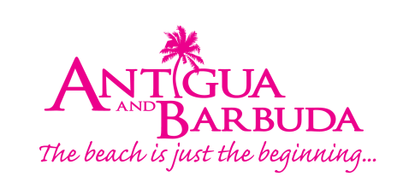

FOR IMMEDIATE RELEASE
ANTIGUA AND BARBUDA CELEBRATE TOURISM HEROES AT BLACK PINEAPPLE AWARDS
Annual Awards Ceremony Hosted in the USA Recognized 40 Travel Industry Partners

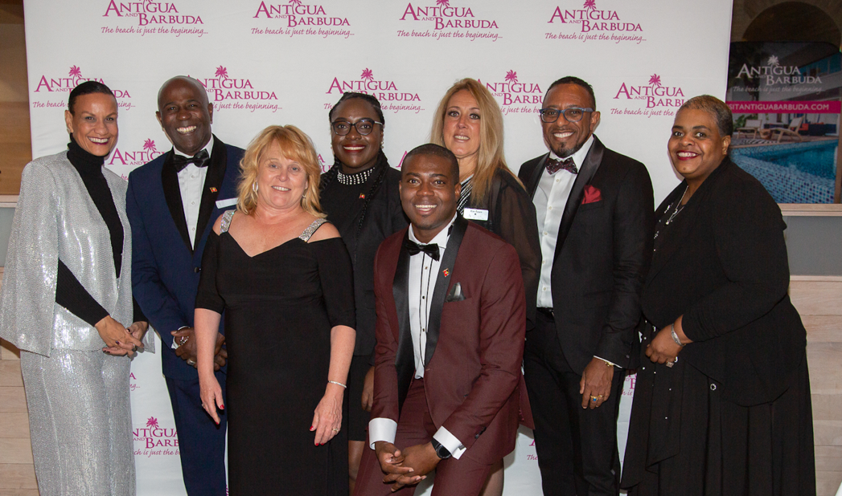

Photo Caption: The Antigua and Barbuda Tourism Authority (ABTA), US Sales & Marketing Team
with ABTA CEO, Colin C. James

New York, NY (December 6, 2019) - Antigua and Barbuda celebrated the success of a record-breaking year in Tourism by hosting the inaugural annual Black Pineapple Awards Ceremony in New York on Wednesday, December 4th. The Black Pineapple Awards – eponymous to the Black Pineapple that is only found in Antigua – were created solely to honor the partners, tour operators, resorts, travel agents and media, who have diligently and tirelessly worked to promote Antigua and Barbuda. The Black Pineapple Awards, held at Sarabeth’s Park Avenue South, was hosted by the US Office of the Antigua and Barbuda Tourism Authority (ABTA) led by US Director of Tourism, Dean Fenton. The evening celebrated 40 partners who played a key role in helping the twin-island nation reach record-breaking numbers of visitors in 2019.

ABTA CEO, Colin C. James who was in New York for the event, shared the importance of the awards, “I am incredibly proud of the record-breaking tourism arrivals Antigua and Barbuda have seen this past year – none of which would be possible without our incredible partners across the industry. We have been lucky enough to see consecutive years of tourism growth, and our vision is continue this growth and become the premiere destination not just in the Caribbean but in the world. We know we will only achieve this with the help of our partners and friends. The Black Pineapple Awards offer us a unique opportunity to say ‘thank you’ to everyone and celebrate our wins together.”

With over 150 attendees at the invite-only Awards, guests were treated to celebratory cocktails and dinner, with live music and dancing as entertainment. In addition, guests were provided hand massages and private consultations from Aveda Spa sponsored by Antigua’s Sugar Ridge Resort, which features the only Aveda Spa in the Caribbean. Guests left with gift bags carrying Aveda products, Antigua and Barbuda branded gifts, and the opportunity to be awarded a $1,000 social media campaign prize from ABTA’s business partner: Sugar Mill Estate. Every guest left talking about Antigua and Barbuda, armed with further information of why the twin islands are the hottest destination of the Caribbean.

Dean Fenton, ABTA US Director of Tourism, explained why the team launched the annual awards, saying “The tremendous achievements Antigua and Barbuda has seen would not be possible without the support of our partners who represent the highest standard of excellence in the travel industry. The bonds between our islands and travel partners empowers us to grow stronger – both in the US market and abroad. The Black Pineapple Awards allow us to express how grateful we are to awardees and guests for their tireless dedication and work in positively promoting our twin-island nation. We are excited about ending the year on a strong note, and look forward to beginning the new decade on an even higher one.”

Awardees: Lynn Miller - AAA, Iris Citron - Alice Travel, Linda Clark - Alice Travel, Mary Delello - All About Travel, Amy Hiles - All Inclusive Outlet, Lynn Minard - Altour, Roberta Diaz - Apple Leisure Group, Tom Nero & Team - Avenue Travel, Dawn Anderson - Beaches And Beyond Travel, Anna Wells - Blue Waters, Gary Randall - Blue Waters, Robert Papkin - Bob's Ultimate Travel, Mandy Cameron - Carlisle Bay, Carolyn Waffle - Carolyn Waffle Certified Travel, Feona Bailey - Catamaran Resort & Spa, Verna Hartlove - Charm City Travel, Kandi Edelstein - CI Travel American Express, Lilliana Musmanno - Classic Vacations, Andrew Michellin - Cocos Hotel, Patricia Cooney - Concierge Travel, Robert Sherman - Curtain Bluff, Wendy Eardley - Curtain Bluff, Brianna Kastukevich - Custom Travel, Michelle Thurston - Destinations Weddings Travel, Mark Hennigan - Dreamers Travel, Rod Hinds - Elite Island Resorts, Sherrie Ault - Elite Island Resorts, Susan Hammond - Endless Travel, Kerri Brewster - Escapes Unlimited, Ted Friedli & Team - Excel Travel, Susan Jeske - Finding Paradise With Sue & Travel Wize, Lindsey Taylor - Flight Centre Travel Group, Carol Rice - Frosch Mann Travels, Lian Alston - Generation Al Travel, Heather Travis - Globe Getaways, Natalie Faggianelli - Gramatan Travel, Donna Borrelli - Hamden Travel, Andy Thesen - Hermitage Bay, Karen Bull - Hermitage Bay, Andrea Wolter - Intoxicating Travel Group, Jodi Lubin - Island Destinations, Kim Sheer-Goldstein - Journey's Inc., Beth Mollo - Largay Travel, Bill Lynch - Largay Travel, Molly Sumption - Molly's Caribbean, Jill Smith - Moonlight Travel, Ian Fraser - Nonsuch Bay Resort & Spa, Jim Marino - Oyster Bay Travel, Annie Davis - Palm Beach Travel/Altour, Alison Turner - Powell Travel And Tours, Vivian Gringer - Power Travel, Katherine Schweiger - Prestige Travel Group, Kimberly Jacoby - Romantics Travel, Ruby Stanfield & Team - Rubys Travel, Elisabeth "Lili" Richter - Saddle River Travel Service, Alice Mccalla – Sandals, Gen Edwards - Sharp Travel Int'l, Janet Haber - Simplicity Travel, Debbie Ryan - Springhouse Travel, Roseann Freeman - Spring House Travel, Vernon Jeffers - Sugar Ridge Resort & Spa, Susan Peavey - Susan Peavey Travel, Rufus Gobat - Tamarind Hills Resort & Spa, Heather Coyle - The Journey Group, Sally Jane - Smith & Team- The Travel Smiths, Susan Coulton - Travel Dreams Unlimited, Cookie Carney - Travel Experts, Heather Howard DiPietro - Travel Sales Group, Paula McCarty- Travel Smart With Paula, Marianna Darie - Traveling With Marianna, Leslie Kepplinger - Trips Ahoy, Karen Cavadas - Twinsburg Travel & Cruise, Howard Kaplin - Tzell Travel, Marilyn Pires - Tzell Travel, Barry Posner - Ultimate Vacations & Honeymoons, Lila Nicholas - Uniglobe Travel, Jennifer Doncsecz & Team - Vacations By VIP, Jacqueline Cort-Thomas - Villas At Sunset Lane, Brenda Oneale - With This Ring Destination, Devin Joseph - Yacht Club.

Additional photos available upon request.
###

ABOUT ANTIGUA AND BARBUDA
Antigua (pronounced An-tee'ga) and Barbuda (Bar-byew’da) is located in the heart of the Caribbean Sea. Voted the World Travel Awards 2015, 2016, 2017, and 2018 Caribbean’s Most Romantic Destination, the twin-island paradise offers visitors two uniquely distinct experiences, ideal temperatures year-round, a rich history, vibrant culture, exhilarating excursions, award-winning resorts, mouth-watering cuisine and 365 stunning pink and white-sand beaches - one for every day of the year. The largest of the Leeward Islands, Antigua comprises 108-square miles with rich history and spectacular topography that provides a variety of popular sightseeing opportunities. Nelson’s Dockyard, the only remaining example of a Georgian fort a listed UNESCO World Heritage site, is perhaps the most renowned landmark. Antigua’s tourism events calendar includes the prestigious Antigua Sailing Week, Antigua Classic Yacht Regatta, and the annual Antigua Carnival; known as the Caribbean’s Greatest Summer Festival. Barbuda, Antigua’s smaller sister island, is the ultimate celebrity hideaway. The island lies 27 miles north-east of Antigua and is just a 15-minute plane ride away. Barbuda is known for its untouched 17 mile stretch of pink sand beach and as the home of the largest Frigate Bird Sanctuary in the Western Hemisphere. Find information on Antigua & Barbuda at: www.visitantiguabarbuda.com or follow us on Twitter. http://twitter.com/antiguabarbuda Facebook www.facebook.com/antiguabarbuda; Instagram: www.instagram.com/AntiguaandBarbuda

For media queries contact:

IN ANTIGUA:
Maria Blackman
Antigua and Barbuda Tourism Authority
T: 1 (268) 562 7600/464-7601
E: maria.blackman@visitaandb.com

IN THE USA:
Karen Gillo
PM Group
E: karen.g@pmgroup.bz
M: 646.628.4895

