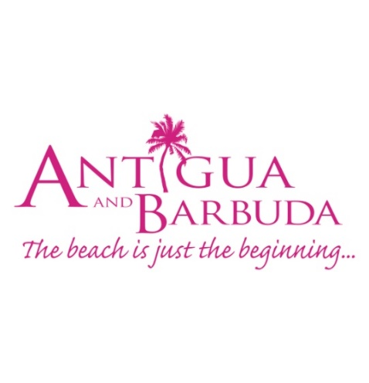

**FOR IMMEDIATE RELEASE:**

**BARBUDA’S LUXURY HOTEL BARBUDA BELLE REOPENS FOR THE FIRST TIME FOLLOWING HURRICANE IRMA**

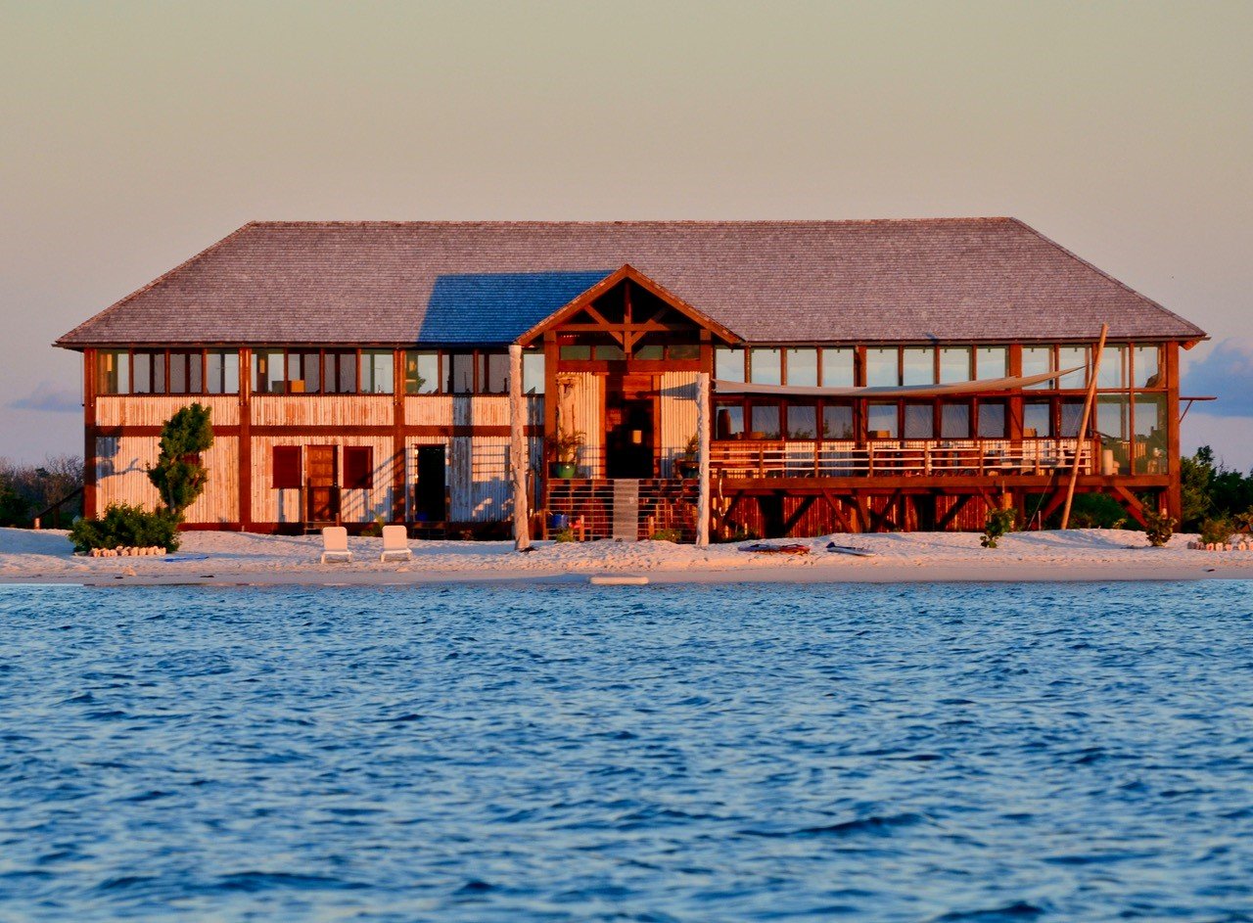

*(Photo Caption: Barbuda Belle has reopened in time for the 2018/2019 Winter Season)*

**ST. JOHN’S, ANTIGUA (November 6, 2018**) – Barbuda Belle, an intimate, luxury boutique hotel on Antigua’s sister island of Barbuda has reopened for the 2018/2019 Winter Season.

This is the first time that the award-winning hotel has opened since being damaged during Hurricane Irma in September 2017.

Accessible by boat via Barbuda’s Codrington Lagoon, the rustic-styled property located at Cedar Point offers ultimate seclusion, tucked neatly away behind of lush mangrove trees and a picturesque pink sand beach. Originally a seven bungalow property, Barbuda Belle now boasts eight beachfront bungalows since renovations saw the total rebuild of one bungalow damaged during the storm, and the addition of a completely new bungalow. A beach bar and grill is also a new addition. Daily rates for Barbuda Belle start at US$890.

Minister of State in the Ministry of Tourism and Investment, Senator, The Hon. Mary-Clare Hurst spoke at the November 3 reopening Ceremony on behalf of the Minister of Tourism and Investment, The Hon. Charles Fernandez who was away on duty.

“Today marks a very important step in Barbuda’s recovery post Hurricane Irma and a significant step in our Country’s Tourism. Today is our collective affirmation to our visitors far and wide, that Barbuda is open for business!”, Hurst said.

“The Government of Antigua and Barbuda is excited by the momentum and progress that we have seen so far, as it relates to Barbuda’s Tourism and progress just one year on.”

The Barbuda Belle re-opening is the first in many openings that will take place in Barbuda for the season. The Barbuda Ocean Club, and Barbuda Cottages are expected to open in December.

For more information on Antigua and Barbuda go to: visitantiguabarbuda.com

To book Barbuda Belle go to: barbudabelle.com

###

**ABOUT ANTIGUA AND BARBUDA**

Antigua (pronounced An-tee'ga) and Barbuda (Bar-byew’da) is located in the heart of the Caribbean Sea. Voted the World Travel Awards 2015, 2016, 2017 and 2018 *Caribbean’s Most Romantic Destination*, the twin-island paradise offers visitors two uniquely distinct experiences, ideal temperatures year-round, a rich history, vibrant culture, exhilarating excursions, award-winning resorts, mouth-watering cuisine and 365 stunning pink and white-sand beaches - one for every day of the year. The largest of the Leeward Islands, Antigua comprises 108-square miles with rich history and spectacular topography that provides a variety of popular sightseeing opportunities. Nelson’s Dockyard, the only remaining example of a Georgian fort a listed UNESCO World Heritage site, is perhaps the most renowned landmark. Antigua’s tourism events calendar includes the prestigious Antigua Sailing Week, Antigua Classic Yacht Regatta, and the annual Antigua Carnival; known as the Caribbean’s Greatest Summer Festival. Barbuda, Antigua’s smaller sister island, is the ultimate celebrity hideaway. The island lies 27 miles north-east of Antigua and is just a 15-minute plane ride away. Barbuda is known for its untouched 17 mile stretch of pink sand beach and as the home of the largest Frigate Bird Sanctuary in the Western Hemisphere.  Find information on Antigua & Barbuda at: [www.visitantiguabarbuda.com](http://www.visitantiguabarbuda.com) or follow us on **Twitter**. <http://twitter.com/antiguabarbuda>  **Facebook** [www.facebook.com/antiguabarbuda](http://www.facebook.com/antiguabarbuda); **Instagram**: [www.instagram.com/AntiguaandBarbuda](http://www.instagram.com/AntiguaandBarbuda)

**For Antigua and Barbuda media queries, contact:**

**Maria Blackman**

Antigua and Barbuda Tourism Authority

T: 1 268 464 7601 /1 268 562 7600

E: [Maria.blackman@visitaandb.com](mailto:Maria.blackman@visitaandb.com)