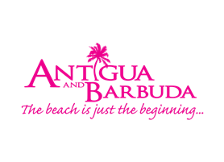

**MINISTER OF TOURISM OFFERS WELL-WISHES TO ATLANTIC CHALLENGE DUO, AS ANTIGUA AND BARBUDA’S ADVENTUROUS NAUTICAL PROWESS IS TESTED**

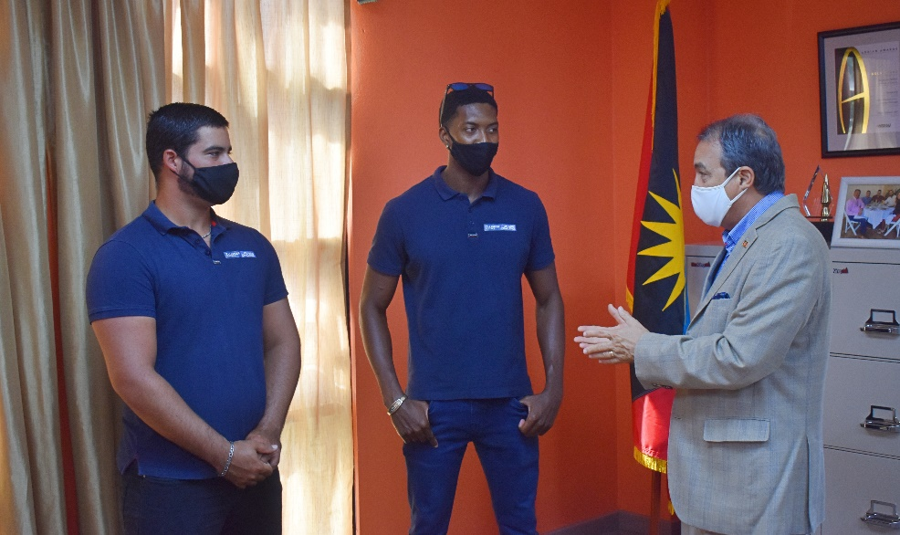

*L-R: The Team Antigua Pairs duo of Joseph Nunes and Travis Weste, receive words of encouragement from Minister of Tourism, The Honourable Charles Fernandez*

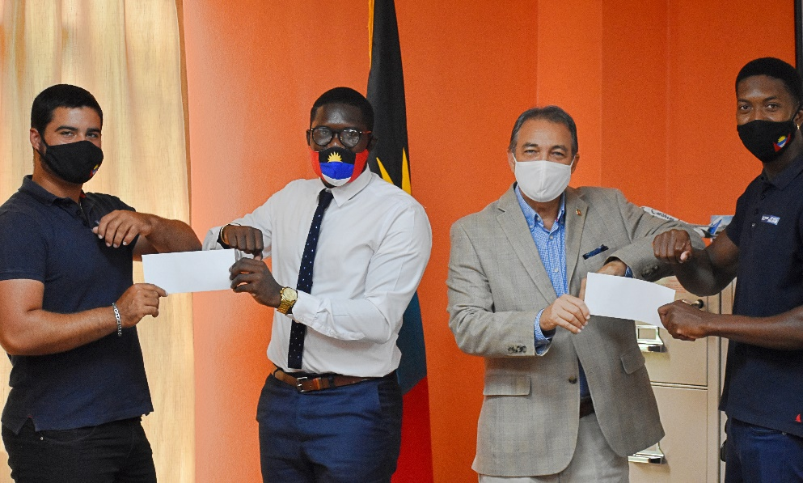

*The Team Antigua Pairs duo of Joseph Nunes and Travis Weste, receive financial support from the Ministry of Tourism and the Antigua and Barbuda Tourism Authority for their December 12 Atlantic Crossing. Joseph Nunes and Travis Weste are pictured with Minister of Tourism, the Hon. Charles Fernandez and Operations Manager of the Antigua and Barbuda Tourism Authority Javier Jacobs*

**ST. JOHN’S, ANTIGUA (November 3, 2020) –** The rowing adventure of a lifetime for two young nationals of Antigua and Barbuda is about to start, and with a challenge that places Antigua and Barbuda’s nautical prowess on full display, the Antigua and Barbuda Ministry of Tourism and the Antigua and Barbuda Tourism Authority are providing their full support to the Antigua seamen.

The Talisker Whisky Atlantic Challenge ‘Team Antigua Pairs’ team of Joseph Nunes and Travis Weste was presented with flights sponsorship by the Ministry of Tourism and the Antigua and Barbuda Tourism Authority.

The Minister of Tourism, The Hon. Charles Fernandez made the presentation to the high-spirited Antigua Team, today at the Ministry of Tourism headquarters.

The Ministry of Tourism and the Antigua and Barbuda Tourism Authority are long-standing supporters of the Talisker Whisky Atlantic Challenge and have made a commitment to supporting Antigua and Barbuda teams entering the race.

Speaking at the handover presentation, Minister Fernandez said, “We at the Ministry of Tourism signed a contract to sponsor the Talisker Whisky Atlantic Challenge, and so it is very fitting that we have Antiguans represented in the race.

“I want to take the opportunity to congratulate Travis and Joseph on the bold initiative that they are taking, and we wish them God’s speed and the best of luck.”

The Minister said the Ministry of Tourism and the Antigua and Barbuda Tourism Authority felt it was necessary to offer assistance to the Antigua and Barbuda Team, and encouraged anyone who could offer assistance to the adventurous team, to do so.

“The most important thing is to encourage all Antiguans and Barbudans, whom they will be representing on the trip across the Atlantic, to assist in any way they can.”

Nunes and Weste are now the fourth team and first pair to represent Antigua and Barbuda in the event, known as the ‘World’s Toughest Row’.

Weste said the team is 98% ready for the race. He expressed thanks to the Ministry of Tourism and the entire population of Antigua and Barbuda for their support and words of encouragements.

Nunes and Weste will leave Antigua on November 28, 2020 for La Gomera in the Canary Islands.

They will then spend the next two weeks in safety briefings and will make other preparations for their three-thousand-mile Atlantic crossing, in their two-man row boat known as ‘The Wolf’.

“We are pretty optimistic and have been looking forward to this all year. We are going to do our best, and represent Antigua and Barbuda to the maximum”, said Nunes. The duo will also be raising funds for their charity, The Rotary Club of Antigua Sundown.

The race begins on December 12, 2020, with rowers racing across the Atlantic Ocean towards the finish line at the historic Nelson’s Dockyard, Antigua. There are twenty teams presently participating in the race. The Antigua team will be one of two pairs teams taking part in the event.

Team Antigua Pairs will keep supporters posted on their progress, with regular social media updates. Follow Team Antigua Pairs on: [www.facebook.com/AntiguaPairs](http://www.facebook.com/AntiguaPairs)