FOR IMMEDIATE RELEASE:
ANTIGUA AND BARBUDA CELEBRATES BRITISH AIRWAYS MILESTONE
as the airline marks 60 years of flying to Antigua
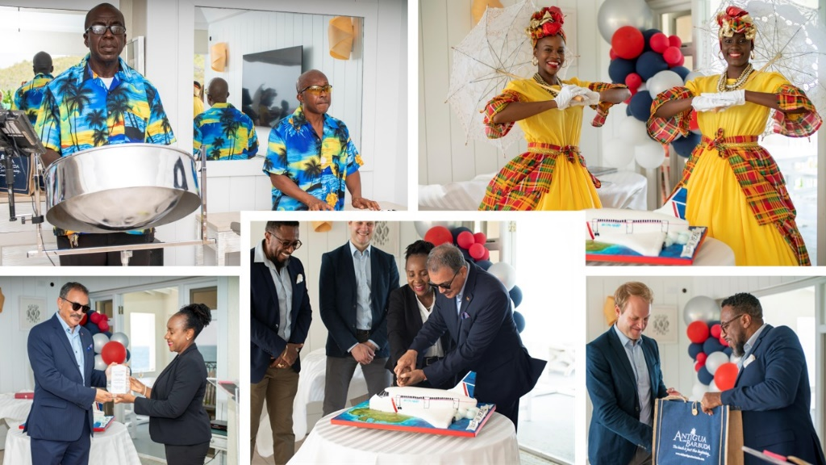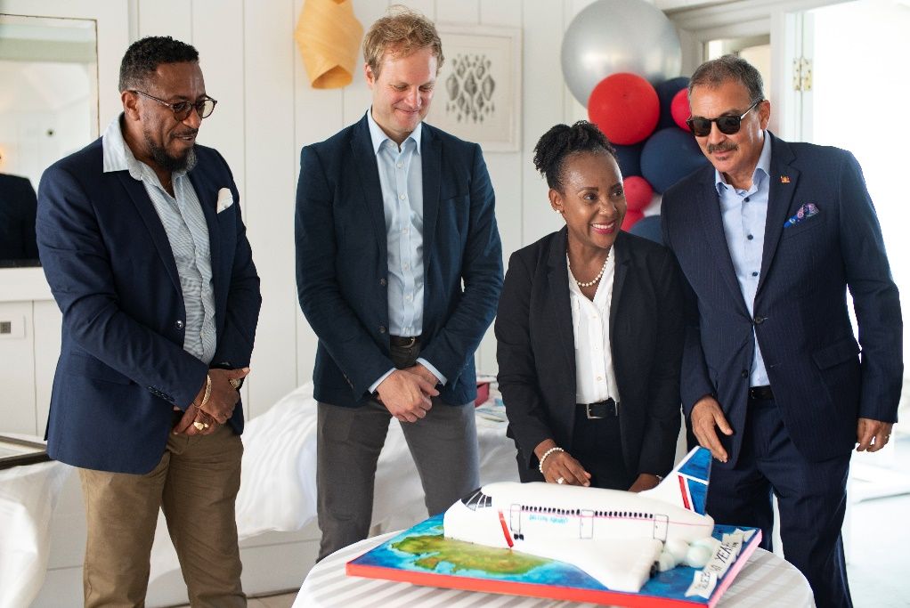
Photo Caption: Patrice Skerritt, British Airway Regional Director – Airports (Antigua, St. Kitts, and Turks & Caicos), and Marc James, Key Partnership Manager British Airways were all smiles as the Minister of Tourism The Hon Charles Fernandez and CEO of the Antigua and Barbuda Tourism Authority Colin C. James present a grand cake to the airline for their sixty-year celebrations.
June 11, 2022 (ST. JOHN’S, ANTIGUA) - Antigua and Barbuda marked British Airways 60th anniversary of flying to Antigua with a cocktail reception hosted yesterday by the Antigua and Barbuda Ministry of Tourism and the Antigua and Barbuda Tourism Authority at the Rock Cottage, Blue Waters.
Setting the celebratory mood and greeting British Airways executives, hoteliers, aviation, and tourism stakeholders to include representatives from the Antigua and Barbuda Hotels and Tourism Association, the Antigua and Barbuda Airport Authority and the Museum of Antigua and Barbuda were welcoming cultural dancers and the melodious sounds of the steelband.
The Honourable Charles Fernandez, Minister of Tourism and Investment speaking at the event, congratulated the airline on the excellent relationship created throughout the sixty-year period. He expressed interest in continued partnership and the further growth of flights to the destination.
“British Airways has for sixty years connected travellers from the UK and Europe to Antigua and Barbuda, allowing us to share our culture, our heritage, our hospitality, and the beauty of our destination. As a trusted partner, British Airways is interwoven into our tourism story. We share a rich history - from destination partnerships, marketing campaigns, to unwavering support during times of need, they have without a doubt contributed to the success of our tourism product. As we share in this momentous occasion, we congratulate and applaud BA. We look forward to many more years of partnership, and a mutually rewarding relationship with our twin-island paradise.”
British Airways, Regional Director (Antigua, St. Kitts, and Turks & Caicos) Patrice Skerritt commenting on the tourism celebrations said: “We are most appreciate of your efforts in recognizing this milestone with us at British Airways.
“British Airways has always had a very strong relationship with Antigua and Barbuda and for sixty years - three generations - we have flown visitors to enjoy holidays, and we have reunited our Caribbean friends and family both here in the region and in London and beyond.”
Skerritt thanked the gathering for joining in the anniversary celebrations and noted that the airline looked forward to serving the route for many more years to come.
British Airways then called British Overseas Airways Corporation (BOAC) first touched down at V. C. Bird International Airport on June 1, 1962.
A sense of nostalgia was brought to the event, as CEO of the Antigua and Barbuda Tourism Authority Colin C. James shared tales of the airline from its first voyage to Antigua in 1962, their 1965 corporate sponsorship of Antigua Carnival, the November 2 1984 arrival of the Concorde to Antigua, and the development of a modern day partnership considered a “marriage made in heaven, with an airline that has always served the destination well”.
In November 2019, the Antigua and Barbuda Tourism Authority honoured British Airways as an outstanding partner by presenting the airline with a ‘Black Pineapple Award’ for their contribution to the success of the summer marketing campaign #WhatCoolLooksLike.
Yesterday’s celebrations featured the presentation of a beautiful British Airways airline sculpted cake to British Airways’ Regional Director – Airports Patrice Skerritt and Key Partnership Manager visiting from the UK, Marc James. British Airways was also presented with a replica of a historic photo obtained from the Museum of Antigua and Barbuda of 1965 Carnival Queen Hyacinth Barrow waving to on-lookers as she prepared to board BOAC on a prize-win flight to England. Minister Fernandez was also gifted with a sixty-year commemorative plaque from the airline.

###
ABOUT THE ANTIGUA AND BARBUDA TOURISM AUTHORITY
The Antigua & Barbuda Tourism Authority is a statutory body dedicated to realizing the tourism potential of Antigua & Barbuda by promoting the twin island state as a unique, quality tourist destination with the overall objective of increasing visitor arrivals thereby providing sustainable economic growth. The Antigua and Barbuda Tourism Authority is headquartered in St. John’s Antigua, where regional marketing is directed. The Authority has three offices overseas in the United Kingdom, United States and Canada.
ABOUT ANTIGUA AND BARBUDA
Antigua (pronounced An-tee'ga) and Barbuda (Bar-byew’da) is located in the heart of the Caribbean Sea. The twin-island paradise offers visitors two uniquely distinct experiences, ideal temperatures year-round, a rich history, vibrant culture, exhilarating excursions, award-winning resorts, mouth-watering cuisine and 365 stunning pink and white-sand beaches - one for every day of the year. The largest of the English-speaking Leeward Islands, Antigua comprises 108-square miles with rich history and spectacular topography that provides a variety of popular sightseeing opportunities. Nelson’s Dockyard, the only remaining example of a Georgian fort a listed UNESCO World Heritage site, is perhaps the most renowned landmark. Antigua’s tourism events calendar includes the prestigious Antigua Sailing Week, Antigua Classic Yacht Regatta, and the annual Antigua Carnival; known as the Caribbean’s Greatest Summer Festival. Barbuda, Antigua’s smaller sister island, is the ultimate celebrity hideaway. The island lies 27 miles north-east of Antigua and is just a 15-minute plane ride away. Barbuda is known for its untouched 11-mile stretch of pink sand beach and as the home of the largest Frigate Bird Sanctuary in the Western Hemisphere. Find information on Antigua & Barbuda at: www.visitantiguabarbuda.com or follow us on Twitter: http://twitter.com/antiguabarbuda Facebook: www.facebook.com/antiguabarbuda; Instagram: www.instagram.com/AntiguaandBarbuda

For Antigua and Barbuda media enquiries, please contact:
Maria Blackman
Marketing Communications Manager
Antigua and Barbuda Tourism Authority
T: 1 (268) 562 7600/464-7601
E: maria.blackman@visitaandb.com

Antigua and Barbuda Images: aandbtourism.fotoseeker.com

