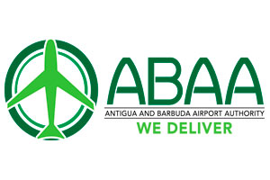

FOR IMMEDIATE RELEASE:

ANTIGUA AND BARBUDA BEGINS VACCINATION FOR TOURISM FRONTLINE WORKERS

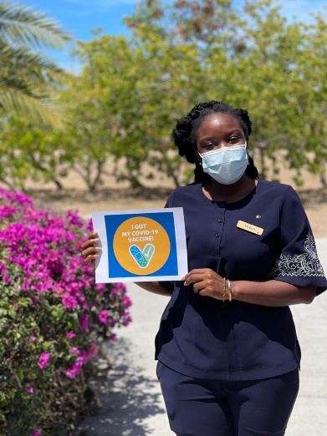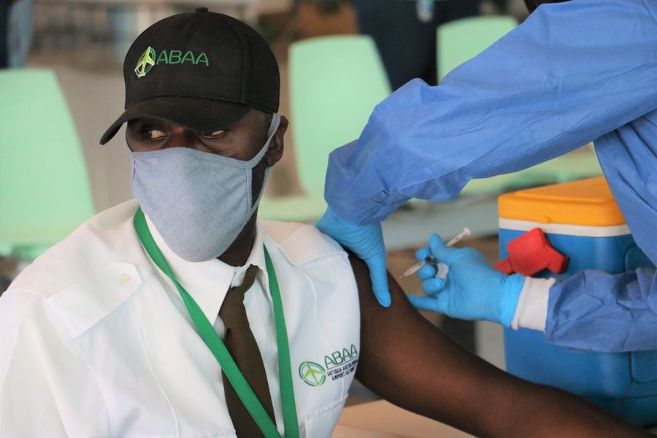
Tourism industry workers in Antigua and Barbuda have received the Covid-19 vaccine. (Photo credits: The Antigua and Barbuda Hotels and Tourism Association and Antigua and Barbuda Airport Authority)

ST. JOHN’S, ANTIGUA (MARCH 15, 2021) - The Government of Antigua and Barbuda has begun the Covid-19 vaccination process for frontline workers in the Tourism Industry.
Speaking on the accelerated vaccination process for those within the country’s vital tourism industry, CEO of the Antigua and Barbuda Tourism Authority, Colin C. James said, “We are encouraged by the enthusiasm of our tourism stakeholders who made themselves available for the vaccine.
The continued health and safety of our tourism workers remains a priority for us as we welcome visitors safely to our destination and prepare for a strong tourism rebound when travel restrictions ease within the next few months in our key source markets.”
Over two thousand (2,000) Hospitality professionals across Antigua and Barbuda to include Hotel workers, Tours Operators, Restaurant and Retail employees were vaccinated this past week.
Mr. Alex de Brito Chairman of the Antigua and Barbuda Hotels and Tourism Association stated that “It is of utmost importance for us to protect our employees. Our industry cannot survive without their dedication, hard work and commitment to seeing the Industry bounce back. With so many already taking the step towards vaccination, we are confident that our destination will have a positive image in the international travel media. Our message is definitely one that promotes the safety of our destination and the commitment that the Government has shown in reviving the economy of Antigua and Barbuda and getting us beyond the grips of the pandemic.”
Additionally, 473 persons from the airline community also received their first doses of the AstraZeneca vaccine last week, at the VC Bird International Airport.
Amongst those given the opportunity to receive the vaccine were Administrative, Operations and Security staff of the Antigua and Barbuda Airport Authority, airline staff, concessionaires, ground handlers, taxi drivers, red caps, and tour companies.
CEO of the Antigua and Barbuda Airport Authority Euletta Francis reflected on the past year.
“In March 2020, the pandemic forced the closure of our borders. Today, I am mindful that we are at this point having come through an extremely challenging year. I am indeed grateful that employees who have sacrificed so much and overcome their worst fears during a difficult time got this important layer of protection in the fight against Covid-19,” Francis noted.
To date, over 23,000 persons in Antigua and Barbuda have been vaccinated. Those vaccinated include health care workers, senior and vulnerable citizens, educators, those within the public sector, and tourism frontline workers.

###

ABOUT THE ANTIGUA AND BARBUDA TOURISM AUTHORITY
The Antigua & Barbuda Tourism Authority is a statutory body dedicated to realizing the tourism potential of Antigua & Barbuda by promoting the twin island state as a unique, quality tourist destination with the overall objective of increasing visitor arrivals thereby providing sustainable economic growth. The Antigua and Barbuda Tourism Authority is headquartered in St. John’s Antigua, where regional marketing is directed. The Authority has three offices overseas in the United Kingdom, United States and Canada.
ABOUT ANTIGUA AND BARBUDA
Antigua (pronounced An-tee'ga) and Barbuda (Bar-byew’da) is located in the heart of the Caribbean Sea. Voted the World Travel Awards 2015, 2016, 2017 and 2018 Caribbean’s Most Romantic Destination, the twin-island paradise offers visitors two uniquely distinct experiences, ideal temperatures year-round, a rich history, vibrant culture, exhilarating excursions, award-winning resorts, mouth-watering cuisine and 365 stunning pink and white-sand beaches - one for every day of the year. The largest of the Leeward Islands, Antigua comprises 108-square miles with rich history and spectacular topography that provides a variety of popular sightseeing opportunities. Nelson’s Dockyard, the only remaining example of a Georgian fort a listed UNESCO World Heritage site, is perhaps the most renowned landmark. Antigua’s tourism events calendar includes the prestigious Antigua Sailing Week, Antigua Classic Yacht Regatta, and the annual Antigua Carnival; known as the Caribbean’s Greatest Summer Festival. Barbuda, Antigua’s smaller sister island, is the ultimate celebrity hideaway. The island lies 27 miles north-east of Antigua and is just a 15-minute plane ride away. Barbuda is known for its untouched 17 mile stretch of pink sand beach and as the home of the largest Frigate Bird Sanctuary in the Western Hemisphere. Find information on Antigua & Barbuda at: www.visitantiguabarbuda.com or follow us on Twitter. http://twitter.com/antiguabarbuda Facebook www.facebook.com/antiguabarbuda; Instagram: www.instagram.com/AntiguaandBarbuda

For media enquiries, please contact:
Maria Blackman
Antigua and Barbuda Tourism Authority
T: 1 (268) 562 7600/464-7601
E: maria.blackman@visitaandb.com

