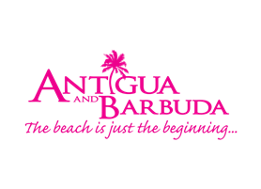

**FOR IMMEDIATE RELEASE:**

**CELEBRATE ANTIGUA SAILING WEEK BY ENTERING TO WIN INCREDIBLE VACATIONS TO ANTIGUA AND BARBUDA STAYING AT CARLISLE BAY RESORT**

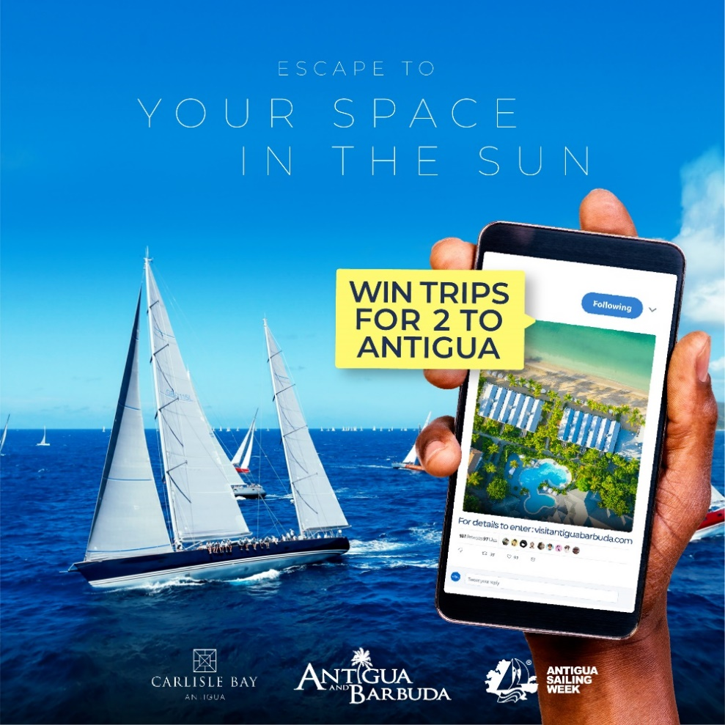

**(ST. JOHN’S ANTIGUA) April 23, 2021** – [Antigua Sailing Week 2021: The Virtual Edition](https://www.sailingweek.com/) is set to take place from April 25 – April 30 in Antigua, and the [Antigua and Barbuda](http://www.visitantiguabarbuda.com) Tourism Authority and the luxurious Carlisle Bay Resort are celebrating the event, by providing vacationers with the chance to win - incredible vacations to Antigua staying at the five star Carlisle Bay Resort.

From April 25 to May 23, residents of the United States of America, the United Kingdom, The Caribbean, and Canada can go to [visitantiguabarbuda.com](http://www.visitantiguabarbuda.com), to enter *The Escape You Deserve: Antigua Sailing Week Sweepstakes*. Two lucky winners will each receive free airfare for two and a four (4) night stay for two, at the Carlisle Bay Resort in an Ocean Suite, inclusive of breakfast, and afternoon tea. Only one entry is allowed, and the winners will be chosen randomly.

“Antigua and Barbuda is open and we’re welcoming travellers to safely experience the destination, said Minister of Tourism, The Hon. Charles Fernandez. “We’re proud of our high vaccination rate within the country, and as more persons get vaccinated globally, we expect to see the safe return of competitive sailing in Antigua and Barbuda!”

The ‘Sailing Capital of the Caribbean’ there is nowhere better to get out on the water than in Antigua and Barbuda, known for its steady tradewinds and safe, indented harbours.

CEO of the Antigua and Barbuda Tourism Authority Colin C. James said “The Escape You Deserve: Antigua Sailing Week Sweepstakes is targeting the leisure traveller, and travellers keen for a unique yachting and sailing adventure. After a year of postponed travel, we are providing them with opportunities to win free vacations to Antigua, where they can enjoy our open spaces on water and land.”

Located on a stunning horseshoe bay on the south-western shore of Antigua, overlooking tranquil turquoise waters and swathed by lush rainforest, [Carlisle Bay](https://www.carlisle-bay.com/) offers a haven of seclusion and relaxation.

The vacation sweepstakes will officially launch during **Sailing Week Sunday**, a virtual 2 hour show on April 25 with live entertainment, interviews and stories hosted by Antigua Sailing Week from 4 p.m. AST on their Facebook [www.facebook.com/SailingWeek](http://www.facebook.com/SailingWeek) and  [Antigua Sailing Week - YouTube](https://www.youtube.com/channel/UCEKCVa0lWpgjvVcUaLNQ-_A) channels.

Travel enthusiasts keen to win one of the two free vacations to Antigua, will be treated to a personalized viewing of the Carlisle Bay Resort on April 28, during the virtual [**Antigua Sailing Week Lay Day**](http://www.facebook.com/antiguabarbuda)hosted by the Antigua and Barbuda Tourism Authority on Facebook.

Viewers watching on social media should be ready for an exciting day in Antigua, as the action-packed Lay Day will include beach competitions, *Rum in the Ruins*, model boat sailing, cultural entertainment by the Cultural Development Division and the Antigua and Barbuda Festivals Commission, and a tour of the Carlisle Bay Resort.

The Antigua and Barbuda Tourism Authority hosted **Antigua Sailing Week** **Lay Day** goes live to the public on April 28 at 11 a.m. AST on the **Antigua and Barbuda Facebook page** [**www.facebook.com/antiguabarbuda**](http://www.facebook.com/antiguabarbuda)

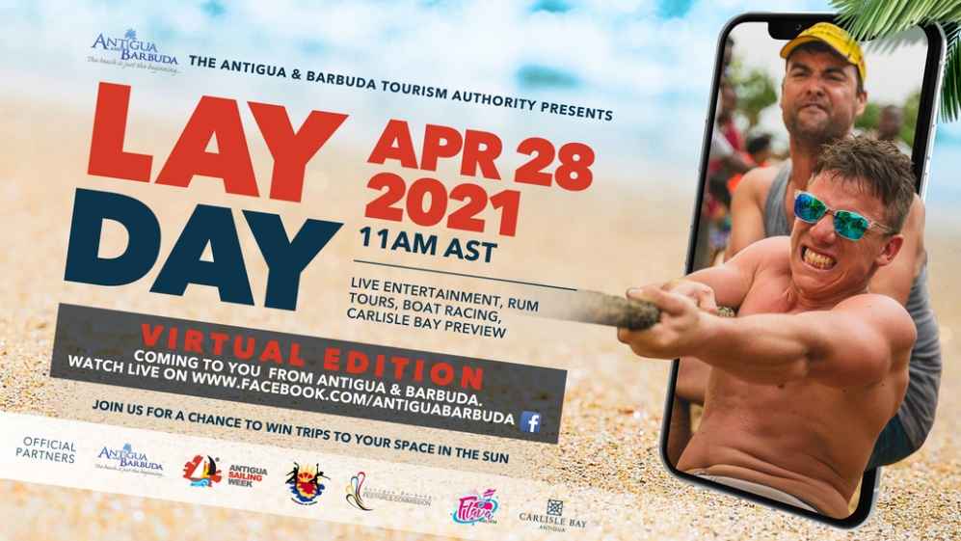

Travellers are welcomed to visit Antigua and Barbuda in 2021 with lots of great experiences that are #sunseasafe in keeping with covid-19 protocols. For more information on Antigua and Barbuda’s travel protocols go to:[visitantiguabarbuda.com](http://www.visitantiguabarbuda.com/)

###

**ABOUT THE ANTIGUA AND BARBUDA TOURISM AUTHORITY**

The Antigua & Barbuda Tourism Authority is a statutory body dedicated to realizing the tourism potential of Antigua & Barbuda by promoting the twin island state as a unique, quality tourist destination with the overall objective of increasing visitor arrivals thereby providing sustainable economic growth. The Antigua and Barbuda Tourism Authority is headquartered in St. John’s Antigua, where regional marketing is directed. The Authority has three offices overseas in the United Kingdom, United States and Canada.

**ABOUT ANTIGUA AND BARBUDA**

Antigua (pronounced An-tee'ga) and Barbuda (Bar-byew’da) is located in the heart of the Caribbean Sea. Voted the World Travel Awards 2015, 2016, 2017 *and 2018* *Caribbean’s Most Romantic Destination*, the twin-island paradise offers visitors two uniquely distinct experiences, ideal temperatures year-round, a rich history, vibrant culture, exhilarating excursions, award-winning resorts, mouth-watering cuisine and 365 stunning pink and white-sand beaches - one for every day of the year. The largest of the Leeward Islands, Antigua comprises 108-square miles with rich history and spectacular topography that provides a variety of popular sightseeing opportunities. Nelson’s Dockyard, the only remaining example of a Georgian fort a listed UNESCO World Heritage site, is perhaps the most renowned landmark. Antigua’s tourism events calendar includes the prestigious Antigua Sailing Week, Antigua Classic Yacht Regatta, and the annual Antigua Carnival; known as the Caribbean’s Greatest Summer Festival. Barbuda, Antigua’s smaller sister island, is the ultimate celebrity hideaway. The island lies 27 miles north-east of Antigua and is just a 15-minute plane ride away. Barbuda is known for its untouched 17 mile stretch of pink sand beach and as the home of the largest Frigate Bird Sanctuary in the Western Hemisphere.  Find information on Antigua & Barbuda at: [www.visitantiguabarbuda.com](http://www.visitantiguabarbuda.com) or follow us on **Twitter**. <http://twitter.com/antiguabarbuda>  **Facebook** [www.facebook.com/antiguabarbuda](http://www.facebook.com/antiguabarbuda); **Instagram**: [www.instagram.com/AntiguaandBarbuda](http://www.instagram.com/AntiguaandBarbuda)

**For media enquiries, please contact:**Maria Blackman  
Antigua and Barbuda Tourism Authority

T: 1 (268) 562 7600/464-7601  
E: [maria.blackman@visitaandb.com](mailto:maria.blackman@visitaandb.com)