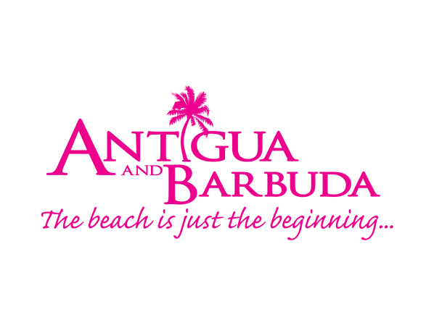

FOR IMMEDIATE RELEASE:

ANTIGUA AND BARBUDA TOURISM AUTHORTY AND WELLNESS STAKEHOLDERS MOVE FORWARD WITH WELLNESS TOURISM INITITATIVES

ST. JOHN’S, ANTIGUA (FEBRUARY 28, 2022) - The Antigua and Barbuda Tourism Authority (ABTA) is consulting with all the key players within the wellness sector, this March, as it prepares to launch a destination-wide wellness initiative geared towards further promoting the destination to wellness-minded travelers.
Talks are set for Thursday, March 3, and Thursday, March 24 with the Antigua and Barbuda Tourism Authority and featured speaker Anne Dimon, President/CEO of the North American-based Wellness Tourism Association, and Owner/Editor of the consumer-facing online resource www.TravelToWellness.com.
Dimon led a Wellness Tourism Audit and Forum organised by the Antigua and Barbuda Tourism Authority with wellness service providers in 2019. The audit and forum identified the destination’s untapped selling points, gaps and marketable qualities within the wellness space of the tourism industry.
On March 3, Dimon will present her findings from the 2019 wellness audit to stakeholders during a virtual wellness tourism webinar taking place at 1:00 p.m. on the Zoom platform.
"As travel resumes and the tourism industry recovers, “wellness” is a hot topic. Antigua & Barbuda is ideally positioned not only to host the wellness-minded traveler for a Wellness Vacation, but to become a key player in one of the fastest growing sectors of the global tourism industry,” said Dimon.
Director of Tourism (Ag) – Canada and Lead on the ABTA’s Wellness Pillar, Tameka Wharton added, “We are looking forward to welcoming all stakeholders aligned with our wellness sector to the webinar and are excited to have the discussion with them on the next stage of our wellness journey.”
A number of programmes followed the Antigua and Barbuda Tourism Authority’s 2019 audit, including the award-winning #CoolisClean campaign, along with a stronger focus on incorporating wellness experiences into tourism marketing efforts.
“Particularly during the pandemic, health and wellness was of significant global importance, and our #YourSpaceInTheSun campaign, tapped into the destination’s natural attributes. We are committed to moving forward with our wellness programme in 2022, and are calling on wellness service providers to join us in this initiative,” said Wharton.
The one-hour Zoom webinar will address what Antigua & Barbuda currently offers under the umbrella of wellness, and answer the question: “Can the country become a recognized Wellness Destination?” Attendees will hear about who is driving demand and why demand will grow post pandemic, the factors that are extremely important to wellness-minded travellers as travel resumes, and the “must haves” for a supplier and/or individual looking to become a wellness tourism stakeholder, as well as other relevant topics.
The Tourism Authority is inviting agro-processors, farmers, restaurants, tour and excursion operators, fitness and outdoor activity providers, hotels and hospitality providers, spas, yoga, meditation and indoor fitness consultants, educators in food & beverage and hospitality, preventative medical care providers and anyone with an interest in providing a wellness product or experience in Antigua and Barbuda, to join the session.
Persons are invited to register for the webinar being held on the Zoom platform using the following link: https://us06web.zoom.us/webinar/register/WN_yIc4PM05TC-uapD8ervfIw
Once registered, participants will then receive a link to access the webinar on March 3, 2022.
For more information, contact the Antigua and Barbuda Tourism Authority on 1 (268) 562 7600.

###

For Antigua and Barbuda media enquiries, please contact:
Maria Blackman
Antigua and Barbuda Tourism Authority
T: 1 (268) 562 7600/464-7601
E: maria.blackman@visitaandb.com

ABOUT THE ANTIGUA AND BARBUDA TOURISM AUTHORITY
The Antigua & Barbuda Tourism Authority is a statutory body dedicated to realizing the tourism potential of Antigua & Barbuda by promoting the twin island state as a unique, quality tourist destination with the overall objective of increasing visitor arrivals thereby providing sustainable economic growth. The Antigua and Barbuda Tourism Authority is headquartered in St. John’s Antigua, where regional marketing is directed. The Authority has three offices overseas in the United Kingdom, United States and Canada.

ABOUT ANTIGUA AND BARBUDA
Antigua (pronounced An-tee'ga) and Barbuda (Bar-byew’da) is located in the heart of the Caribbean Sea. Voted the World Travel Awards 2015, 2016, 2017 and 2018 Caribbean’s Most Romantic Destination, the twin-island paradise offers visitors two uniquely distinct experiences, ideal temperatures year-round, a rich history, vibrant culture, exhilarating excursions, award-winning resorts, mouth-watering cuisine and 365 stunning pink and white-sand beaches - one for every day of the year. The largest of the Leeward Islands, Antigua comprises 108-square miles with rich history and spectacular topography that provides a variety of popular sightseeing opportunities. Nelson’s Dockyard, the only remaining example of a Georgian fort a listed UNESCO World Heritage site, is perhaps the most renowned landmark. Antigua’s tourism events calendar includes the prestigious Antigua Sailing Week, Antigua Classic Yacht Regatta, and the annual Antigua Carnival; known as the Caribbean’s Greatest Summer Festival. Barbuda, Antigua’s smaller sister island, is the ultimate celebrity hideaway. The island lies 27 miles north-east of Antigua and is just a 15-minute plane ride away. Barbuda is known for its untouched 17 mile stretch of pink sand beach and as the home of the largest Frigate Bird Sanctuary in the Western Hemisphere. Find information on Antigua & Barbuda at: www.visitantiguabarbuda.com or follow us on Twitter. http://twitter.com/antiguabarbuda Facebook www.facebook.com/antiguabarbuda; Instagram: www.instagram.com/AntiguaandBarbuda

