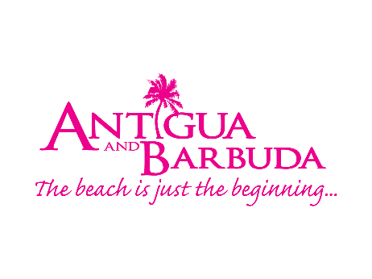

IT’S OFFICIAL – 84% OF BRITS WANT TO WORK FROM A BEACH
THE ANTIGUA AND BARBUDA TOURISM AUTHORITY LAUNCHES BUSINESS ON THE BEACH FOR UK MARKET
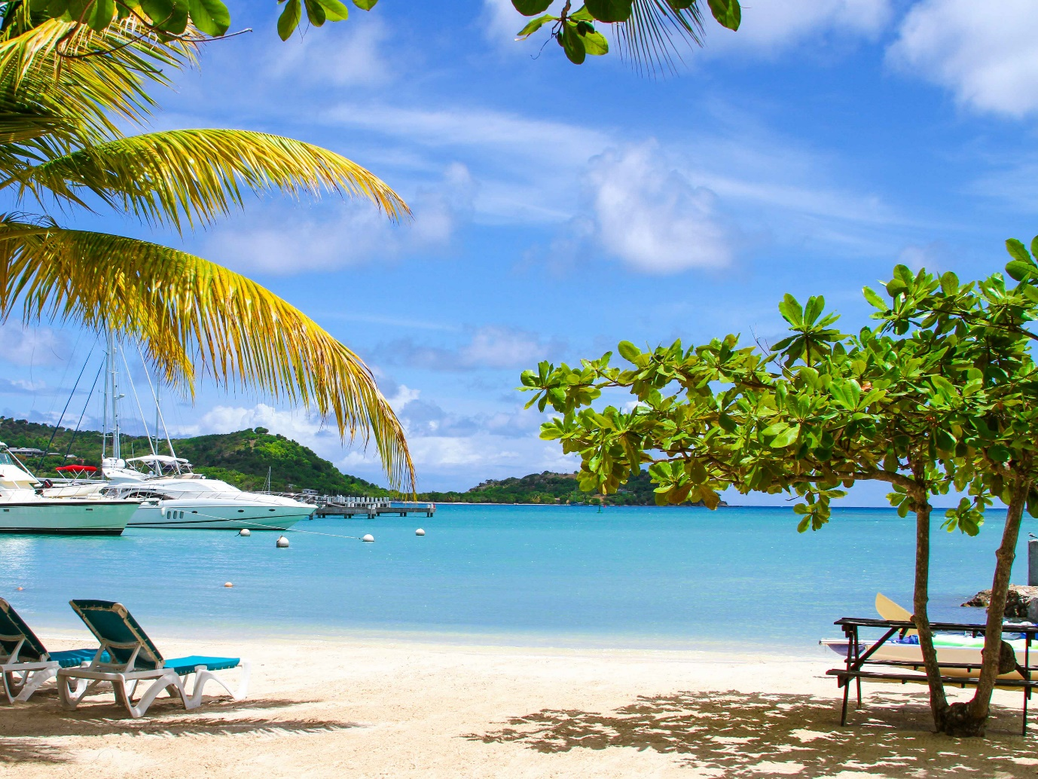
(London, December 2020) The results are in and it is official – Brits are ready to ditch the cold UK weather, and swap their home office for a warm sunny beach.
According to a nationwide survey conducted in the UK by the Antigua and Barbuda Tourism Authority, 84 percent of working Brits would love to replace their Zoom background with a genuine backdrop of the ocean. The Antigua and Barbuda Tourism Authority has heard this message loud and clear and is taking action with the launch of its brand-new campaign: Business on the Beach.
The tourism authority is calling all Brits to swap the morning commute or home office and head to Antigua and Barbuda for the twin-island’s 365 palm fringed beaches, incredible adventure activities and delicious local cuisine.
70 percent of the UK continues to feel the effects of the COVID-19 pandemic on their mental health, and with 74 percent saying that sunshine is good for the soul, Antigua and Barbuda’s island-life mentality is sure to reset, refresh and reboot the minds of working professionals.
Cherrie Osborne, Director of Tourism UK & Europe for the Antigua and Barbuda Tourism Authority has said “Sunnier climes have long proven to boost overall mental well-being, so it comes as no surprise that Brits are eager to swap the confines of their home office for the alluring open spaces of Antigua and Barbuda. The launch of the Business on the Beach campaign is very timely, showcasing the opportunity to work from the destination as a remote working alternative”.
With 93 percent of Brits agreeing that businesses are now more likely than ever before to allow employees to work from home, Antigua and Barbuda’s new campaign is making it easy for Brits to do their business on the beach. Whether from an exclusive use property or one of the country’s spectacular all-inclusive resorts, British remote workers are guaranteed strong WIFI and an idyllic surrounding to boost inspiration and motivation.
Colin C. James, CEO of the Antigua and Barbuda Tourism Authority said, “Antigua and Barbuda offers sun, sea, sand and space. The destination is safe and provides the ideal backdrop for the ultimate remote working experience. A swim between meetings, a spectacular Zoom backdrop, and finishing each working day with freshly caught fish and local produce– working remotely in Antigua and Barbuda might just be the perfect remedy following a tumultuous 2020”.

Interested in working remotely from Antigua and Barbuda? For more information on the process go to: Antigua Nomad Digital Residence (antiguanomadresidence.com)

ENDS
NOTE TO EDITORS:

Survey Results have also shown that:
Over half of Brits (57 percent) definitely agree that businesses are now more willing than ever to allow employees to work remotely, saying there has been a real change in the last year.

ABOUT THE ANTIGUA AND BARBUDA TOURISM AUTHORITY
The Antigua & Barbuda Tourism Authority is a statutory body dedicated to realizing the tourism potential of Antigua & Barbuda by promoting the twin island state as a unique, quality tourist destination with the overall objective of increasing visitor arrivals thereby providing sustainable economic growth. The Antigua and Barbuda Tourism Authority is headquartered in St. John’s Antigua, where regional marketing is directed. The Authority has three offices overseas in the United Kingdom, United States and Canada.
ABOUT ANTIGUA AND BARBUDA
Antigua (pronounced An-tee'ga) and Barbuda (Bar-byew’da) is located in the heart of the Caribbean Sea. Voted the World Travel Awards 2015, 2016, 2017 and 2018 Caribbean’s Most Romantic Destination, the twin-island paradise offers visitors two uniquely distinct experiences, ideal temperatures year-round, a rich history, vibrant culture, exhilarating excursions, award-winning resorts, mouth-watering cuisine and 365 stunning pink and white-sand beaches - one for every day of the year. The largest of the Leeward Islands, Antigua comprises 108-square miles with rich history and spectacular topography that provides a variety of popular sightseeing opportunities. Nelson’s Dockyard, the only remaining example of a Georgian fort a listed UNESCO World Heritage site, is perhaps the most renowned landmark. Antigua’s tourism events calendar includes the prestigious Antigua Sailing Week, Antigua Classic Yacht Regatta, and the annual Antigua Carnival; known as the Caribbean’s Greatest Summer Festival. Barbuda, Antigua’s smaller sister island, is the ultimate celebrity hideaway. The island lies 27 miles north-east of Antigua and is just a 15-minute plane ride away. Barbuda is known for its untouched 17 mile stretch of pink sand beach and as the home of the largest Frigate Bird Sanctuary in the Western Hemisphere. Find information on Antigua & Barbuda at: www.visitantiguabarbuda.com or follow us on Twitter. http://twitter.com/antiguabarbuda Facebook www.facebook.com/antiguabarbuda; Instagram: www.instagram.com/AntiguaandBarbuda

For UK media enquiries contact The Brighter Group on Antigua@finnpartners.com

For Antigua and Barbuda media enquiries, please contact:
Maria Blackman
Antigua and Barbuda Tourism Authority
T: 1 (268) 562 7600/464-7601
E: maria.blackman@visitaandb.com

