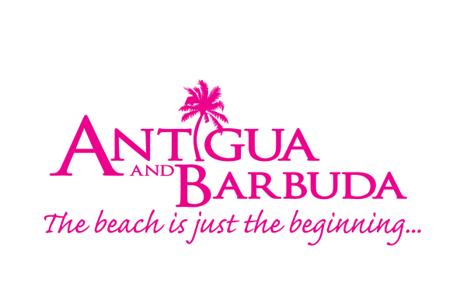

BARBUDA FACT SHEET

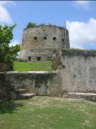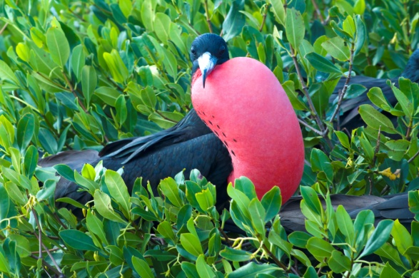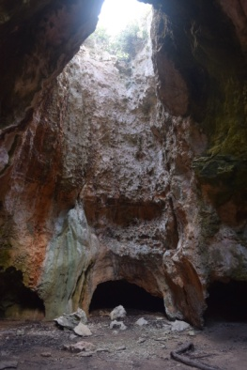

Location Barbuda, which lies 27 miles northeast of its sister island Antigua, has a land area of 62-square-miles (or 14 miles by 8 miles in size). A low-lying coral island, known for its untouched pink coral and white sand beaches, its highest point is only 125 ft above sea level.

Capital The capital of Barbuda is Codrington.

Climate Sunny and warm all year with soothing trade winds, the average temperature ranges from the mid-seventies in the winter to the mid-eighties in the summer. Annual rainfall averages only 45 inches, making Antigua and Barbuda the sunniest of the eastern Caribbean islands and the northeast trade winds are nearly constant, flagging only in September.

Language English is the spoken language.

Population A majority of Barbuda’s over 1,500 inhabitants live in Codrington.

Getting Here ABM Air, and Fly Montserrat operate flights between Antigua and Barbuda. Private Charters are also available with CalvinAir Helicopters. The flight takes 15 minutes. Passports are not needed as the point of entry for both islands is Antigua. Visitors may also opt to take the daily Barbuda Express or Island Escape, which are 90-minute catamaran ferries operating between the islands. The Antigua – Barbuda Express Ferry costs EC$195 return and Island Escape Barbuda Ferry cost EC$160. Once on the island, taxis and bikes are available. Please review the latest travel advisory on www.vistiantiguabarbuda.com for entry requirements related to Covid-19.

Accommodation There are exclusive resorts on the island: Barbuda Belle being the main resort. Barbuda also has a selection of guest houses and B&B’s. Small properties include Barbuda Cottages and Palm Tree Guesthouse.

Dining There is a small selection of restaurants to include the popular Uncle Roddy’s and the internationally recognized Nobu. Snack bars on the island, also offer traditional Barbudan cuisine and seafood specialties.

Activities & Sites Swimming, diving, snorkeling, shipwreck exploring, deep sea fishing, bird watching, turtle-watching hiking in and up the caves, horseback riding, and beachcombing are most often the activities of choice on the island. Sights, other than the beaches, most often visited include:

- Frigate Bird Sanctuary, accessible by boat, is home to 170 species of birds including the Magnificent Frigate Birds.
- Dark Cave, a low, boulder-hung passage that leads 400 feet underground to (almost) fresh-water pools teeming with rare blind shrimp and certain species of crustacean found nowhere else in the world.
- Darby’s Cave featuring a large sink hole, about 350 feet in diameter and 70 feet deep that contains a small but lush rainforest.
- Martello Tower, built in c.1745, is an old fort used both for defence and as a look-out along the south coast
- Indian Cave is one of the most interesting prehistoric sites in Barbuda. Located at Two Foot Bay the caves have several chambers where bays can be found hanging and small Amerindian petroglyphs (rock carvings) can be seen.
- Low Bay and Palmetto Point are two of the best beaches to witness the pink sands of Barbuda. The pink shells cover the beaches in abundance from November – April.
- Barbuda’s pink sand beaches are covered with an abundance of pink shells from October – May.

Sight-seeing tours with lunch are available at prices starting at US$80 per person.

Transportation Individuals must have a valid driver’s licence. Visitors must obtain a temporary Antigua and Barbuda driver’s licence which can be obtained from the Antigua and Barbuda Transport Board or the Licence Office in Barbuda at a cost of US$20 or EC$50 and is valid for three months. Vehicle rentals are US$60 or EC$165 per day.

Cuisine Foods that are indigenous to Barbuda include: venison (deer meat), lobster, conch, fish, land crab, land turtle, hermit crab, fungee, ducana, white beans and pigeon peas.

Fishing Fishing vessels need a special aerial permit to fish within a certain mile of Barbuda waters

Closed Seasons are as follows:
Lobster: May 1 – June 30
Conch: July 1 – August 31
Grouper: January 1 – March 31

For more information on Barbuda, contact us on:
Facebook: www.facebook.com/VisitBarbuda
Email: barbudacounciltourism@gmail.com
Telephone: 1 268 721 2955

