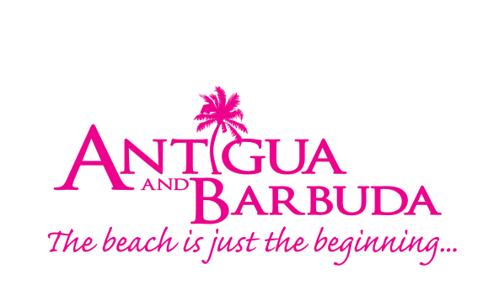

Antigua Fact Sheet

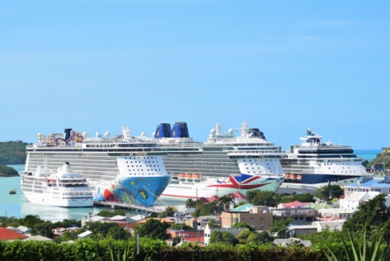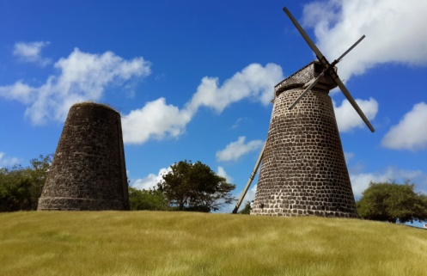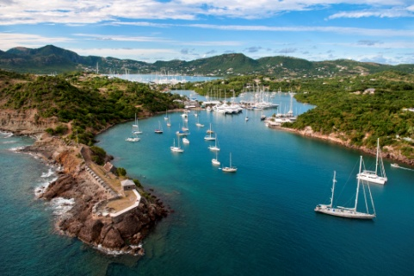

Location Antigua (pronounced An-tee'ga) is located in the heart of the Caribbean Sea. Antigua is a 108-square mile limestone and coral island recognized for its numerous coves, bays, 365 white sand beaches and clear turquoise-colored waters. The sister island of Barbuda (Bar-byew’ da) lies 27 miles northeast of Antigua with a land area of 62 square miles. The uninhabited island of Redonda lies 34 miles south west of Antigua and is 0.6 square miles.

Capital The capital of Antigua is St. John’s with two distinctive waterfront areas and a selection of shops and restaurants.

Constitution Antigua and Barbuda is a parliamentary democracy modelled on the British system. The Head of State is Queen Elizabeth II. The Prime Minister of Antigua and Barbuda is The Honourable Gaston Browne and the Minister of Tourism and Investment is The Honourable Charles Fernandez.

Climate Sunny and warm all year with soothing trade winds, the average temperature ranges from the mid-seventies in the winter to the mid-eighties in the summer. Annual rainfall averages only 45 inches, making it the sunniest of the eastern Caribbean islands, and the northeast trade winds are nearly constant, flagging only in September.

Language English is the spoken language.

Population A majority of the estimated 90,755 (est 2015) people residing in Antigua and Barbuda are of African descent, the remainder being of British, Lebanese, Syrian, Chinese and Portuguese origin.

History Antigua was named by Christopher Columbus in 1493 in homage to Santa Maria de la Antigua, the miracle-working saint of Seville, Spain. In 1632, Antigua was permanently settled as a colony by the British. The arrival of Sir Christopher Codrington began the sugar era for the island with more than 150 cane-processing windmills. By the end of the 18th Century, Antigua had become an important strategic port and valuable commercial colony. Known as the "gateway to the Caribbean," it was situated in a position that offered control over the major sailing routes. Most of the island's historical sites, from its many ruined fortification, to the impeccably-restored architecture of English Harbour, are reminders of colonial efforts to ensure its safety from invasion. Horatio Nelson arrived in 1784 to develop the British naval facilities at English Harbour and to enforce stringent commercial shipping laws. The first of these two tasks resulted in construction of Nelson's Dockyard. Serving under Nelson at the time was the future King William IV and It was during William's reign, in 1834, that Britain abolished slavery in the empire. In 1967, under the leadership of V.C. Bird, with Barbuda and the tiny island of Redonda as dependencies, Antigua became an associated state of the Commonwealth and in 1981 it achieved full independent status.

How to Get There Antigua is served by several major airlines in the United Kingdom, Europe, The United States of America and Canada. Flight times from: the UK and Europe range from 8 – 9.5 hours; the USA 3 – 4 hours, while Canada is approximately 5.5 hours. LIAT, Air Antilles, InterCaribbean, St. Barth Commuter, Tradewinds Aviation, ABM Air, Fly Montserrat, Winair and CalvinAir provide inter-island connections. Flights land at the modern V.C. Bird International Airport located in Coolidge.

Cruise ship ports are located in St. John's Harbour. Private boaters can enter at St. John's Harbour, Jolly Harbour, English Harbour, Falmouth Harbour, Shell Beach Marina, North Sound Marina.

Entry Requirements All visitors to Antigua and Barbuda must be in possession of an onward or round-trip ticket. Visitors require a valid passport with at least six months validity before expiry from arrival date. UK and USA passport holders do not require a visa. Please review the latest travel advisory on www.vistiantiguabarbuda.com for entry requirements related to Covid-19.

Getting Around Renting a car is an ideal way for visitors to discover more of Antigua. A valid driver's license and an EC$50 fee are required to obtain a permit to drive in Antigua. The rental agency will assist in securing this temporary license, which is valid for 90 days. Motorists drive on the left. Taxis are available throughout Antigua. Fares between the airport, harbour, and many hotels and destinations are fixed and can be obtained upon arrival. Taxi drivers are also qualified as tour guides for sightseeing trips. Tour rates can be obtained beforehand through hotels.

For those interested in exploring via public transportation, the West Bus Station and the East Bus Station are located in the capital city of St. John’s. Buses at the West Bus Station, serve the South and South West side of the island, while the East Bus Station serve the East and North East. Bus fares start from US$1.

Accommodations There are over 3500 hotel rooms available in Antigua. Accommodation ranges from comprehensive resort facilities and luxury hotels to smaller, more intimate boutique hotels, guesthouses and cottages.

Sites Antigua’s rich history and spectacular topography provide a variety of popular sightseeing opportunities, and from the capital of St. John’s attractions and activities are no further than a 45-minute taxi-ride. Popular sites include:

Nelson’s Dockyard and the surrounding archaeological sites are featured UNESCO World Heritage sites and the naval dockyard is the only remaining example of a Georgian fort commissioned by the British in 1755 and is perhaps the most renowned landmark in Antigua. The Dockyard, houses a museum, bakery and gift shop, while the surrounding area of English Harbour is filled with a variety of quaint restaurants, lively bars and marinas.

Dow’s Hill Interpretation Centre provides a historic overview of six periods of Antiguan history through a multimedia presentation.

Shirley Heights Lookout offers visitors a panoramic view of Nelson’s Dockyard, one of Antigua’s iconic landmarks.

The Bust of Sir VC Bird Senior, Antigua and Barbuda’s first Premier and Prime Minister, is displayed within the area of the St. John’s Market.

St. John’s Anglican Cathedral, visible from around the capital is regarded as one of Antigua’s national monuments.
The Museum of Antigua and Barbuda housed in the old St. John’s Court House provides a wealth of information and insight into the history of Antigua and Barbuda.
Fort James located within close proximity to St. John’s Harbour is an area filled with history. Visitors can explore remnants of the Fort James, built by the British in the18th century. Formidable canons used to protect the island from the French, are still visible, and make for a dramatic scene.
Betty’s Hope, built in 1674 is the site of one of the first full-scale sugar plantations on Antigua, and offers a chance to step back into time by visiting the only twin restored sugar mills in Antigua.

Fig Tree Drive is where sightseers can explore the lush vegetation of the rainforest, and sample fresh fruit and the ‘Antigua Black’ Pineapple at fruit stalls on the journey.

Devil’s Bridge, located at the eastern tip of the island in Indian Town National Park, where Atlantic breakers have carved out a natural limestone arch.

Wallings Nature Reserve, one of the finest mixed evergreen deciduous forest walks may be had at Wallings. 13 acres of the reservoir catchment area were sown with tree seeds with a view to reforestation, as the area had become denuded after the turn of the century. In recent years some attention has been focused for both watershed protection and forestry products. The forest now boasts some of the most beautiful trees and plants in the Eastern Caribbean. The area is also now named the Wallings Nature Reserve.

Beaches There are 365 beaches on Antigua, one for every day of the year. The numerous reefs and coves combined with crystal-clear turquoise waters afford beachgoers the luxury of privacy and beauty. The great majority of beaches rest inside the calm, protected waters of the island's Caribbean side. All are open to the public. Popular spots along the west coast of the island include Fort James, Beach, Dickenson Bay, Galley Bay, Ffreyes Beach, Darkwood Beach, Turners Beach and Morris Bay. In addition to snorkeling at Cades Bay, the shoreline along the east side of the island includes Half Moon Bay and Long Bay offer great snorkeling opportunities.

Dining Antigua’s diverse culinary scene is on display at award-winning restaurants with menus consisting of, native dishes, Caribbean, French, Italian and more international cuisines. Local seafood specialties include spiny lobster, fish, and conch. Innovative chefs can be found at more than 60 restaurants across the island.

Shopping Two charming shopping areas of Antigua are located in downtown St. John’s close to the waterfront at Heritage Quay and Redcliffe Quay. In the duty-free district at Heritage Quay, shops sell china, crystals, watches, perfumes, cameras and tobacco. The nearby Vendors mall offers a selection of local arts and crafts, straw goods, pottery and jewelry, while the boutiques at the historic Redcliffe Quay provide artisan products and trendy wine bars and cafes. Most shops are open Monday through Saturday from, 9 a.m. to 5 p.m. On Friday and Saturday mornings the National Public Market on the southern edge of the city has folk crafts, colorful tropical fruits and vegetables, fresh fish and a buzzing crowd that make for a lively morning.

Activities A variety of land and sea activities await the adventure-seeker. Water sports abound from sailing, kayaking, kite-surfing, boat cruising, day trips to Barbuda, scuba diving, deep-sea fishing, Swimming with the Stingrays and snorkeling. The island also offers the unforgettable Antigua Rainforest Canopy Tour, a hire wire course through the verdant forest, high above the trees. For land lovers, two 18-hole golf courses and professional tennis courts are accessible and open to the public. In addition, the island offers other popular recreational activities such as walking tours, horseback riding, helicopter tours, hiking, biking, bird-watching, and visiting museums and historical sites. For nature lovers, the island’s peak turtle-watching season is from July – September. The Island also harbours a fierce devotion to the sport of cricket, with the season running from January to July.

Entertainment Entertainment hubs in Antigua can be found in St. John’s City and along stretches in Dickenson Bay, Jolly Harbour and English Harbour. A relaxed nightlife includes entertainment by steel bands, calypsonians, jazz groups, limbo dancing, poetry nights, and moonlight cruises at most major hotels and restaurants. For those seeking a more energetic nightlife, several nightclubs operate on the island, while three major casinos offer gaming. On a Friday evening, there is a weekly ‘Seafood Fridays’ at Nelson’s Dockyard, while on Sunday evening, visitors to the Shirley Heights Lookout Point in English Harbour can enjoy steelband and live band music at the longest running party in the Caribbean, the Shirley Heights Sunset Party and BBQ. Due to Covid-19 restrictions persons are encouraged to contact the establishments prior to visits.

Weddings Many of the hotels on the island offer special packages and wedding planners. There is no waiting period or residency requirement to secure a marriage license. Couples begin by visiting the Ministry of Justice with a valid passport, complete the application and pay a US$40 registration fee, US$150 application fee and the Marriage Officer's fee of US$100. Once a date and time for the ceremony has been determined, this may be performed in the presence of a registrar or marriage officer and two witnesses. All applicants must be over 18 years of age and, if previously married, the original divorce decree or, in the case of a widow or widower, the original marriage and death certificates will need to be presented.

Currency The unit of currency is the Eastern Caribbean dollar (EC$) although U.S. dollars are widely accepted on the island. Traveller’s checks and major credit cards are accepted and ATM’s are available around the island. The exchange rate is USD$1 = EC$2.70. Most Banks are open from 8:00 a.m. – 2:00 p.m., Monday’s – Thursdays and until 4:00 p.m. on Fridays.

Taxes An 8.5 percent government tax is added to all hotel rates. Most hotels and restaurants also add a 10 percent service charge in lieu of tipping. There is no departure tax payable for Antigua & Barbuda.

Tipping Usually 10-15% depending on the level of service - some restaurants and hotels will automatically add a 10% gratuity. If in doubt, just ask. Porters and bellboys should receive US$1 per bag and taxi drivers expect 10-15% of the fare.

Time -4GMT

Medical Facilities Medical services are provided by the Mount St. John Medical Centre, Tel: 484-2700, as well as several general practitioners and specialists on the island operating privately. There are also community clinics and a private clinic.

