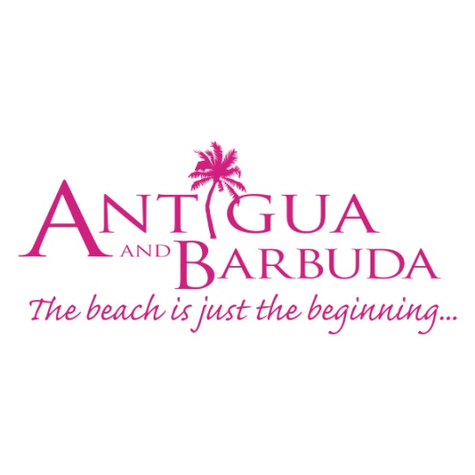

**FOR IMMEDIATE RELEASE:**

**ANTIGUA AND BARBUDA'S INTIMATE AND UNIQUE PROPERTIES SHOWCASED DURING SMALL PROPERTIES ROADSHOW**

(From left to right: Norrell Joseph, Sales & Marketing Manager at Antigua and Barbuda Tourism Authority; Rod Hinds, Regional Sales Manager at Elite Island Resorts; Patrice Simon, Director of the ABHTA; Barbara Colombo, President of the New York City Chapter at the American Society of Travel Agents; Ralph J. Vasami, the immediate Past-President of the New York City Chapter at the American Society of Travel Agents; Dean Fenton, US Director of Tourism at the Antigua and Barbuda Tourism Authority)

**(New York, New York) October 7, 2019 -** The unique attributes of Antigua & Barbuda’s small and boutique properties were recently on display in the tristate area, as the Antigua & Barbuda Tourism Authority (ABTA) and the Antigua & Barbuda Hotels and Tourism Association (ABHTA) embarked upon a roadshow in Northern New Jersey, New York City and Westchester, New York. The team led by the Antigua and Barbuda Tourism Authority’s USA Director of Tourism, Dean Fenton included Executive Director of the ABHTA, Patrice Simon and ABTA’s Sales & Marketing Manager - USA, Norrell Joseph.

Travel agents in each location were very pleased to learn of the unique and intimate accommodations in Antigua which offer travelers an emersion in the history, culture and warm hospitality of the destination. Rod Hinds, Regional Sales Manager at Elite Island Resorts showcased the soon-to-be open Hammock Cove Resort. The team engaged with over 200 travel agents in intimate seminars during the week.

Ralph J. Vasami, the immediate Past-President for the American Society of Travel Agents New York chapter stated, “I was very privileged to be there last evening and learn about Antigua’s boutique resorts; the presentations were very professional and very well received by the agents and they can now take this information to offer more options to their clients who are seeking an ideal vacation in a very special destination”.

“Antigua and Barbuda represent a wide range of resort options. We are delighted to present our smaller properties to travel agents in New York and New Jersey. We sell these properties as unique and authentic Caribbean experiences. Ranging from the historic 350-year-old plantation homes to intimate beachfront locations, our destination truly offers options to suit the desires of many travelers,” said Patrice Simon.

The team participated in roundtable trainings hosted by Royal Caribbean Cruise Line where they interacted with close to 100 travel agents in Bayonne, NJ.

Overall, it was a very successful week promoting an eclectic variety of accommodations in Antigua and Barbuda.

###

**ABOUT ANTIGUA AND BARBUDA**

Antigua (pronounced An-tee'ga) and Barbuda (Bar-byew’da) is located in the heart of the Caribbean Sea. Voted the World Travel Awards 2015, 2016 and 2017 *Caribbean’s Most Romantic Destination*, the twin-island paradise offers visitors two uniquely distinct experiences, ideal temperatures year-round, a rich history, vibrant culture, exhilarating excursions, award-winning resorts, mouth-watering cuisine and 365 stunning pink and white-sand beaches - one for every day of the year. The largest of the Leeward Islands, Antigua comprises 108-square miles with rich history and spectacular topography that provides a variety of popular sightseeing opportunities. Nelson’s Dockyard, the only remaining example of a Georgian fort a listed UNESCO World Heritage site, is perhaps the most renowned landmark. Antigua’s tourism events calendar includes the prestigious Antigua Sailing Week, Antigua Classic Yacht Regatta, and the annual Antigua Carnival; known as the Caribbean’s Greatest Summer Festival. Barbuda, Antigua’s smaller sister island, is the ultimate celebrity hideaway. The island lies 27 miles north-east of Antigua and is just a 15-minute plane ride away. Barbuda is known for its untouched 17 mile stretch of pink sand beach and as the home of the largest Frigate Bird Sanctuary in the Western Hemisphere.  Find information on Antigua & Barbuda at: [www.visitantiguabarbuda.com](http://www.visitantiguabarbuda.com) or follow us on **Twitter**. <http://twitter.com/antiguabarbuda>  **Facebook** [www.facebook.com/antiguabarbuda](http://www.facebook.com/antiguabarbuda); **Instagram**: [www.instagram.com/AntiguaandBarbuda](http://www.instagram.com/AntiguaandBarbuda)

**For media enquiries, please contact:**Maria Blackman  
Antigua and Barbuda Tourism Authority

T: 1 (268) 562 7600/464-7601  
E: [maria.blackman@visitaandb.com](mailto:maria.blackman@visitaandb.com)